*Home work sheet #1

Domain & Range
- Sketch the following functions and find the domain and range:
    - 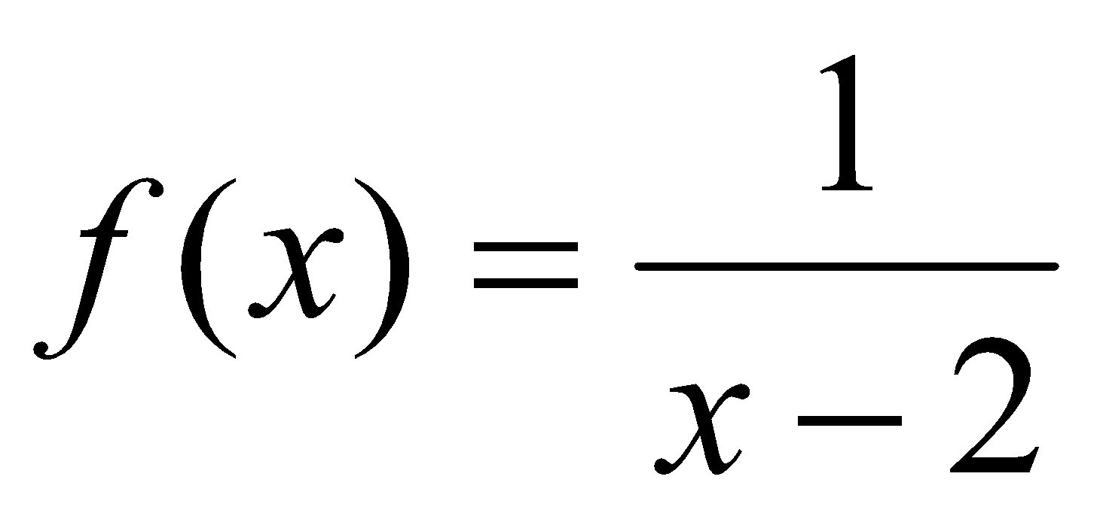
    - 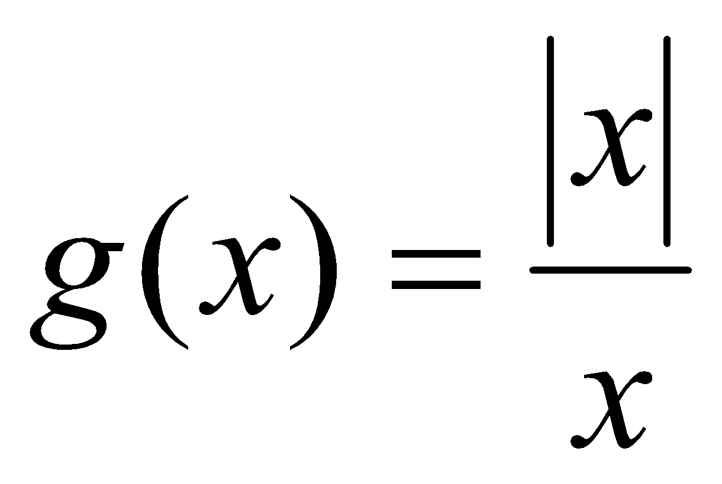
    - 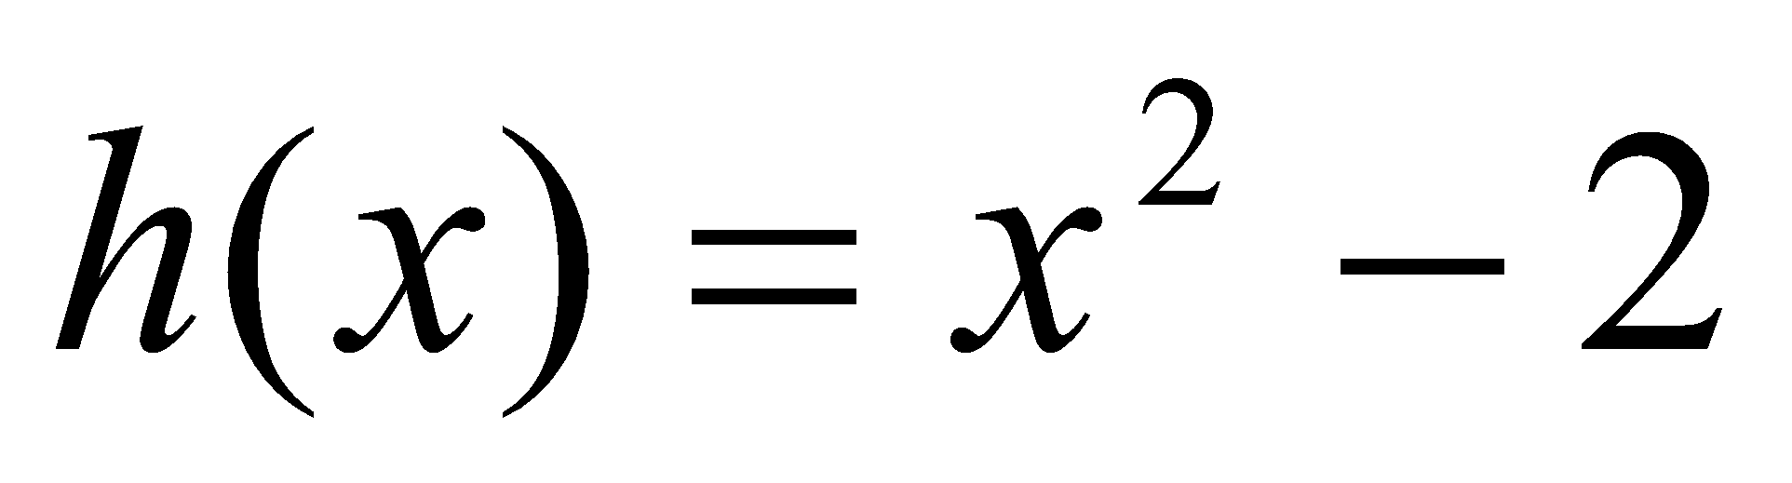
    - 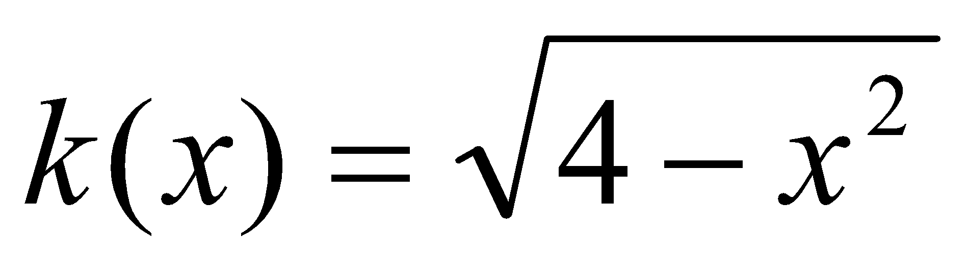

Find out the domain and range of the following functions:

1. 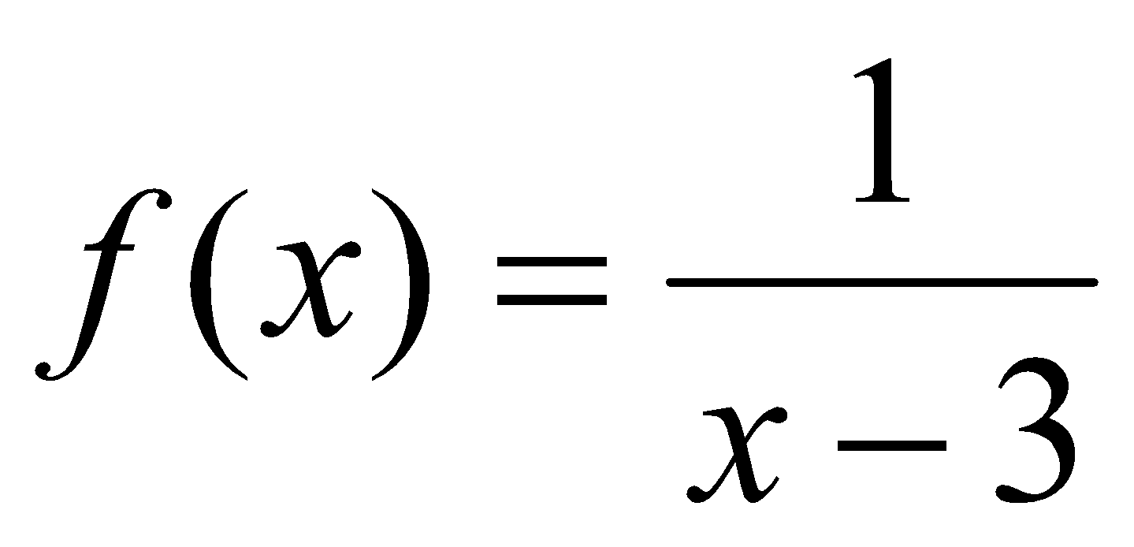 10. 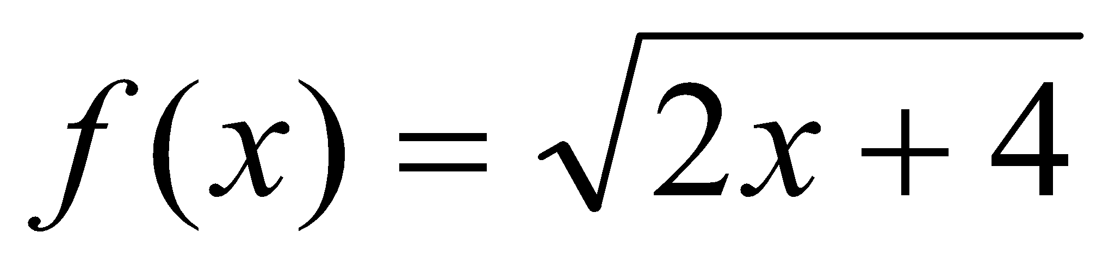

2. 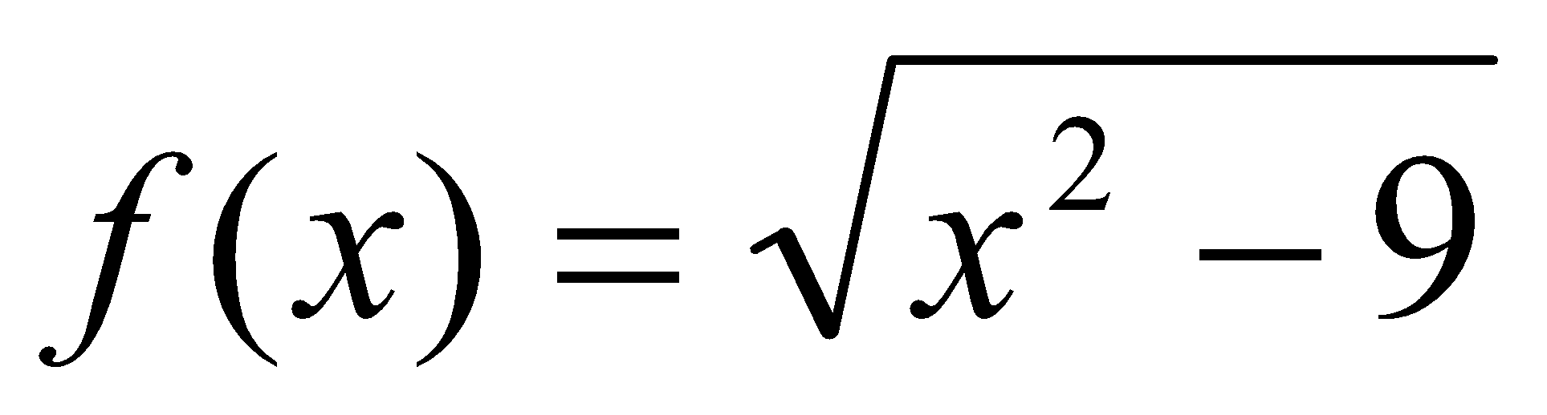 11. 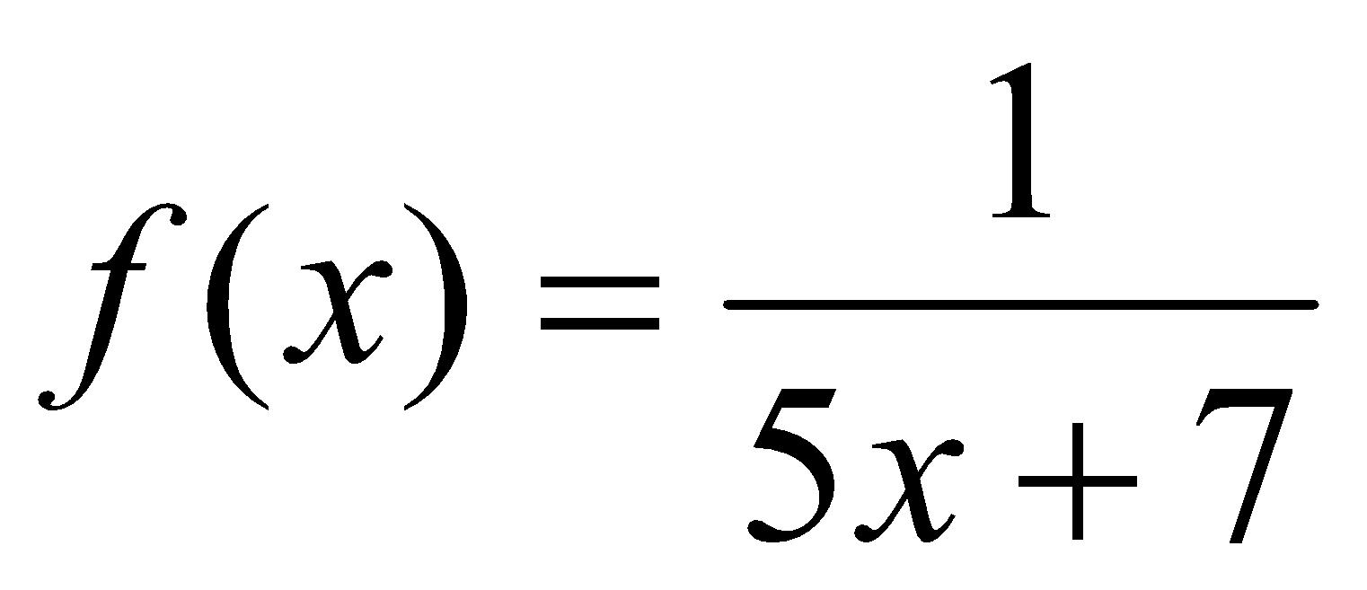

3. 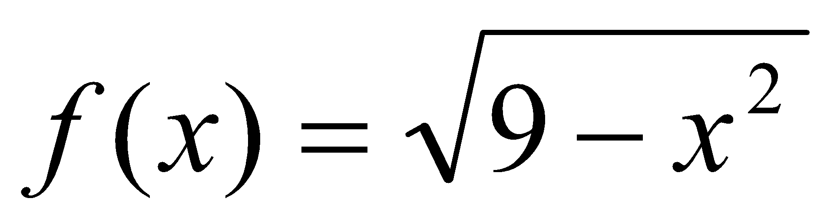 12. 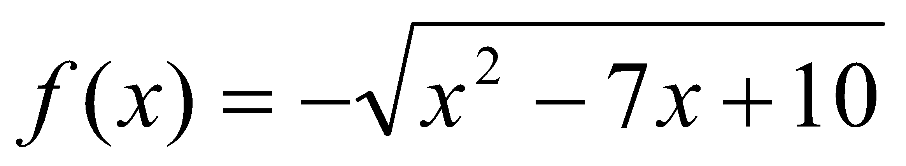

4. 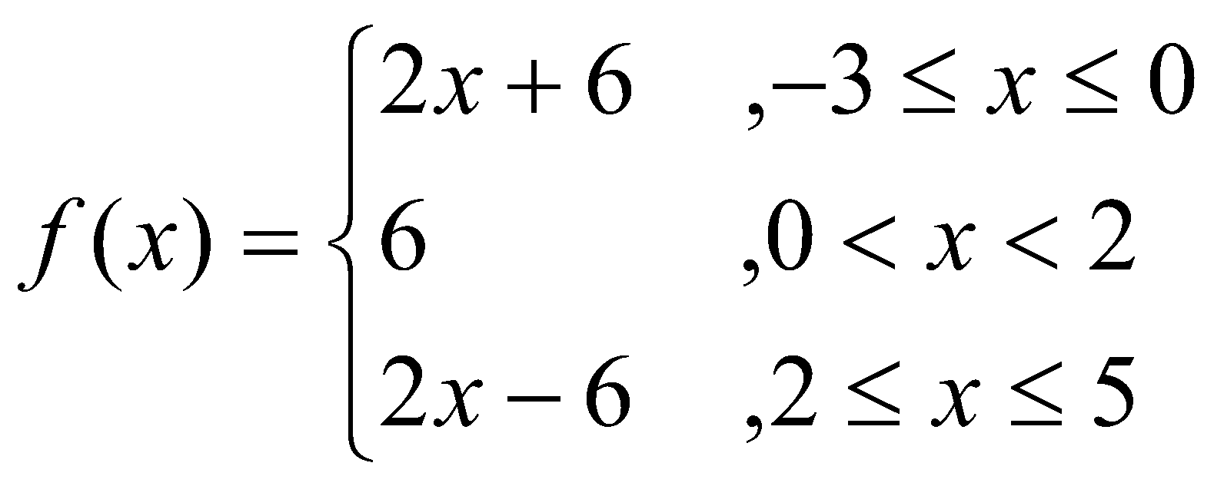 13. 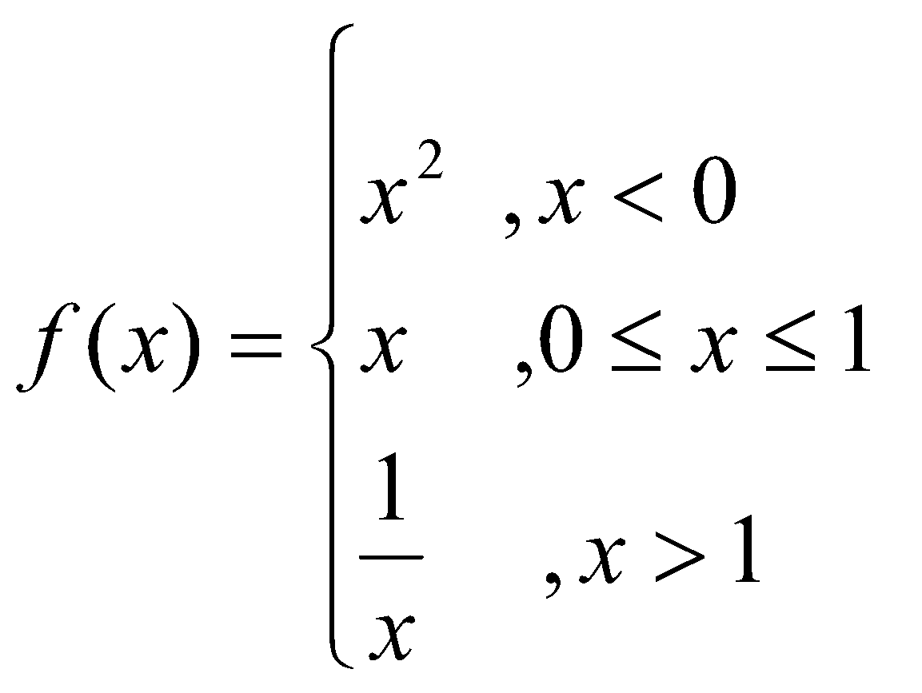

5. 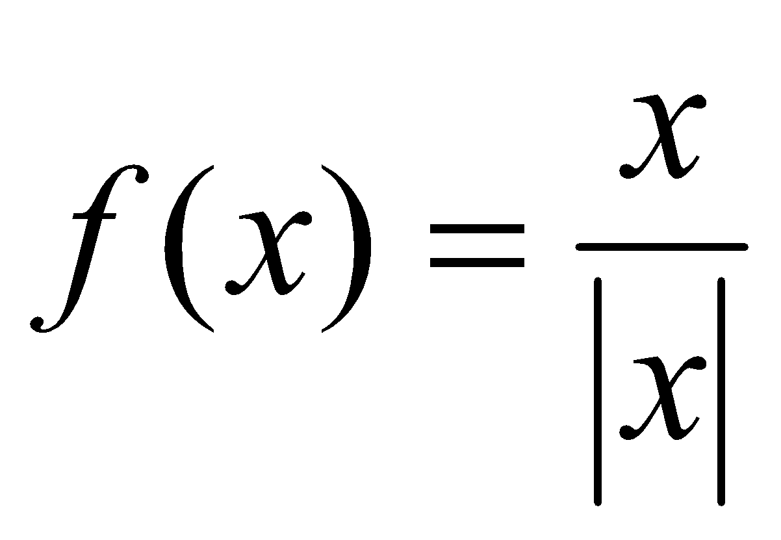 14. 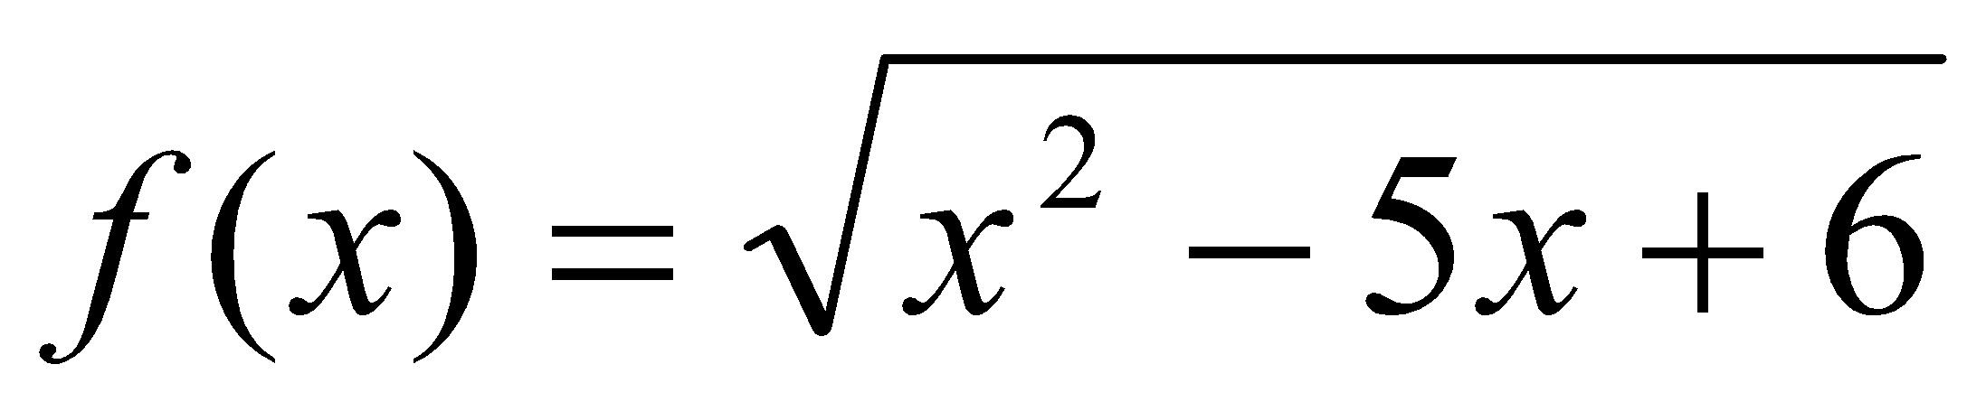

6. 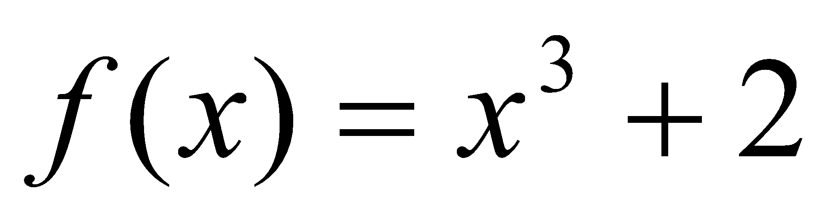 15. 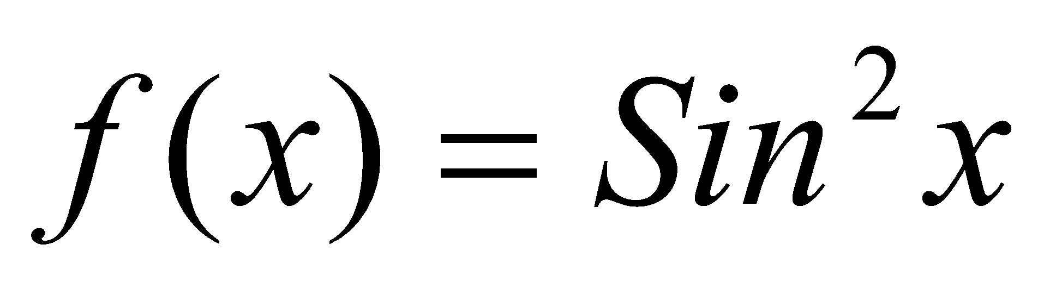

7. 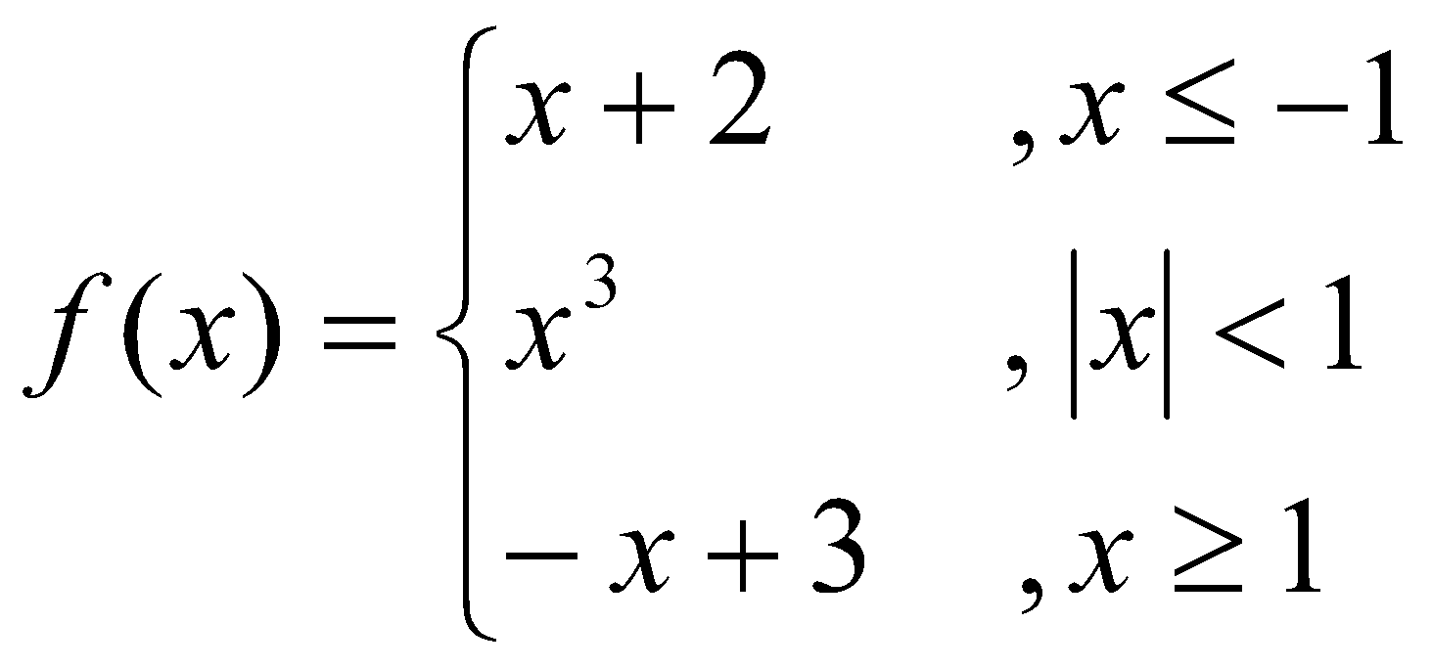 16. 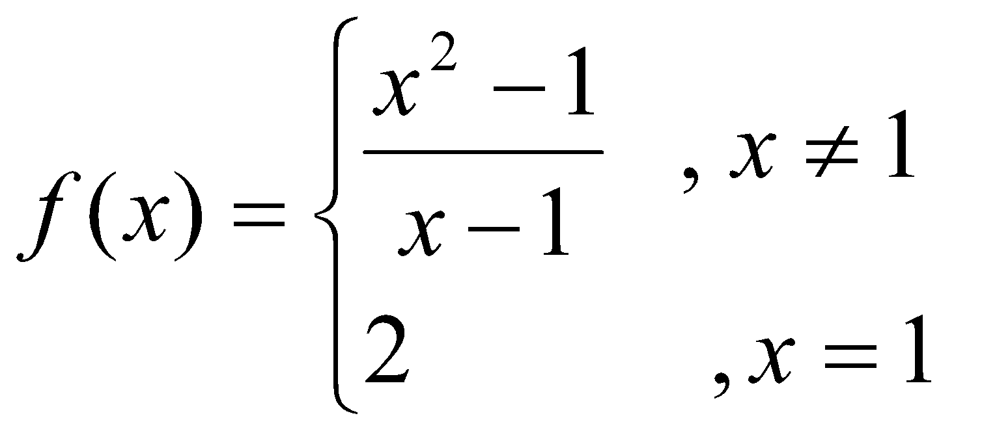

8. 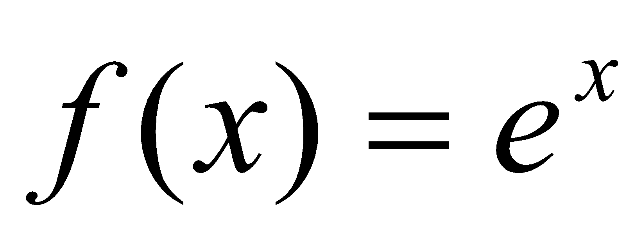 17. 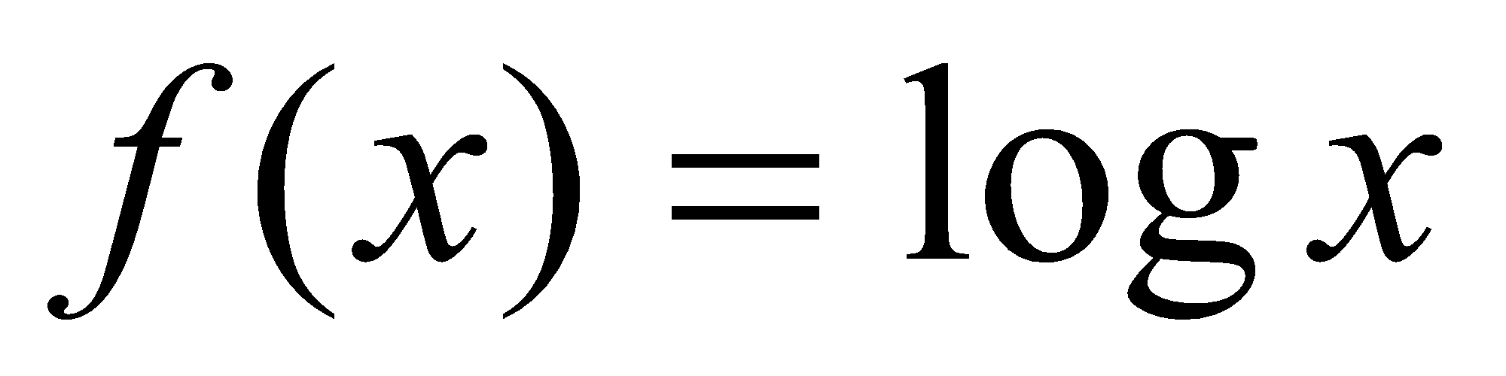

9. 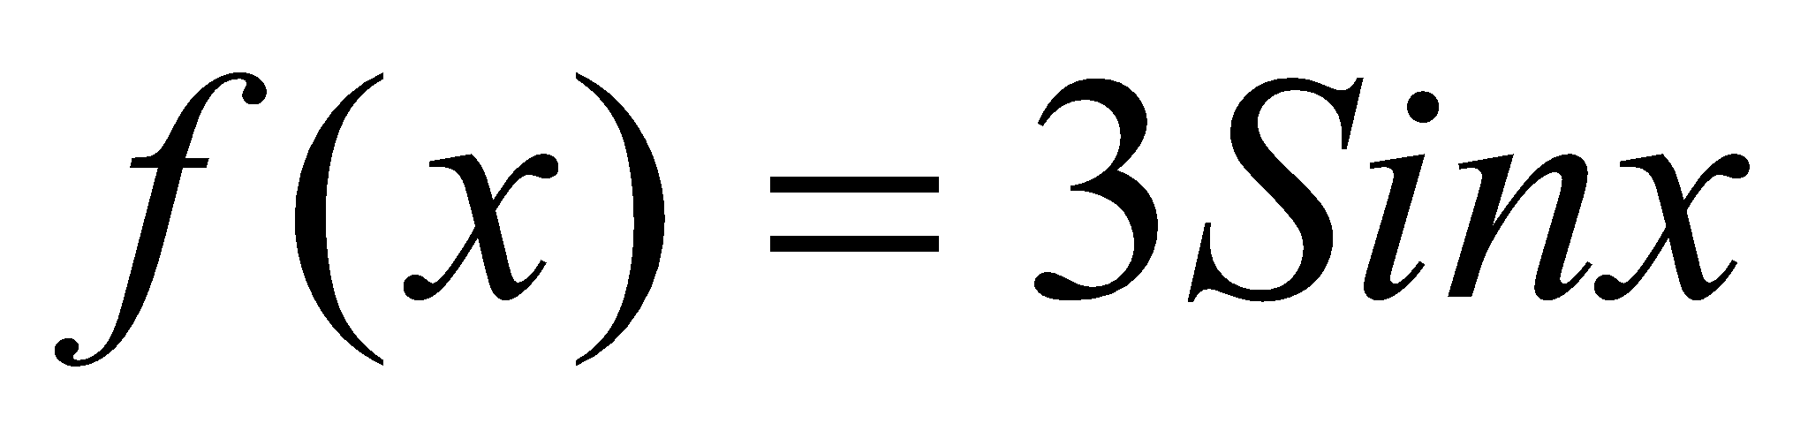 18. 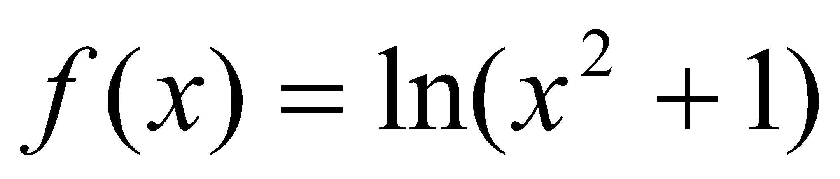

Sketch the above functions except 16 and 18.
*Home work sheet #2
Limit

Find the limit of the following functions:

1. 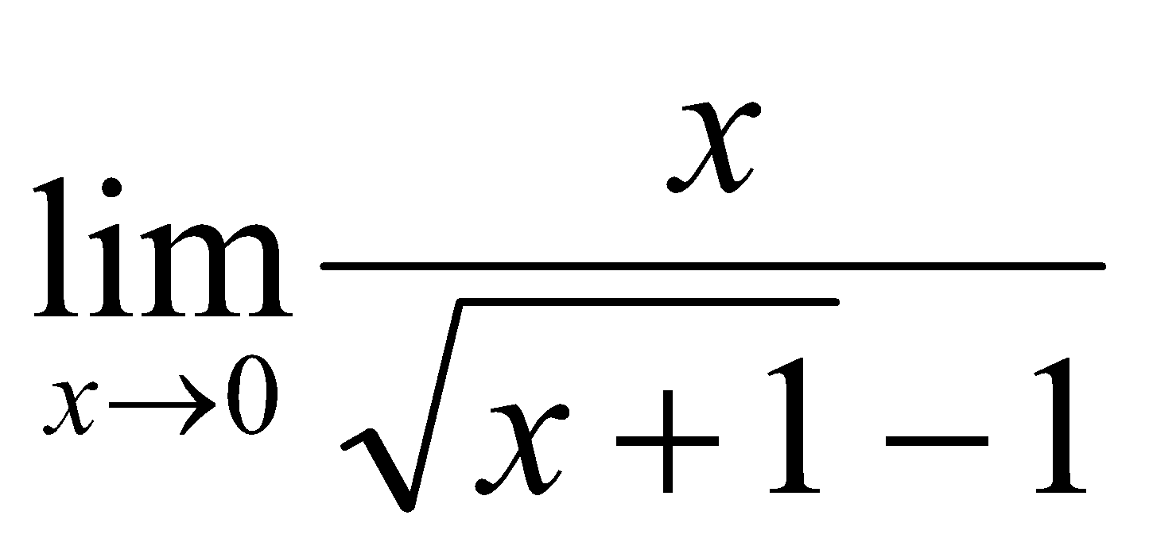 2. 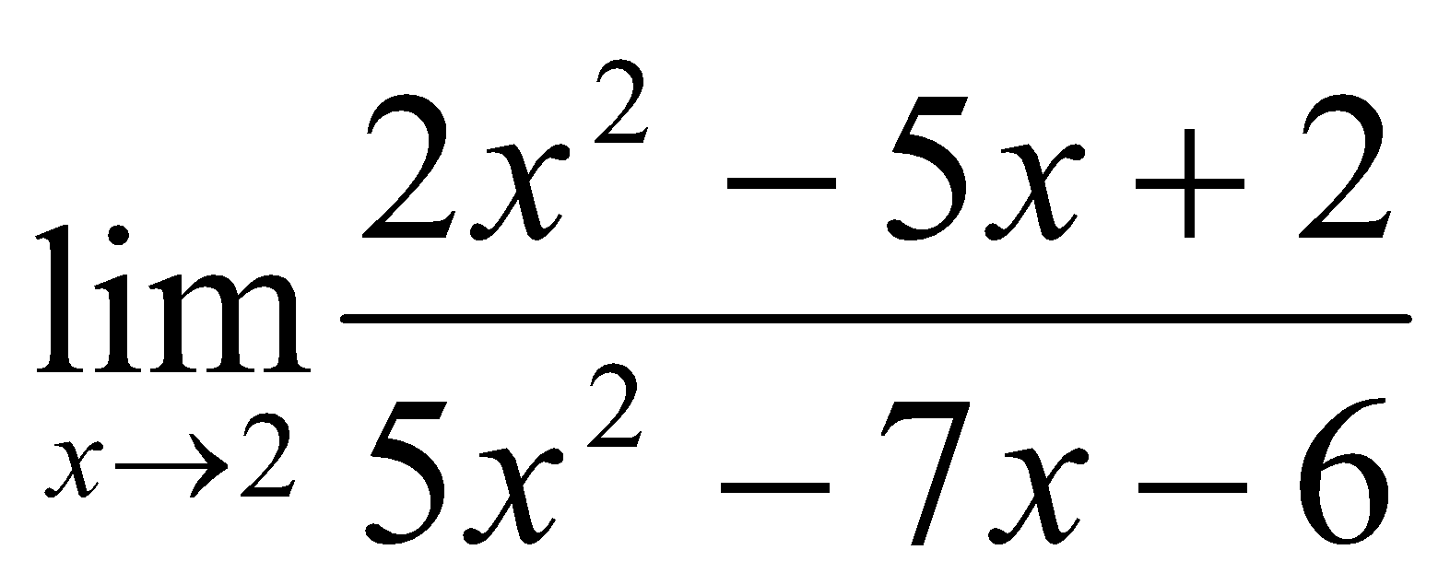

3. 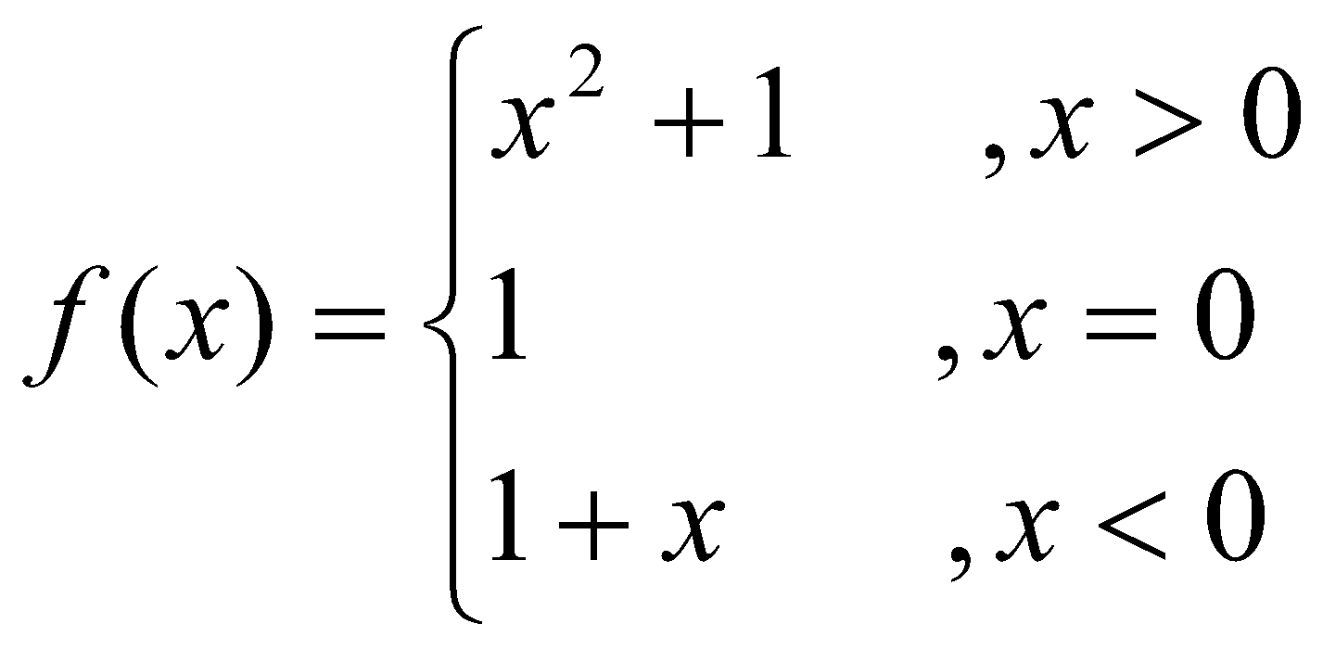 4. 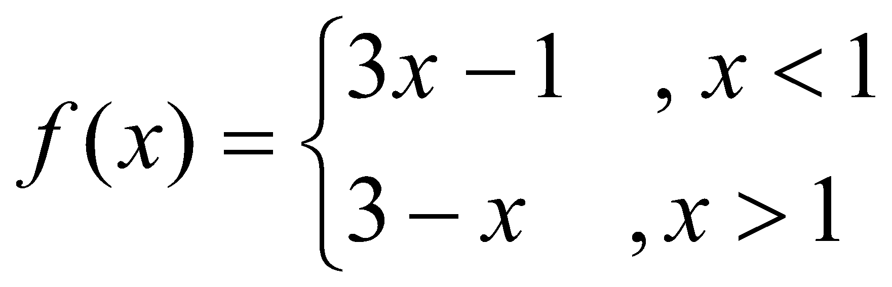

Find 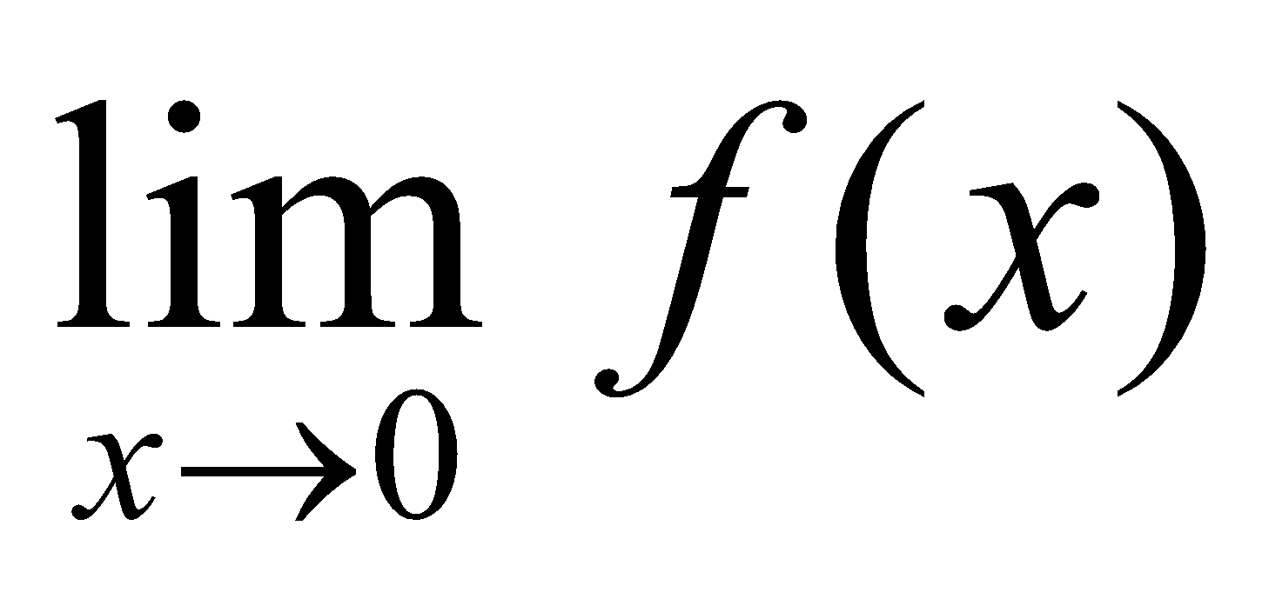 Find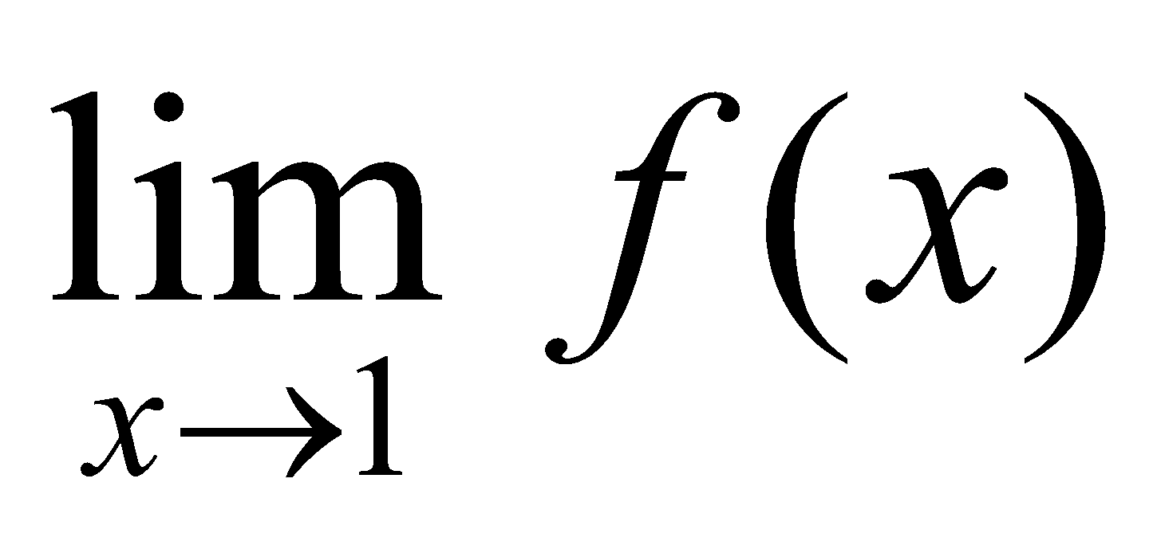

5. 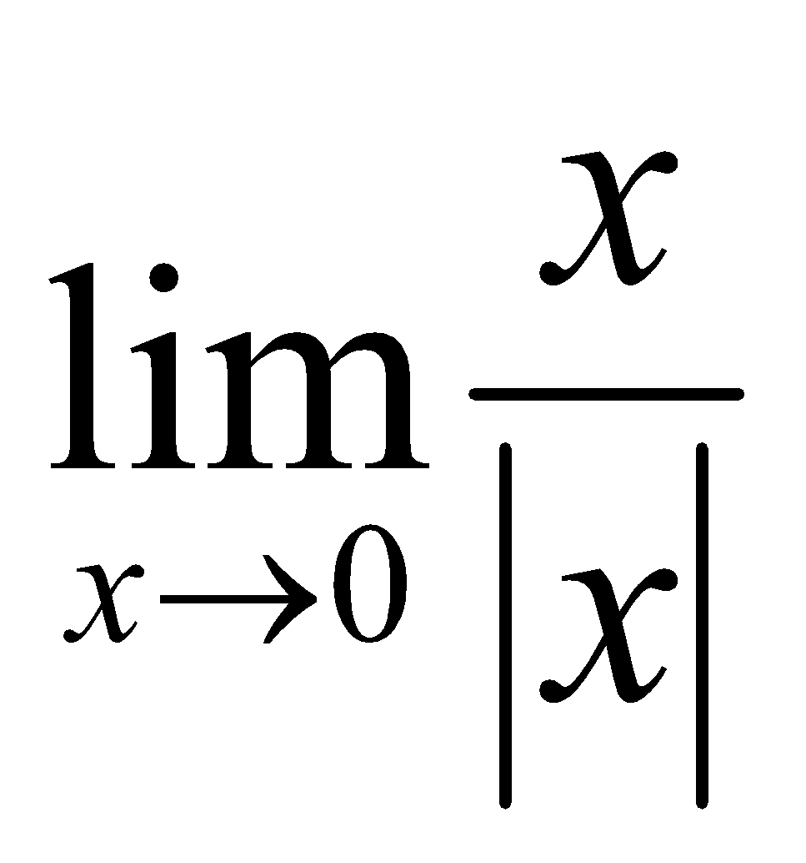 6. 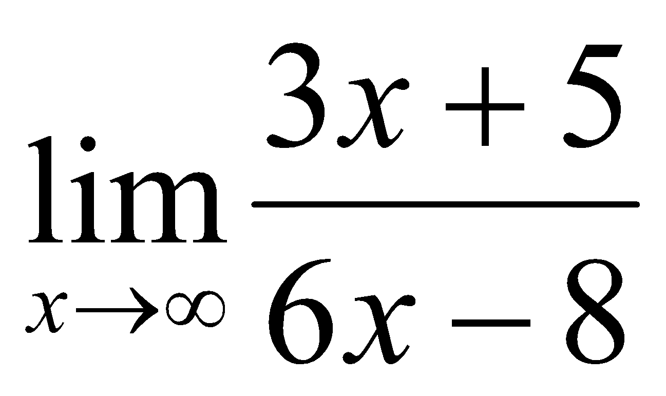

7. 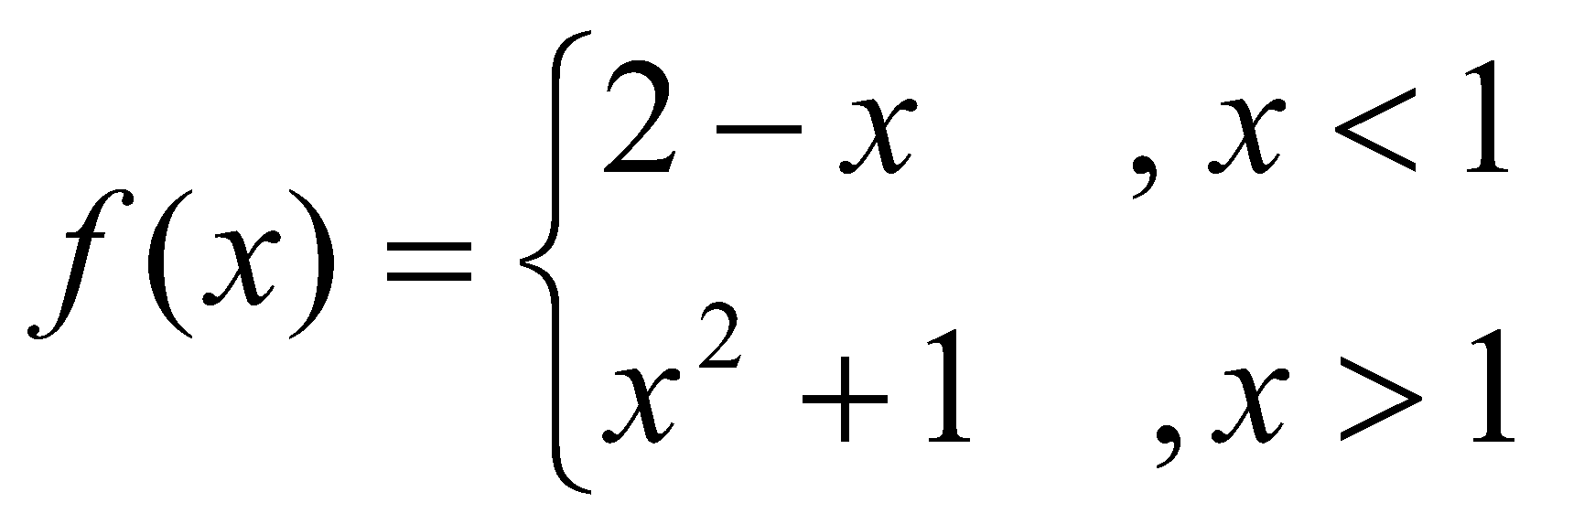 8. 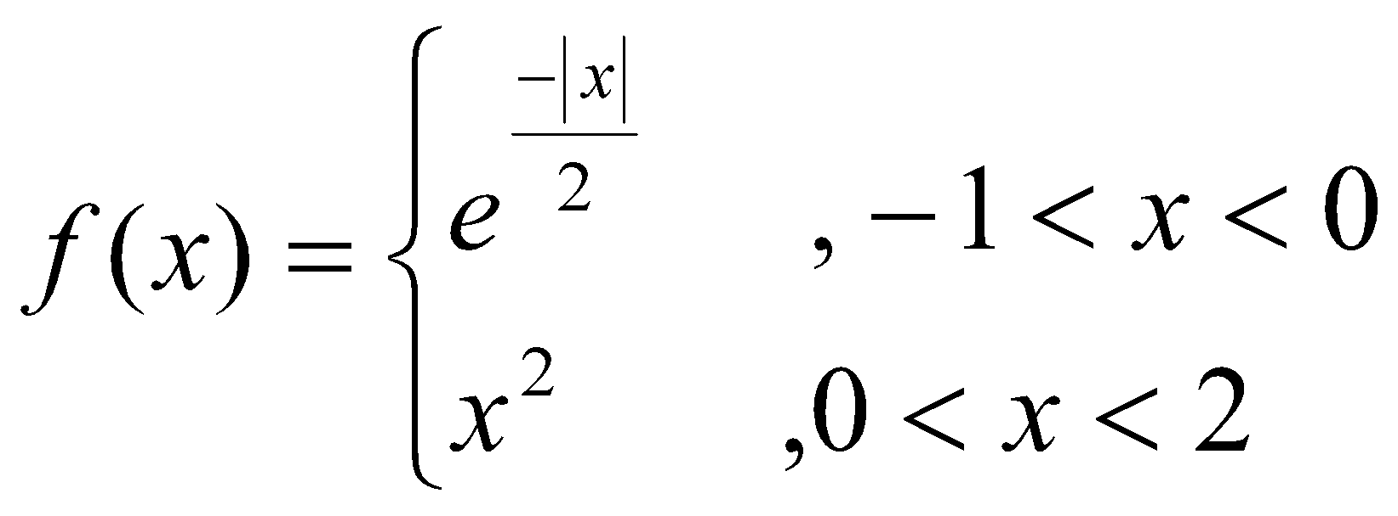
Find 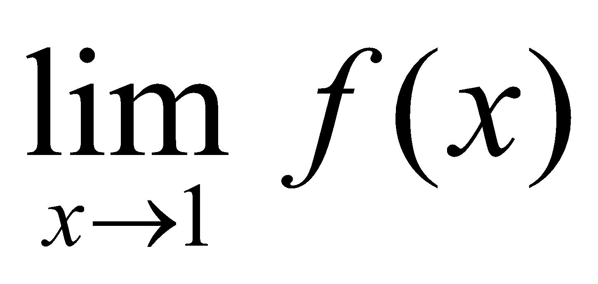Find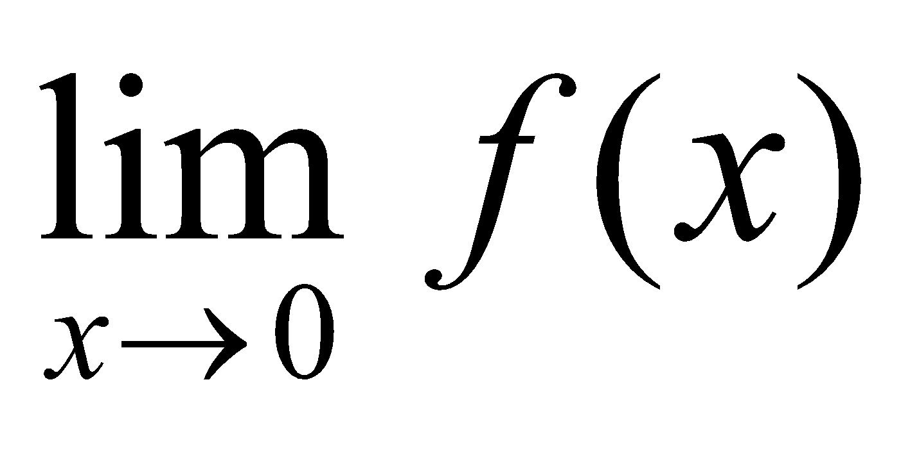

9. 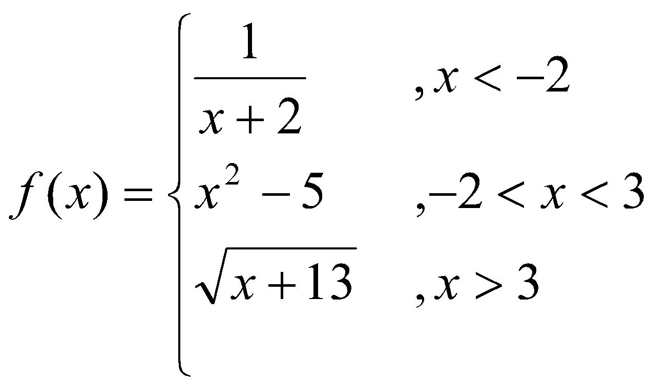 10. 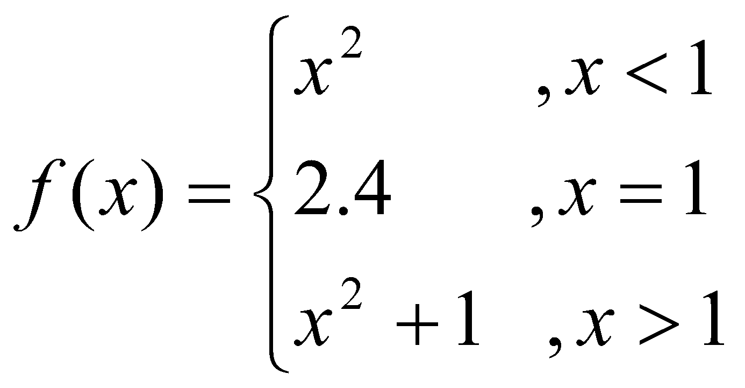
Find 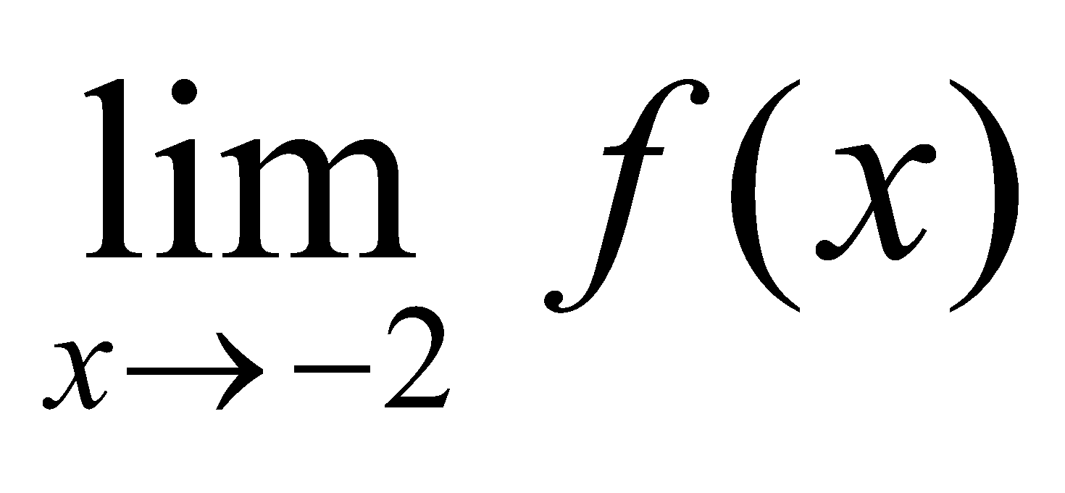 and 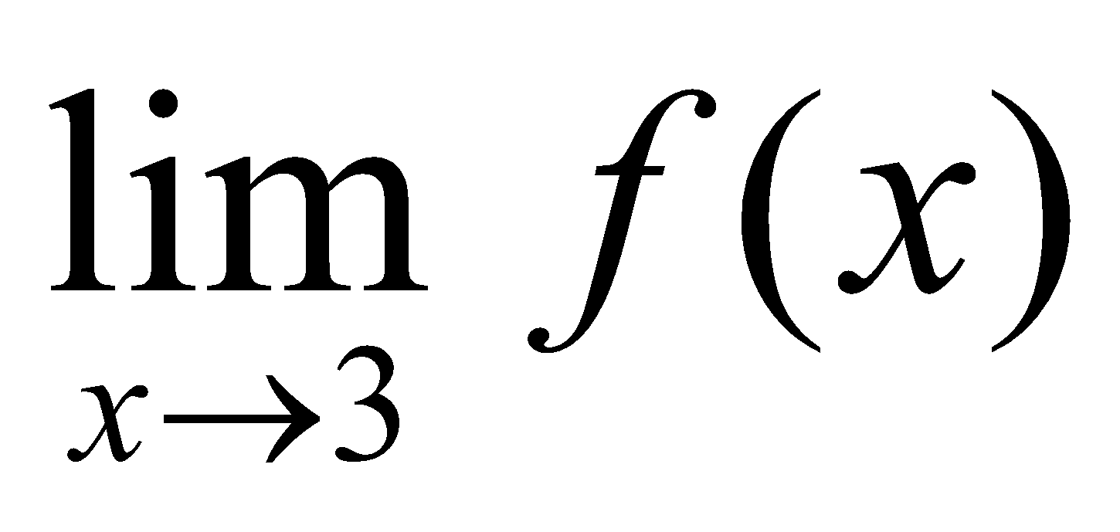Does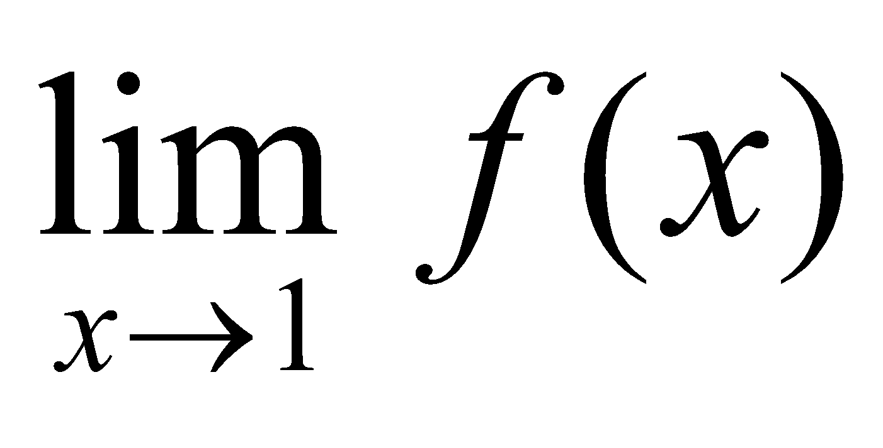 exist?

11. 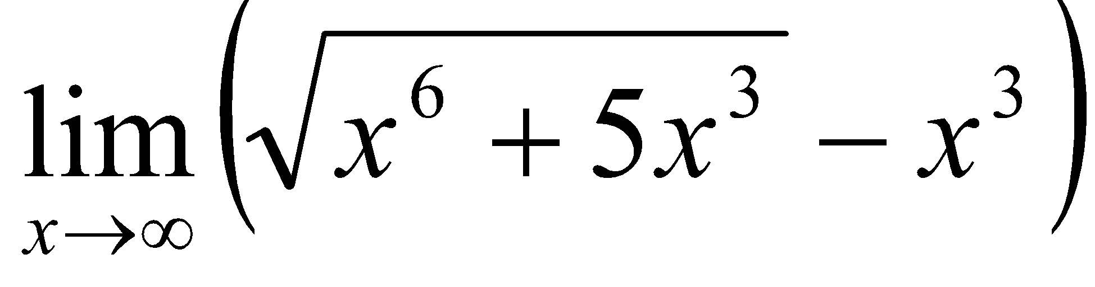 12. Prove that 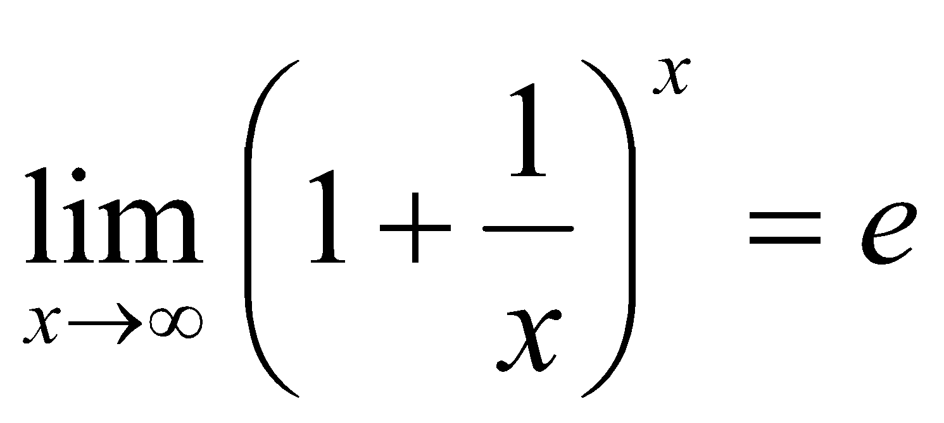

13. 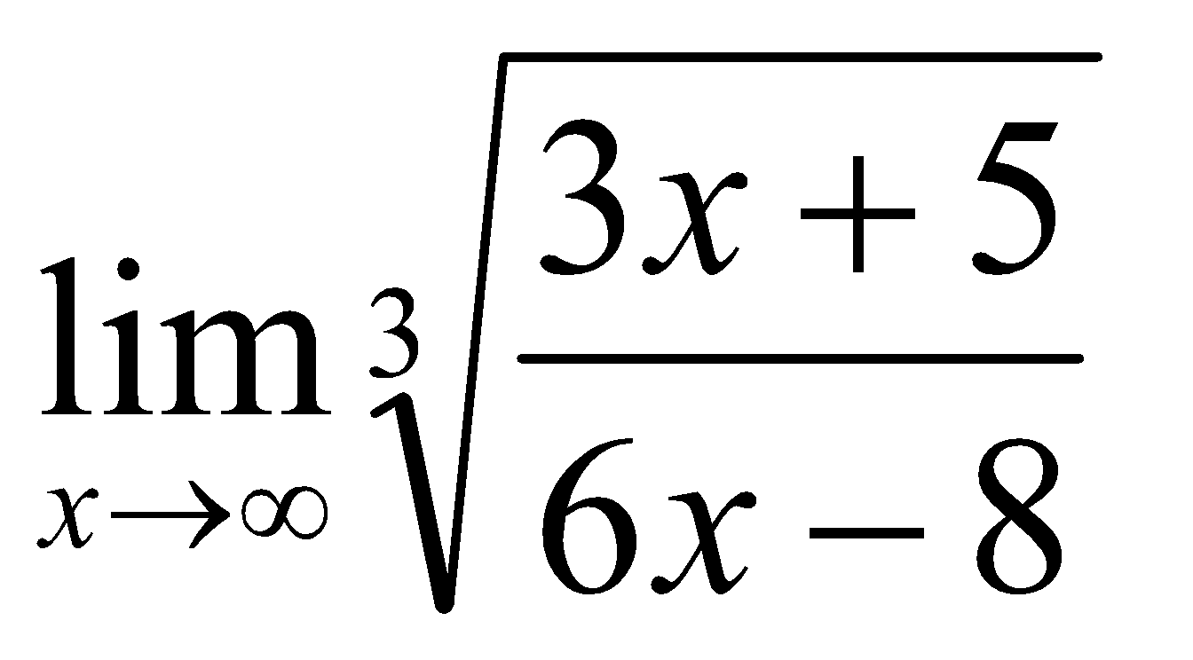 14. 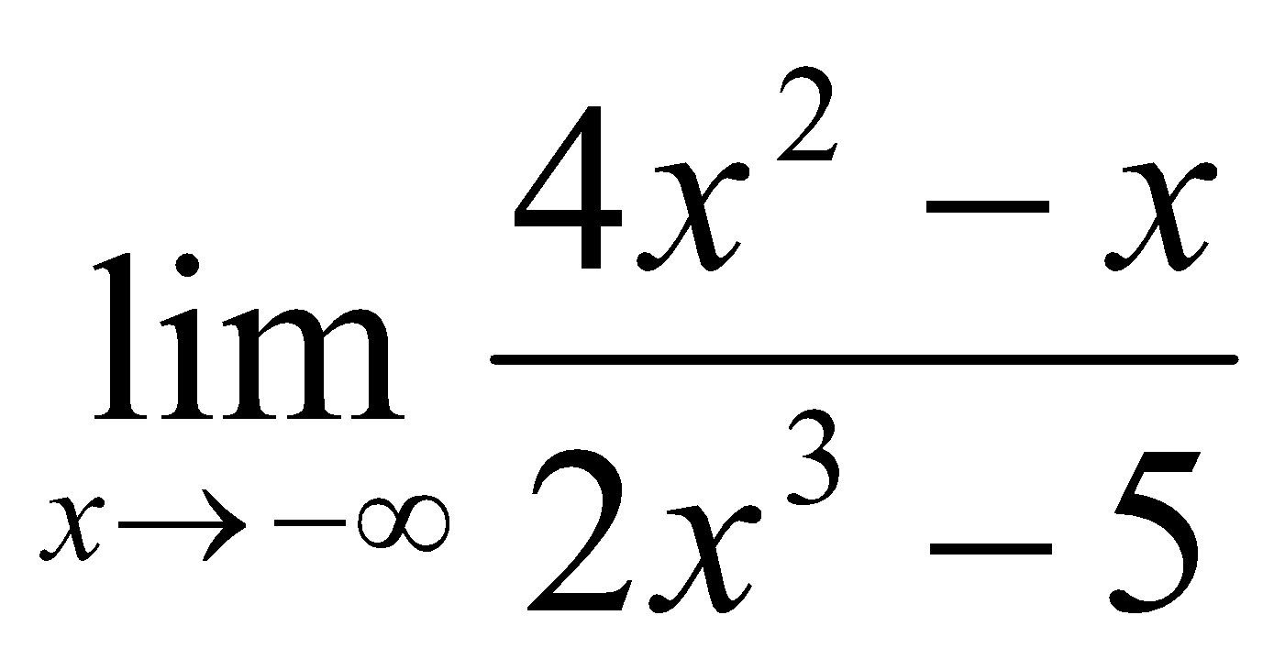

15. Let 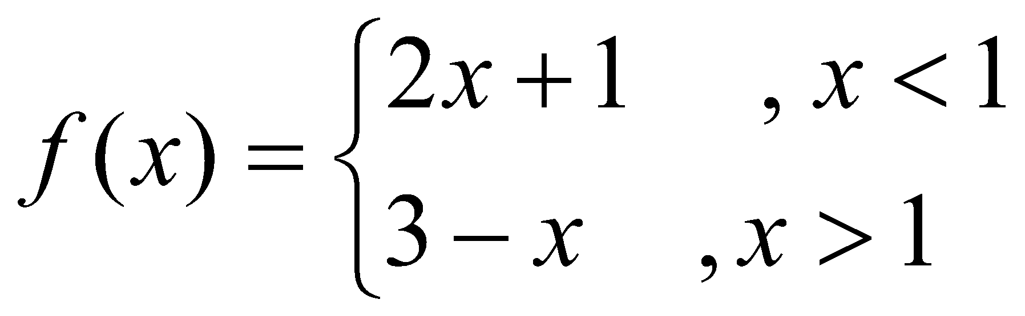, find .
*Home work sheet # 3

Continuity and Differentiability

- Test the continuity of the following functions:

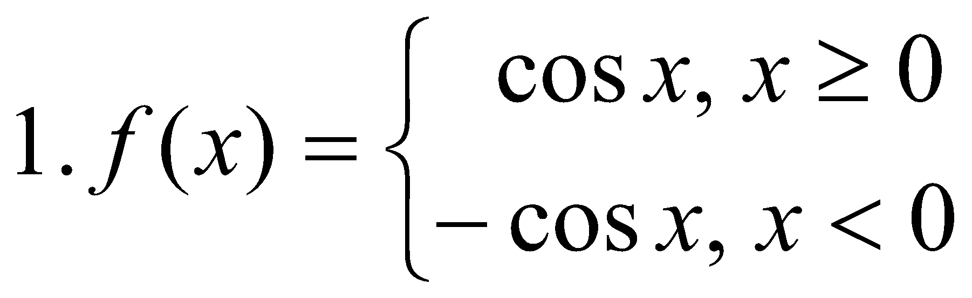at 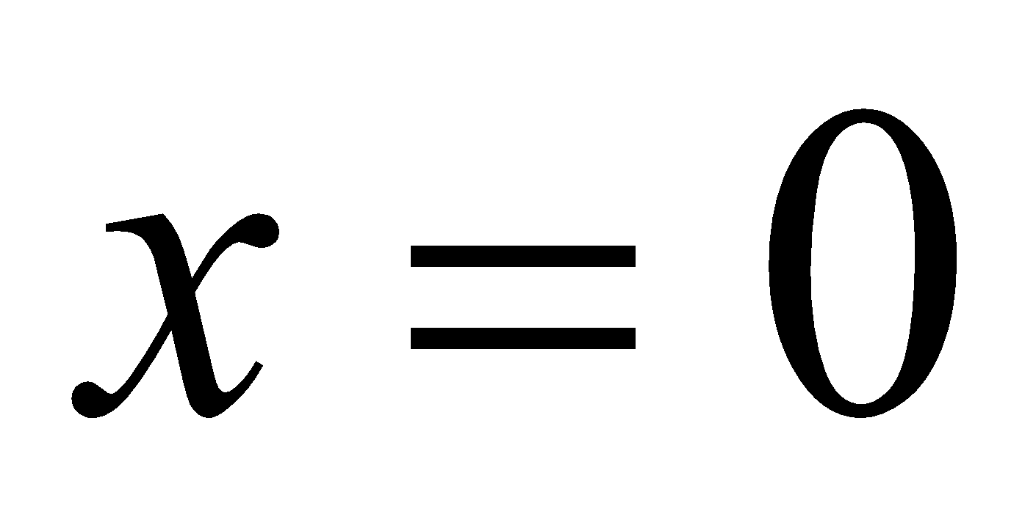.  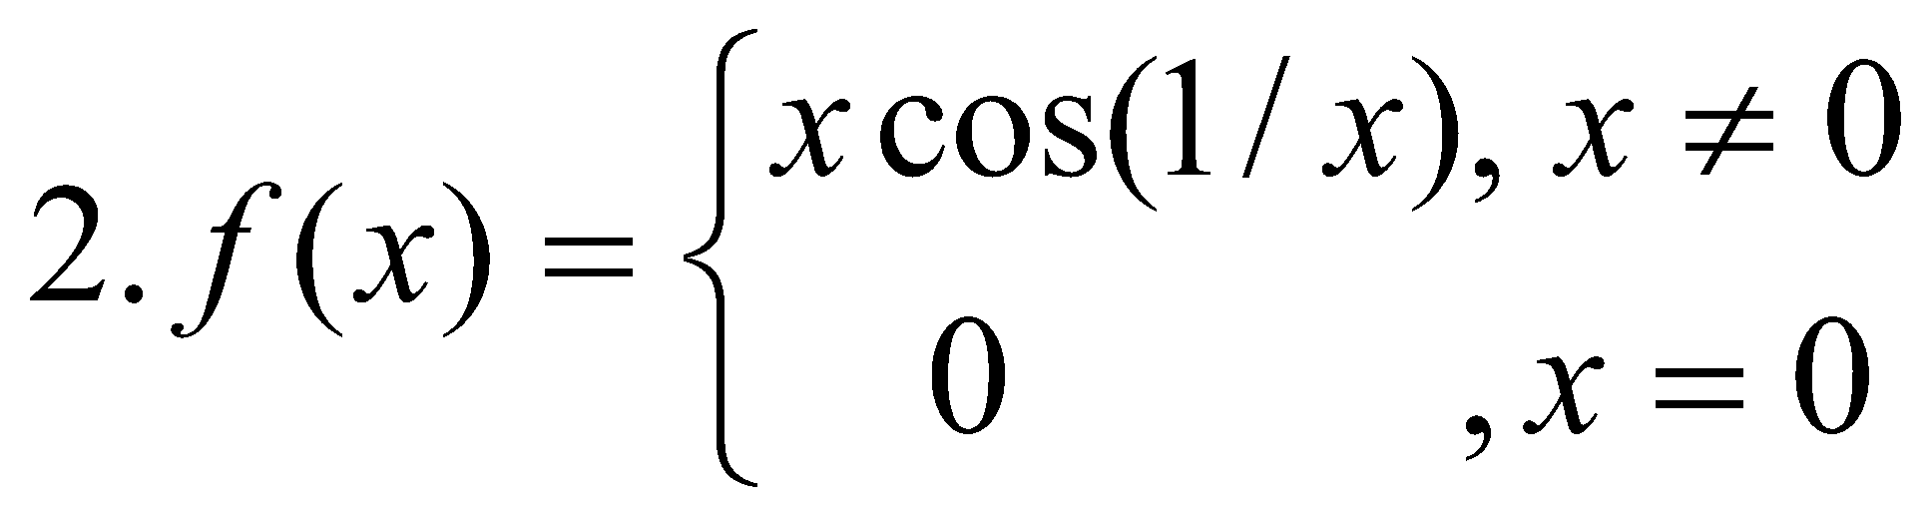 at 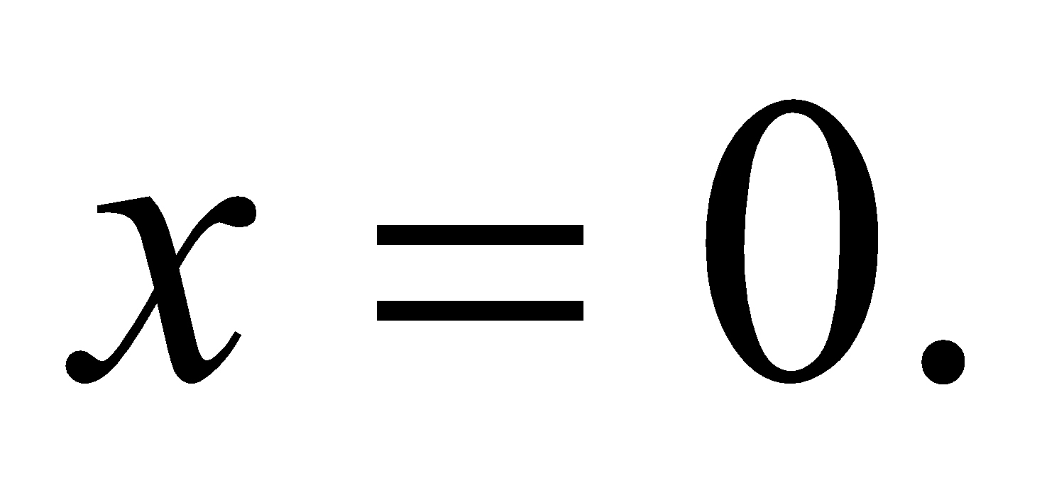  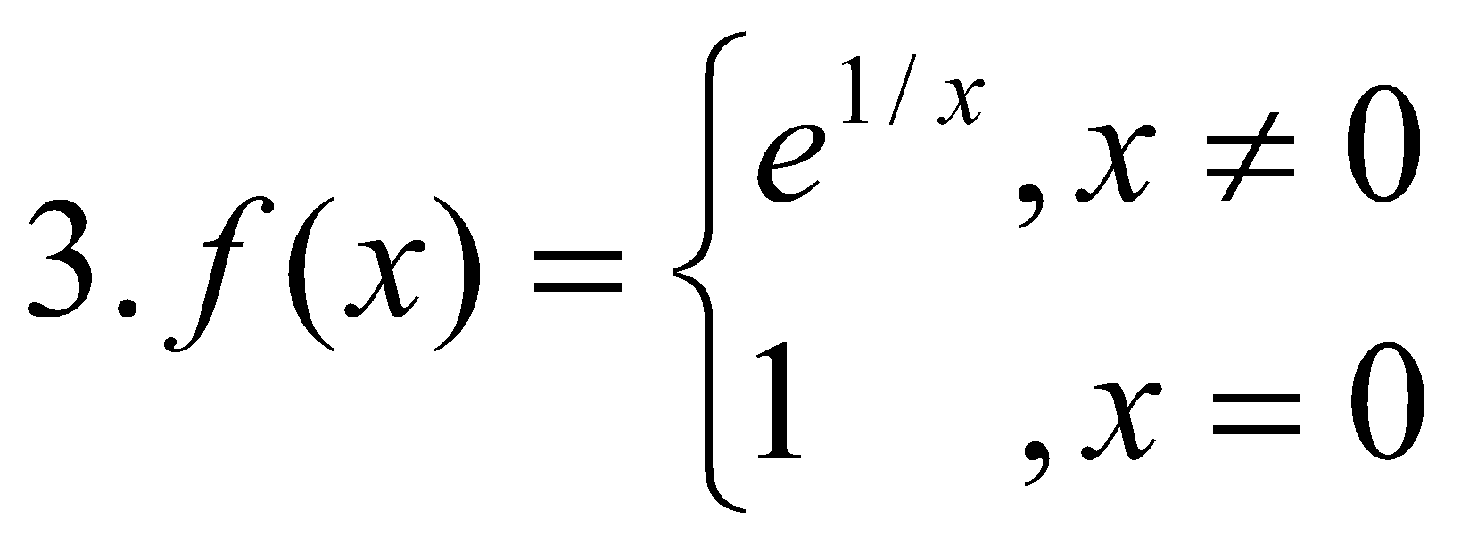 at   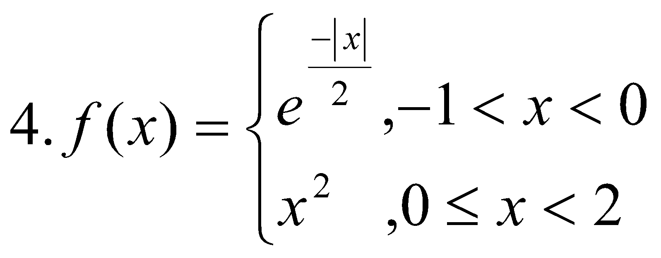 at   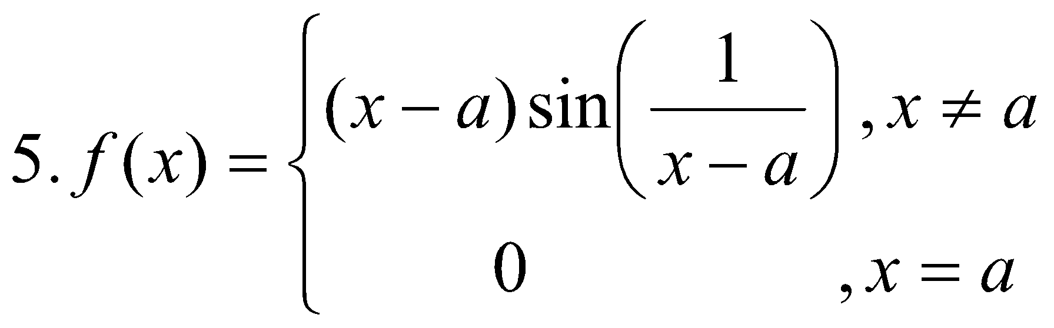 at 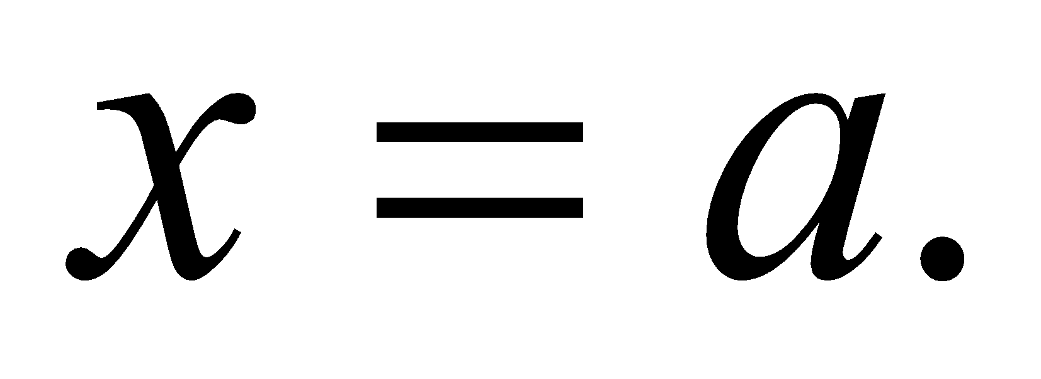 | 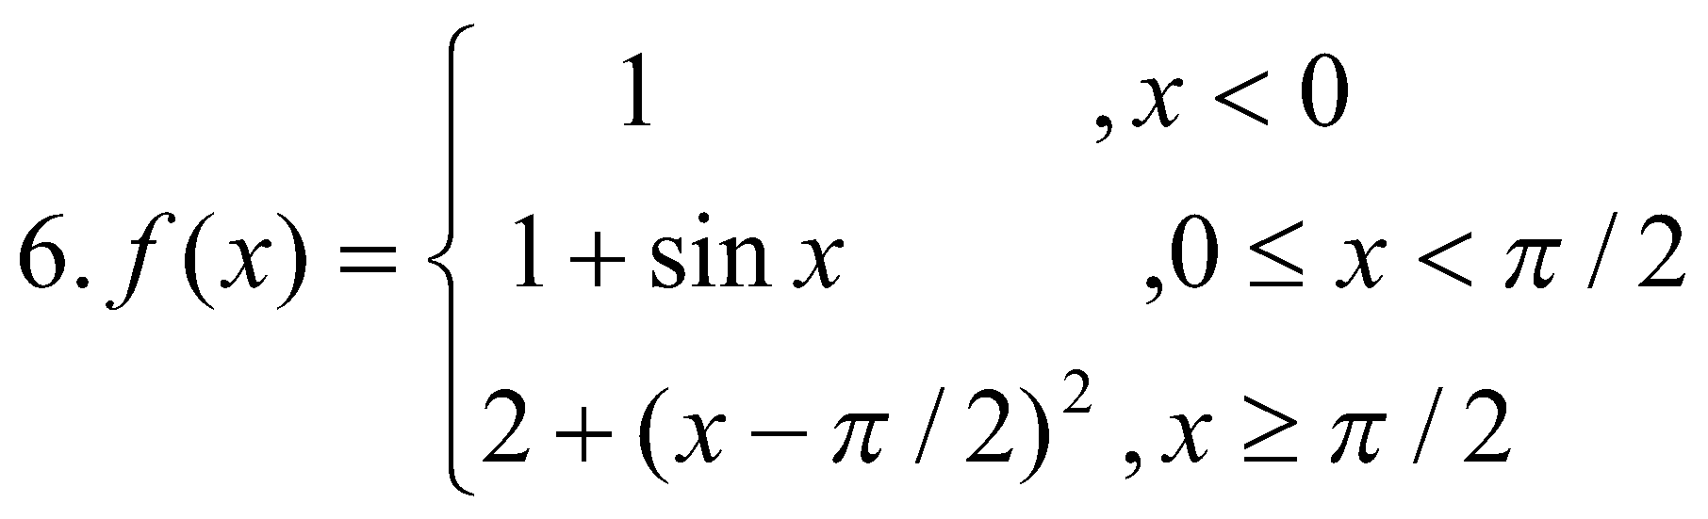  at  and 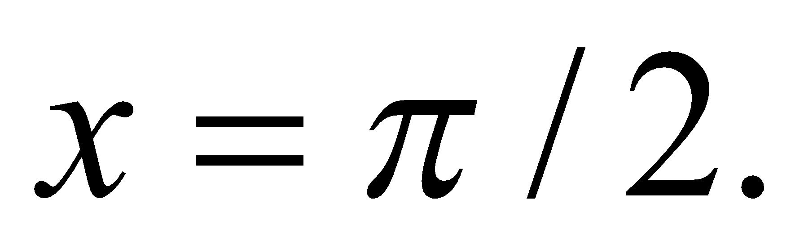  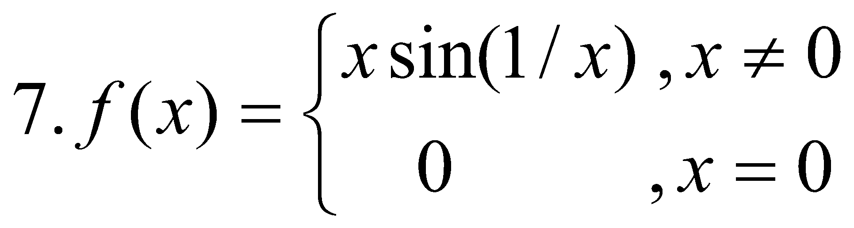 at   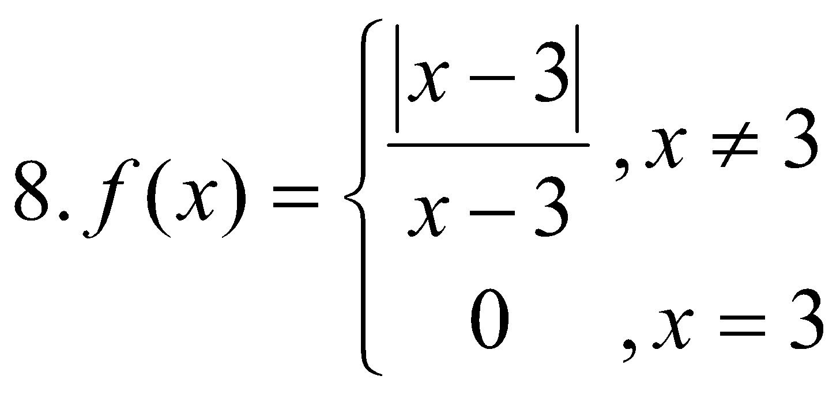 at 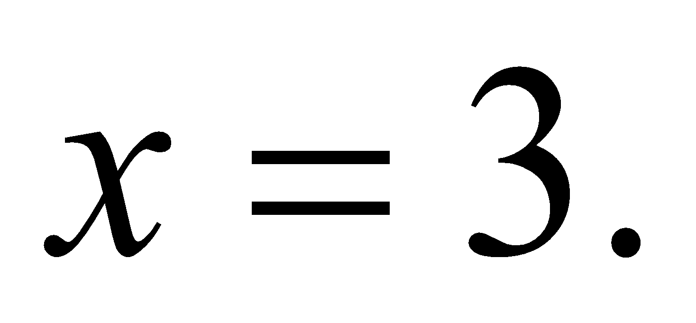  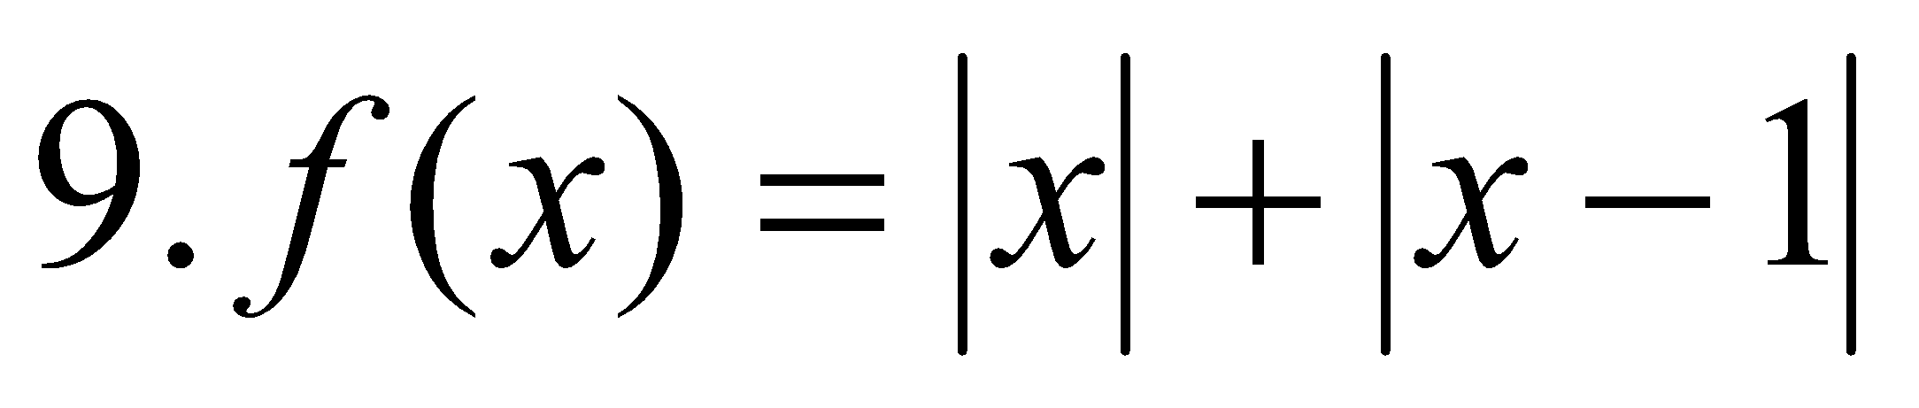 at  and 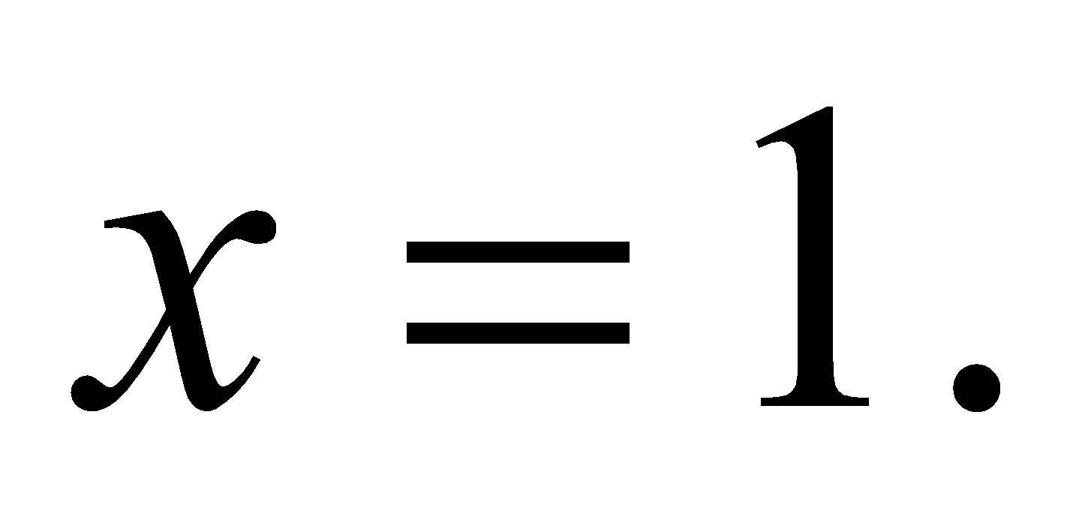  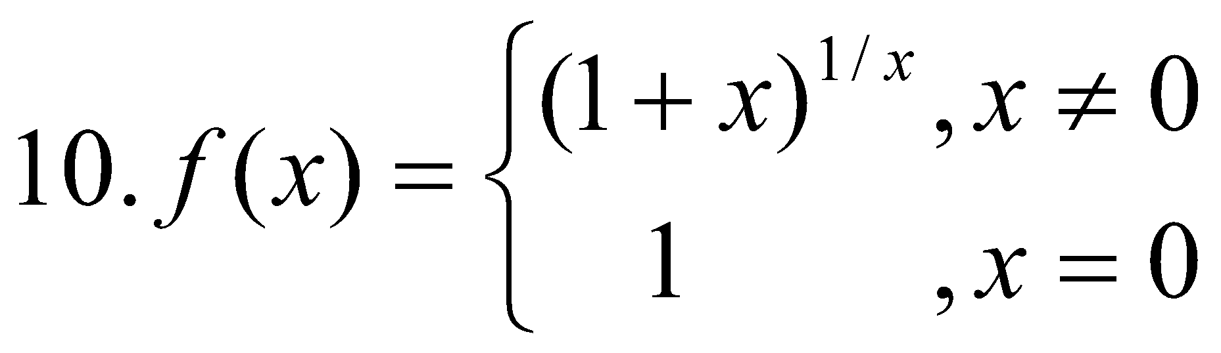 at 

- Test the differentiability of the following functions:

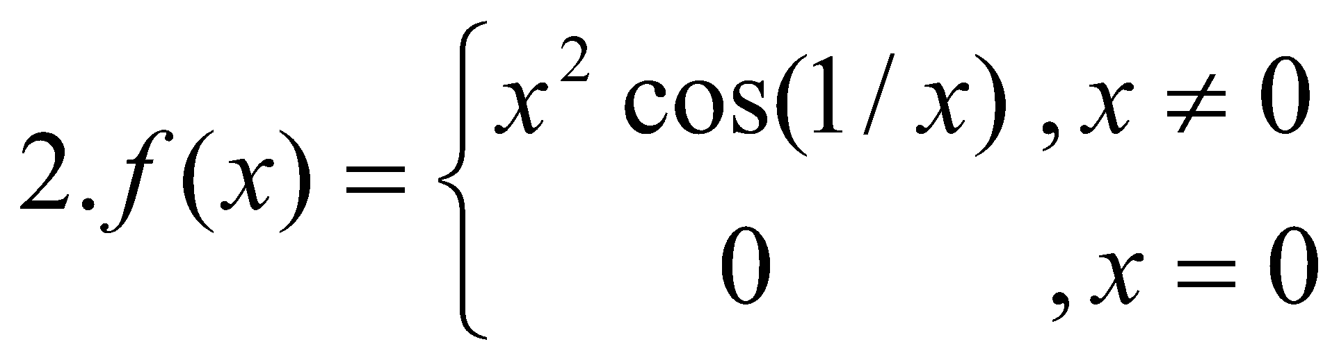 at   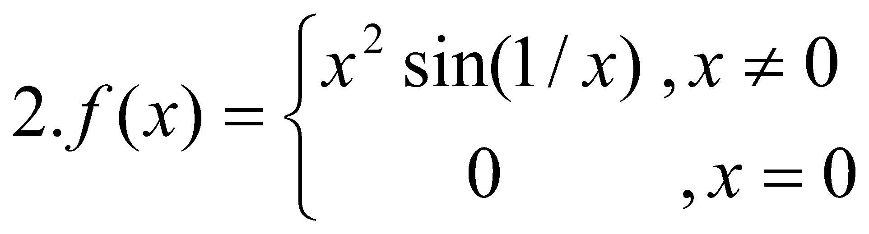 at  | 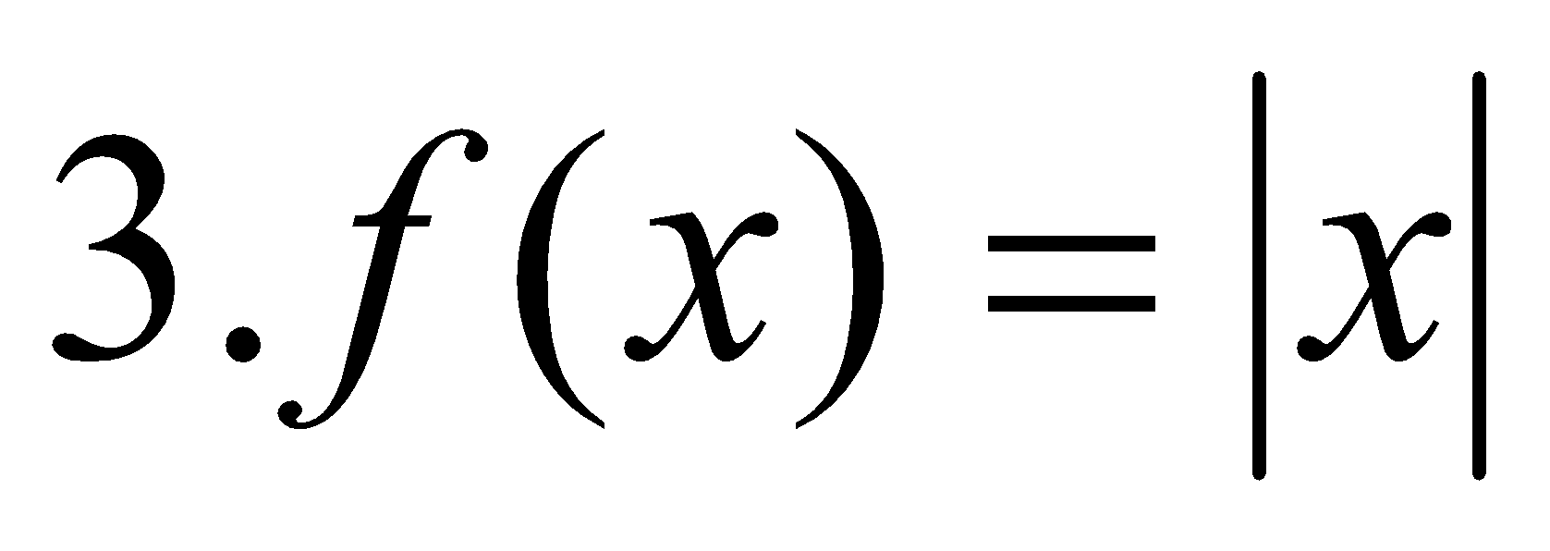 at 

(c) Let 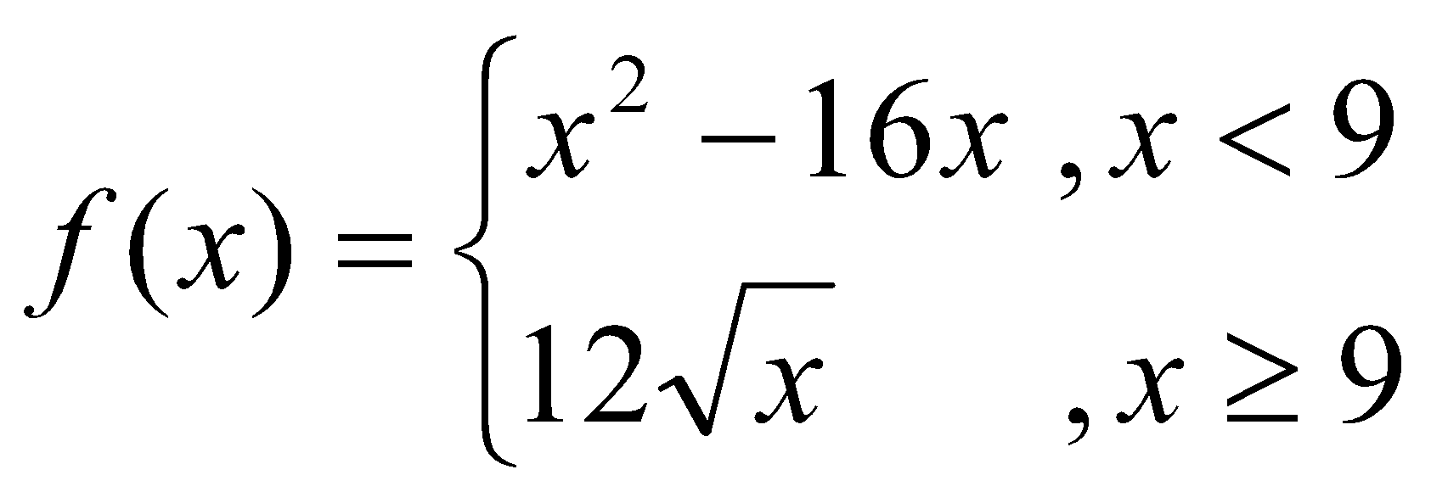. Is f(x) continuous at 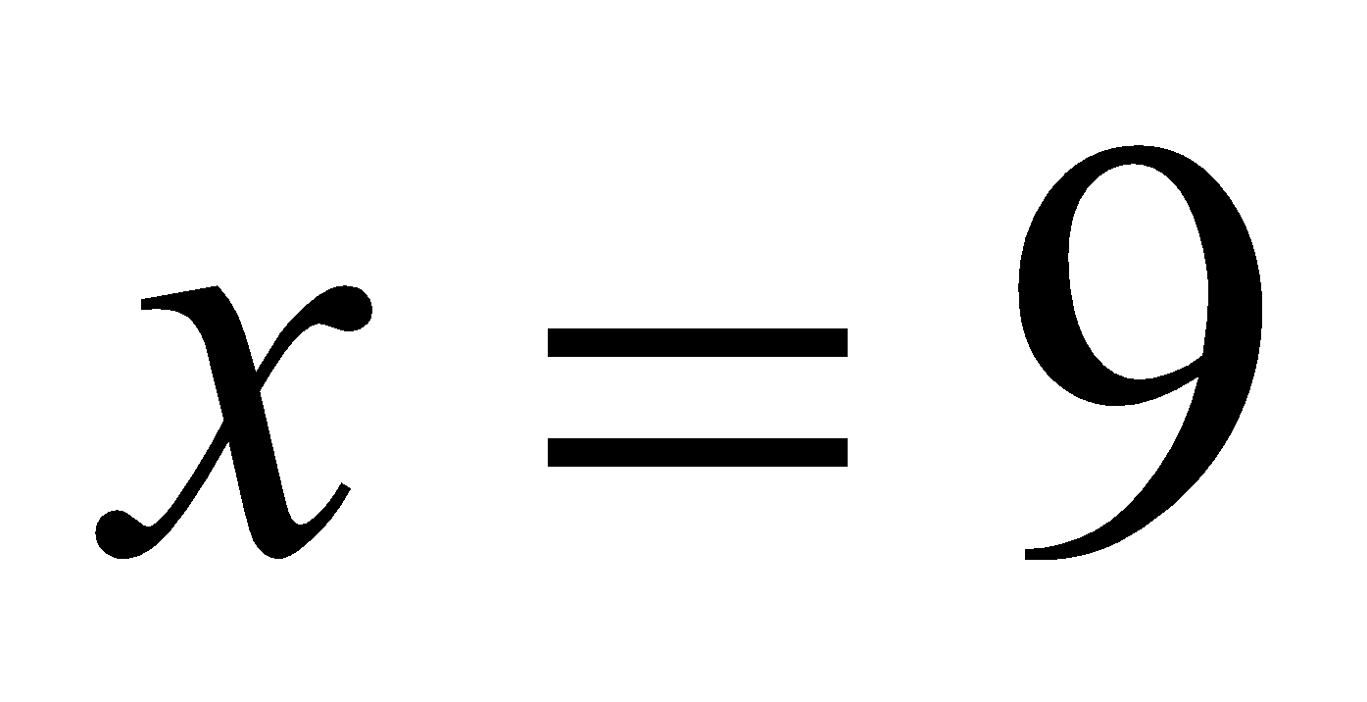? Determine whether 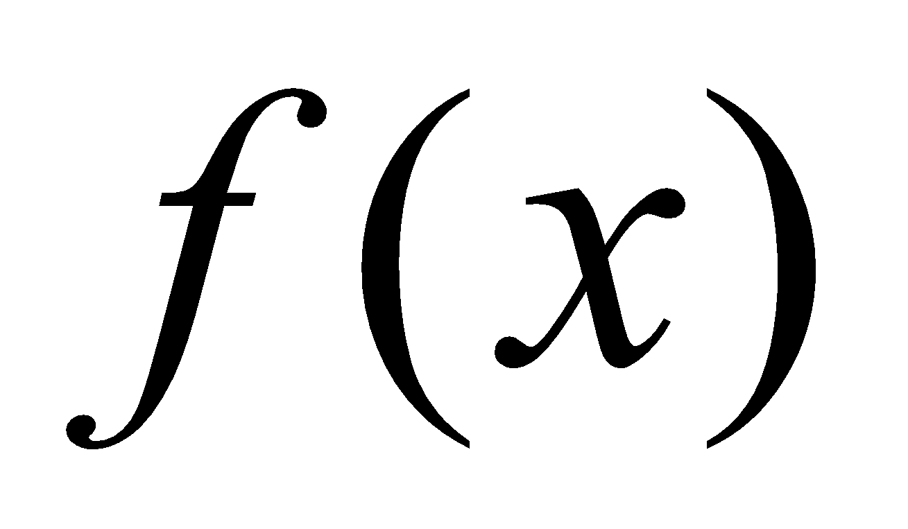 is
differentiable at .

(d) Let 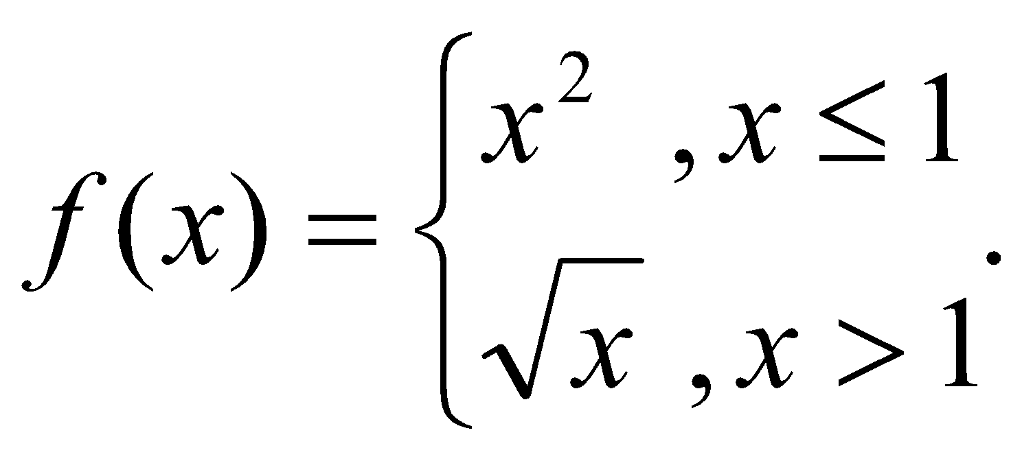Iscontinuous at 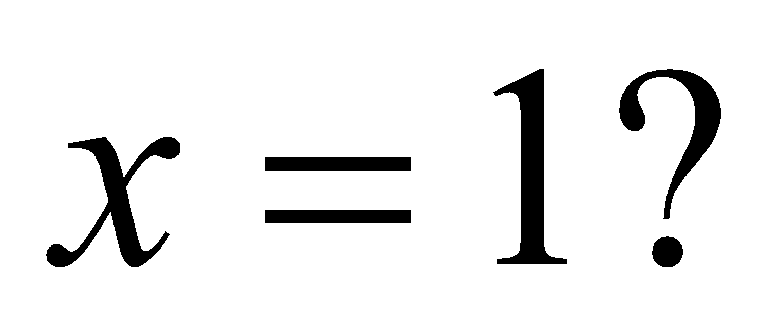 Determine whether  is
differentiable at

(e) Show that 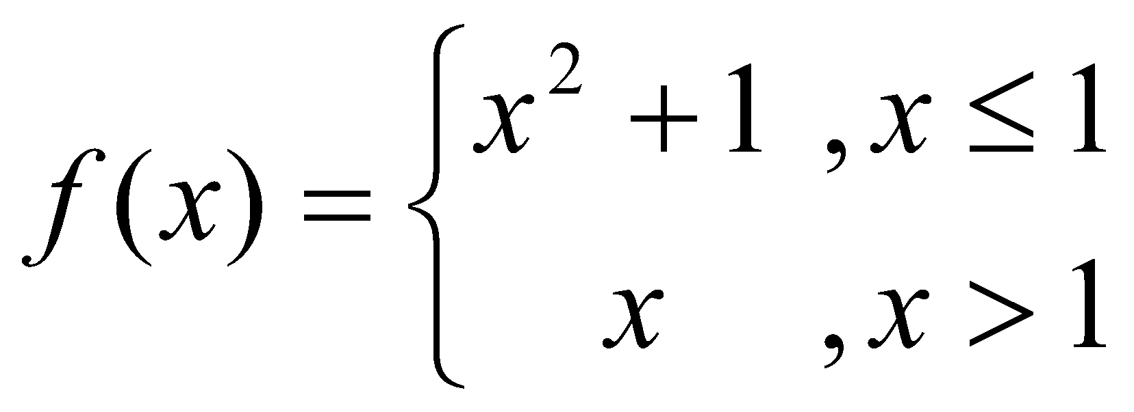 is neither continuous nor differentiable at  Also
sketch the graph of .

*Home work sheet # 4

Techniques of Differentiation

1. Find the differential coefficients of the following functions with respect to x. (i.e. 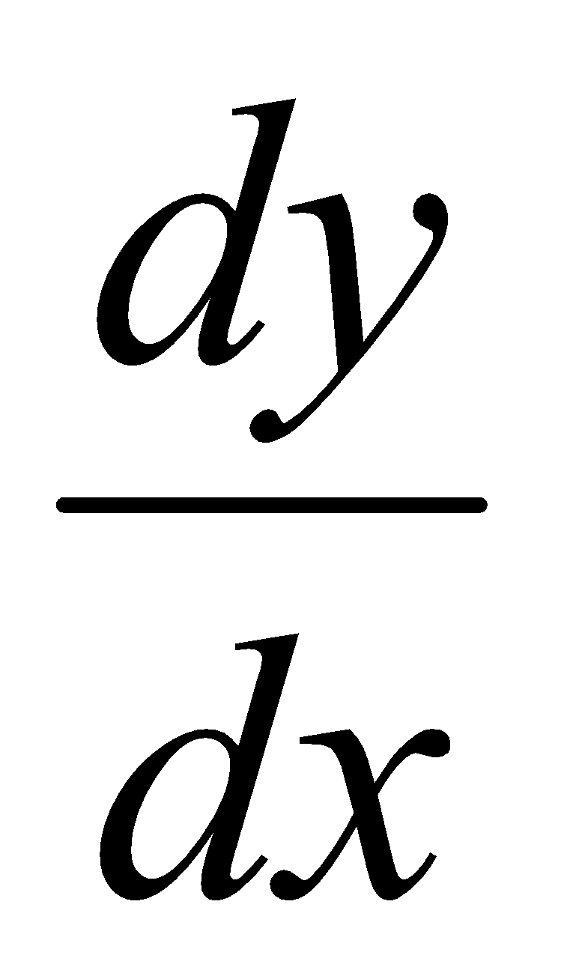).

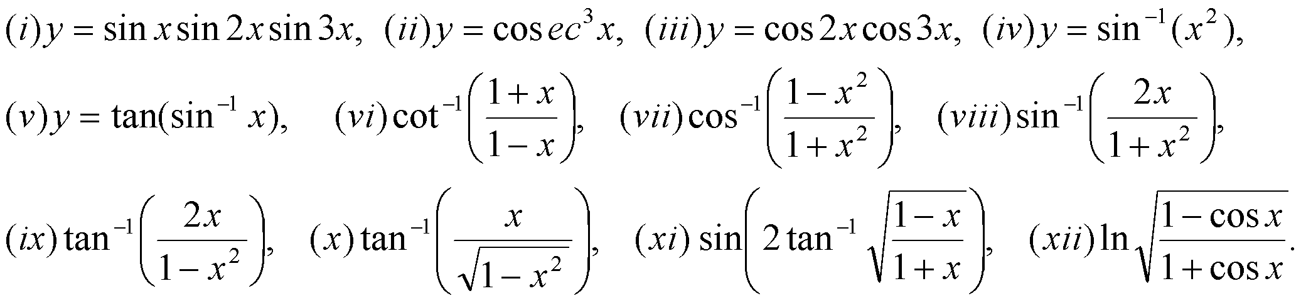

2. Find the differential coefficients of:

.

3. Find  in the following cases:

4. Find  when

5. Differentiate the left-side functions with respect to the right-side ones:

*Home work sheet #5

Maxima and minima

- Find (a) the open intervals on which f is increasing , (b) the open intervals on which f is decreasing, (c) the open intervals on which f is concave up, (d)) the open intervals on which f is concave down and (e) the x- coordinate of all inflection points.
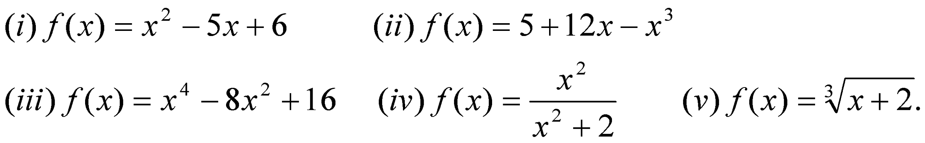
- Locate the critical numbers and identify which critical numbers correspond to
stationary points.

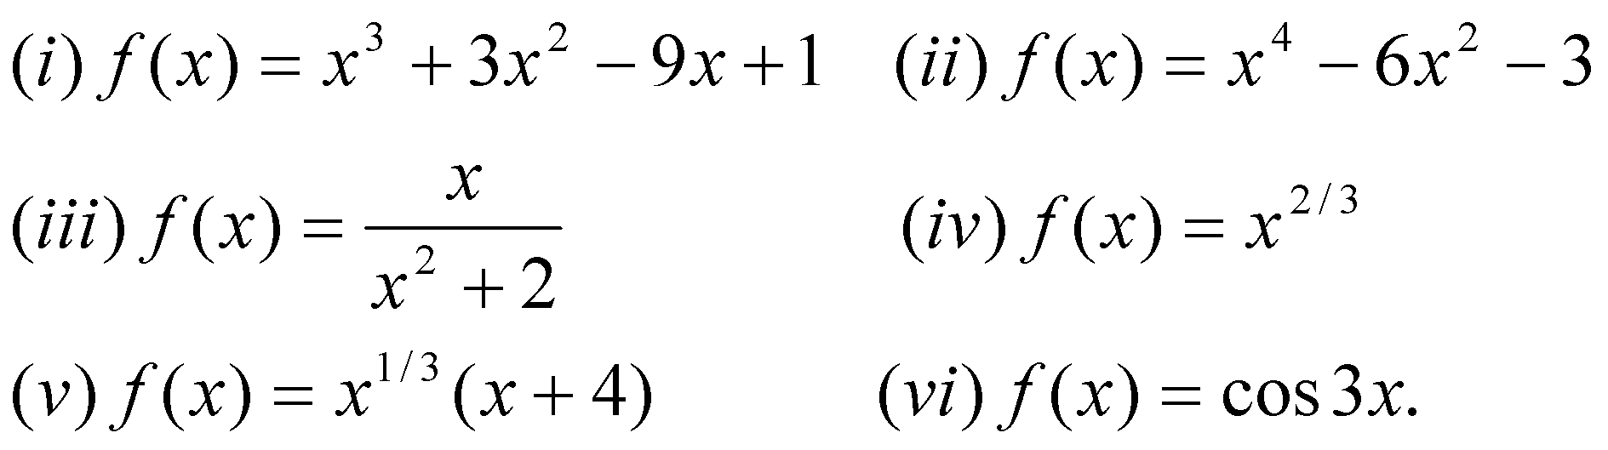

- Find the relative extrema (maxima/ minima) using both the first and second derivative tests.
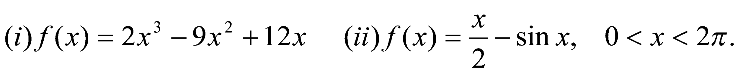
- Use the given derivative to find all critical numbers of fand determine whether a relative maximum, relative minimum, or neither occurs there.
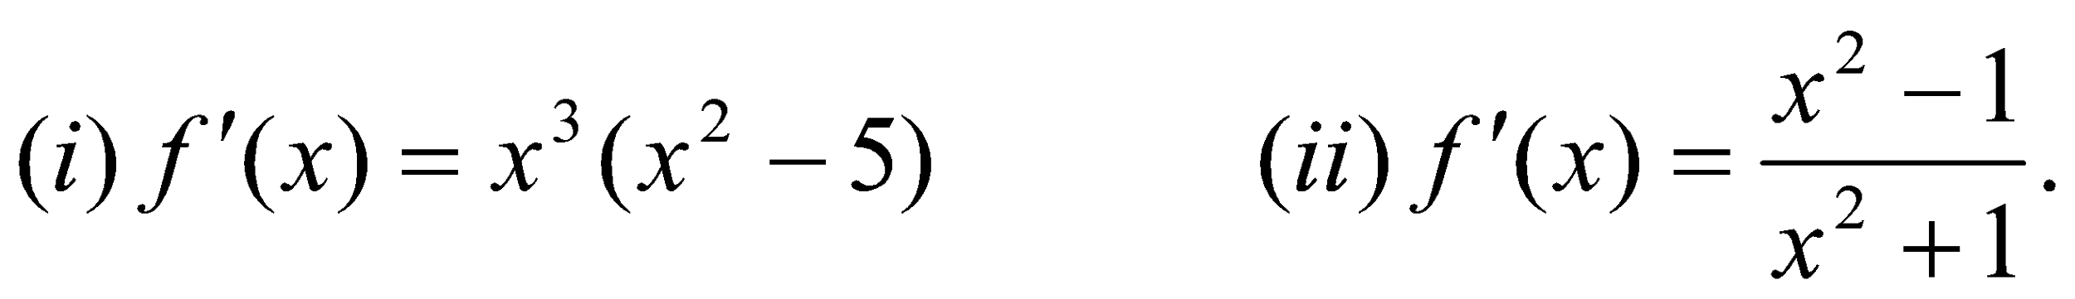

*Home work sheet # 6

Successive Differentiation

a.Find the nth derivative of the following functions:
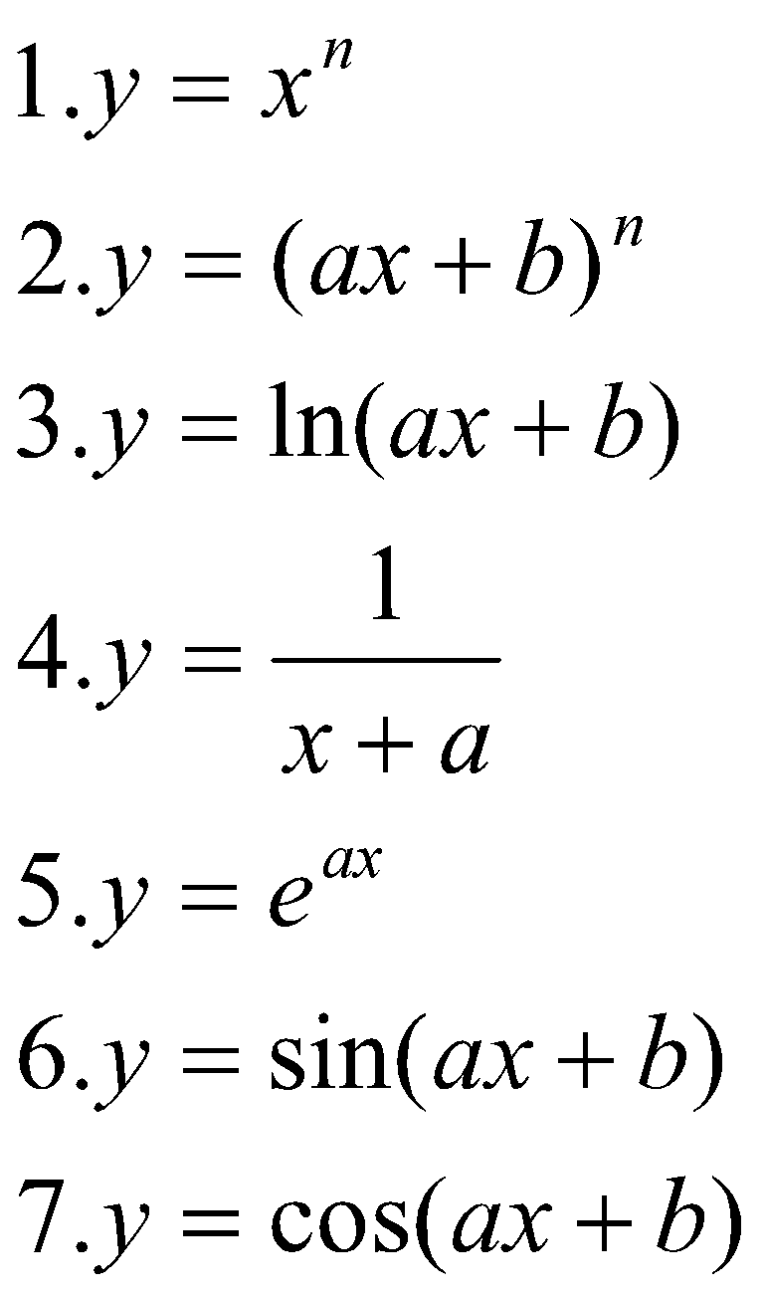
b. If 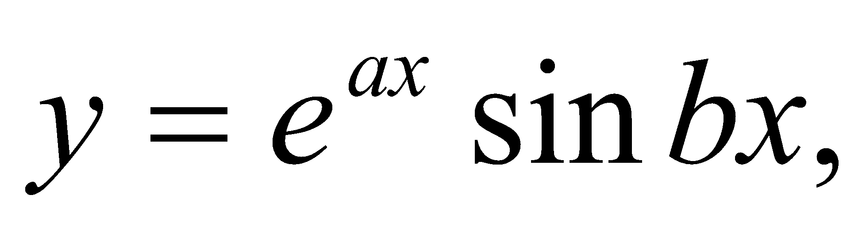 then show that 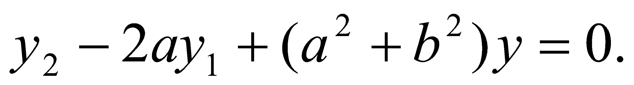
c. If 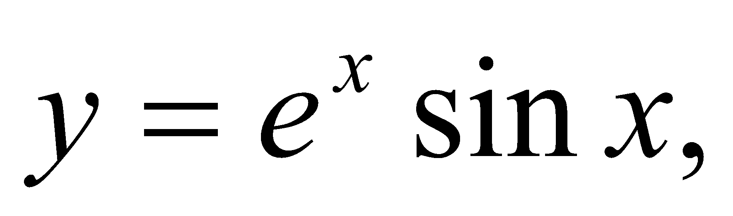 then show that 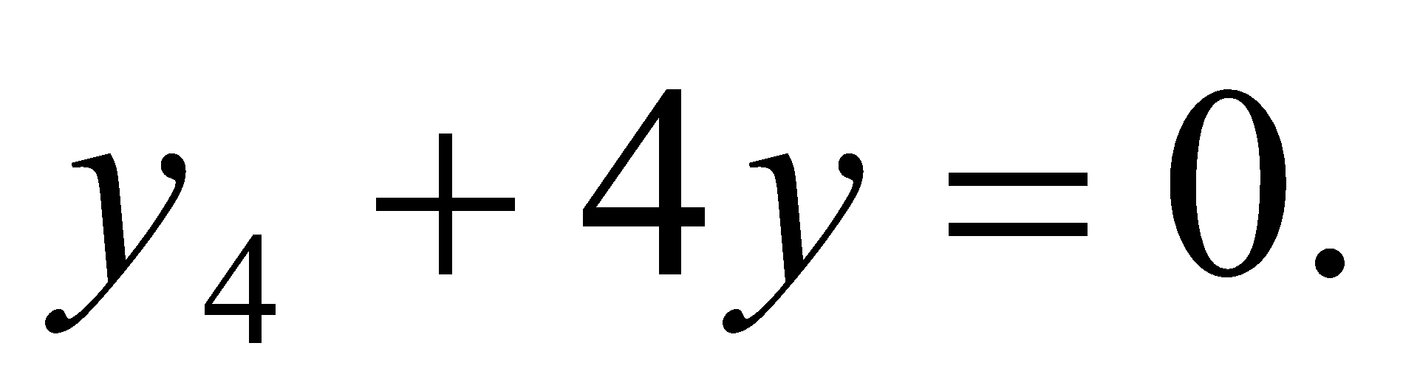
Rolle’s and Mean Value Theorem
a. Verify the hypothesis of Rolle’s Theorem for the following functions:
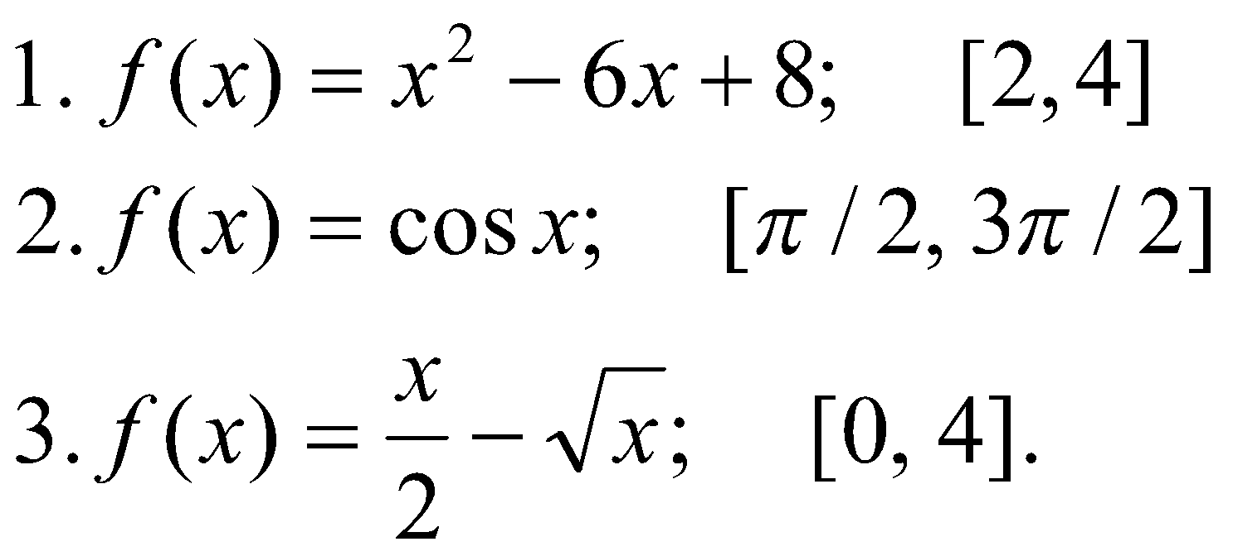
b. Verify the hypothesis of Mean Value Theorem for the following functions:
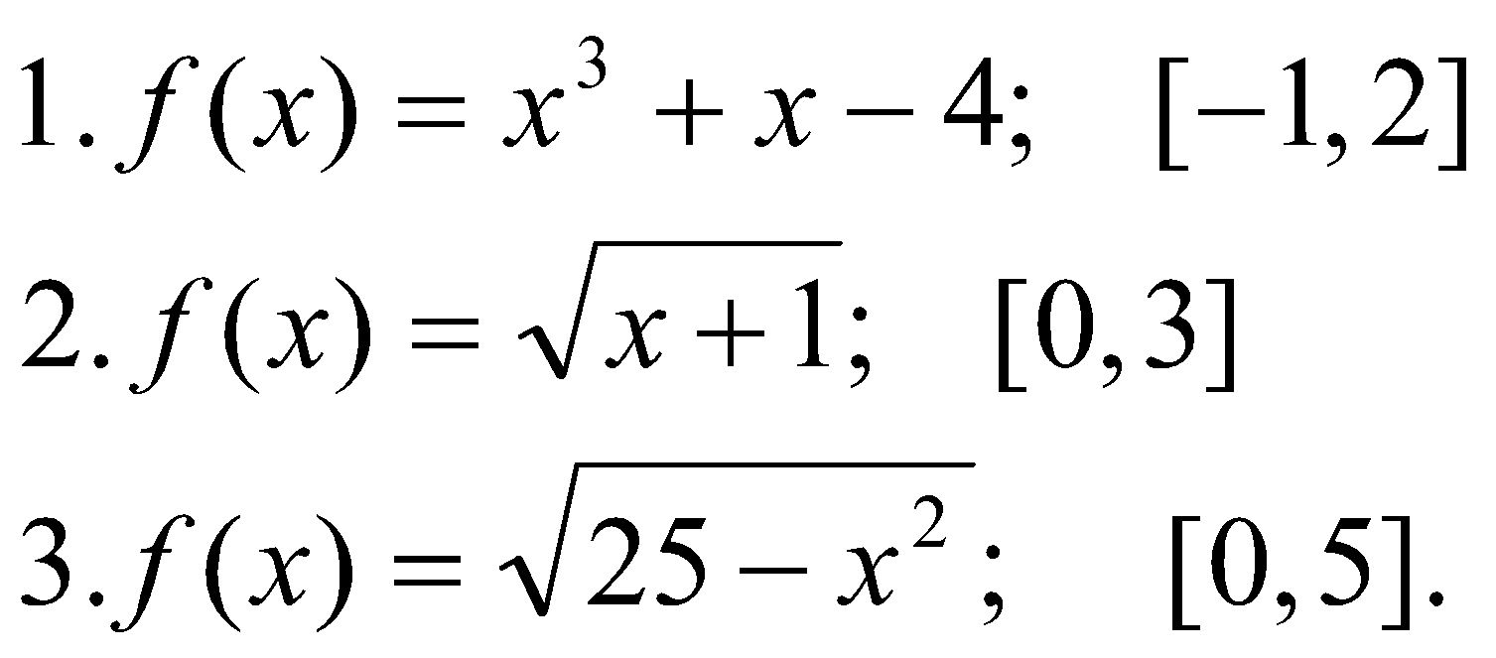

Maclaurin and Taylor Series

- Find the Taylor series for the following functions:
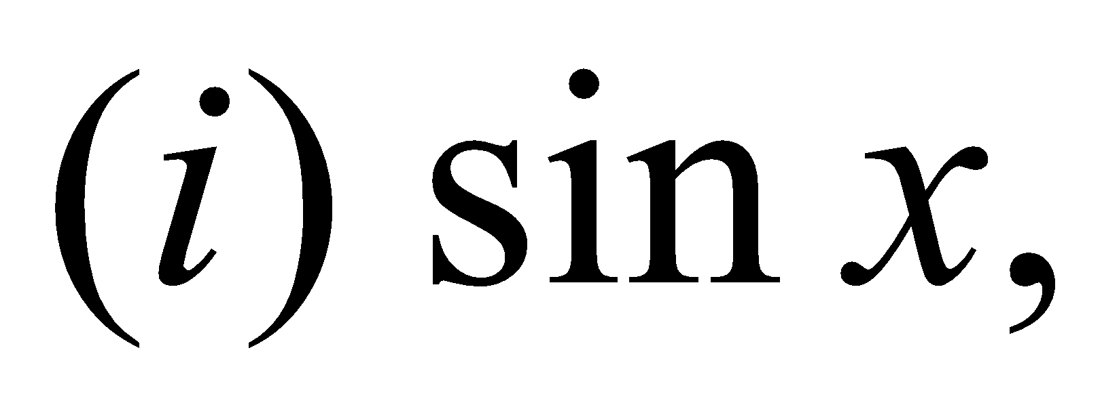at 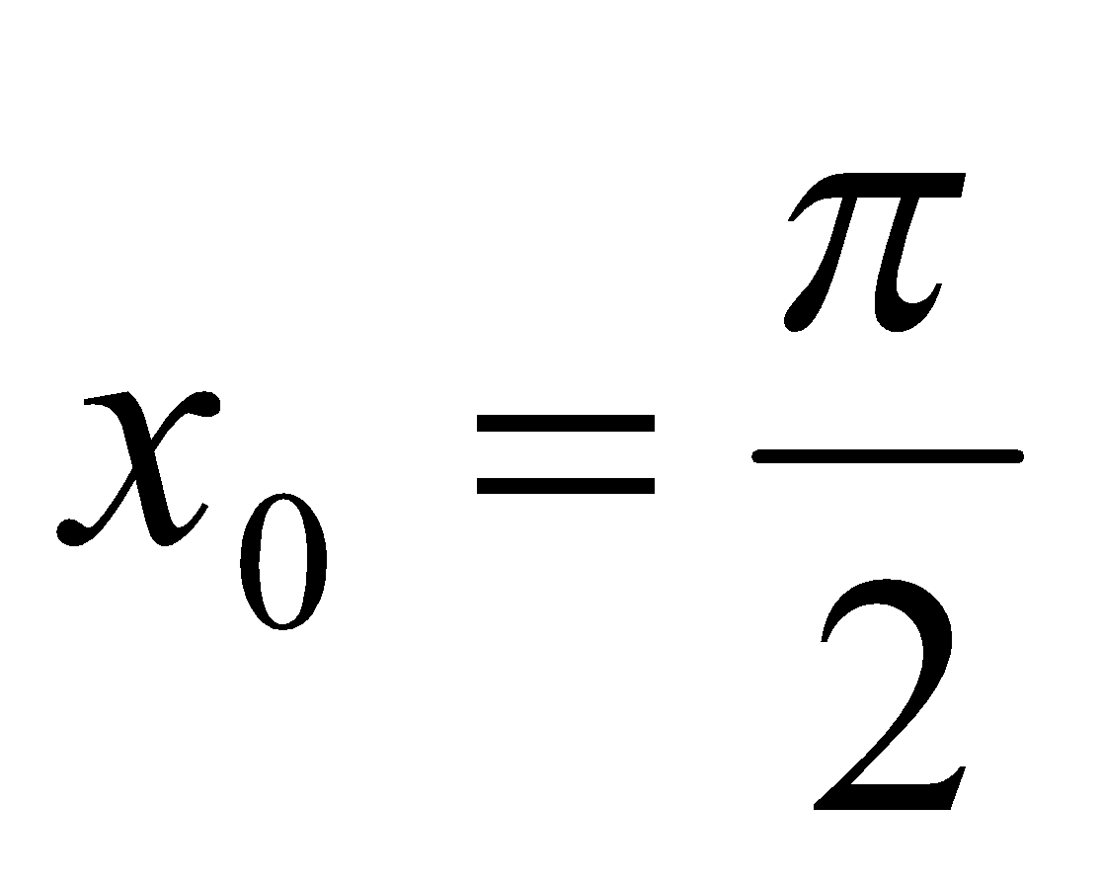. 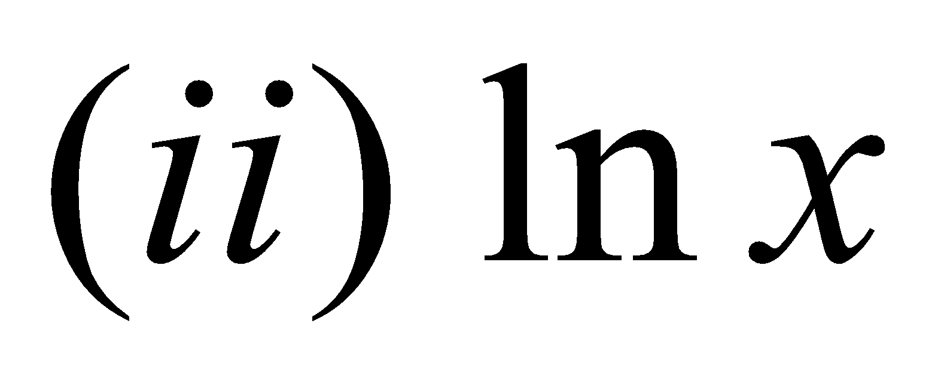, at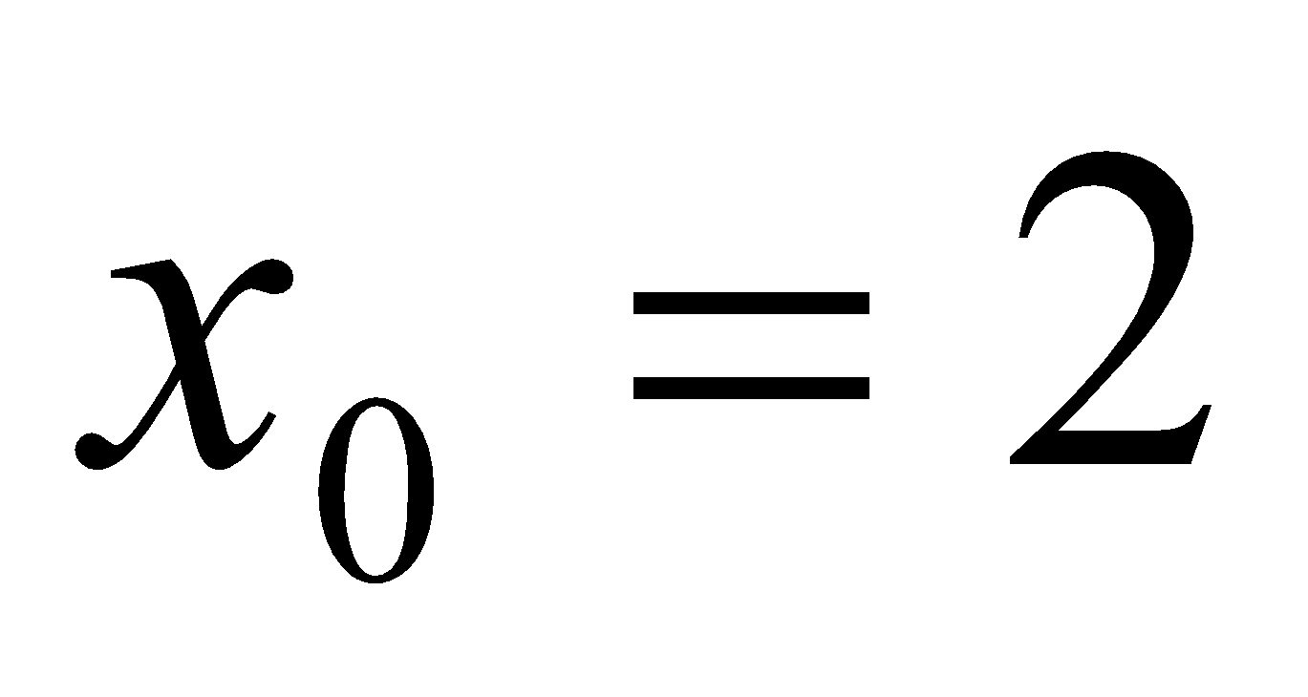.
- Expand 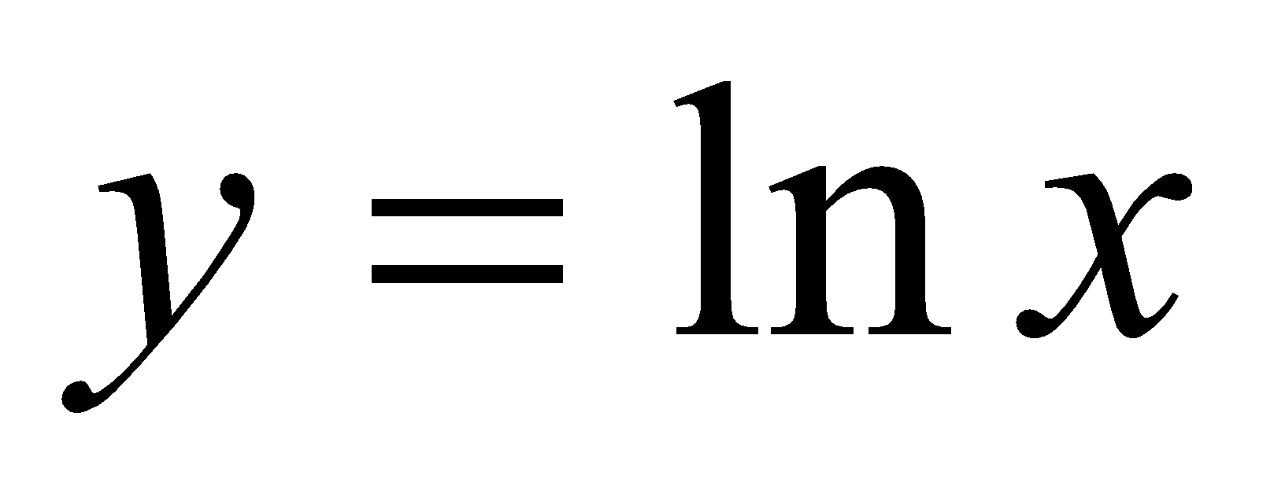 in the power of 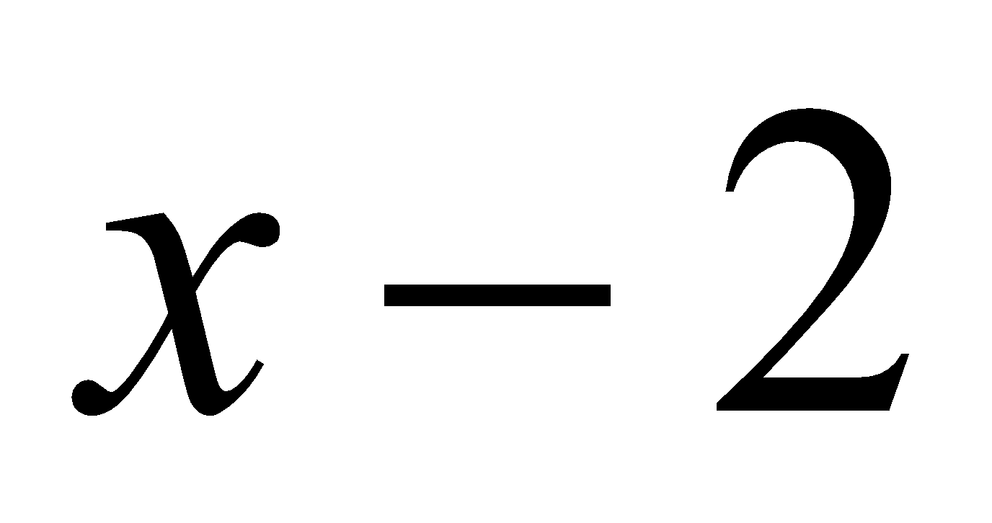 and 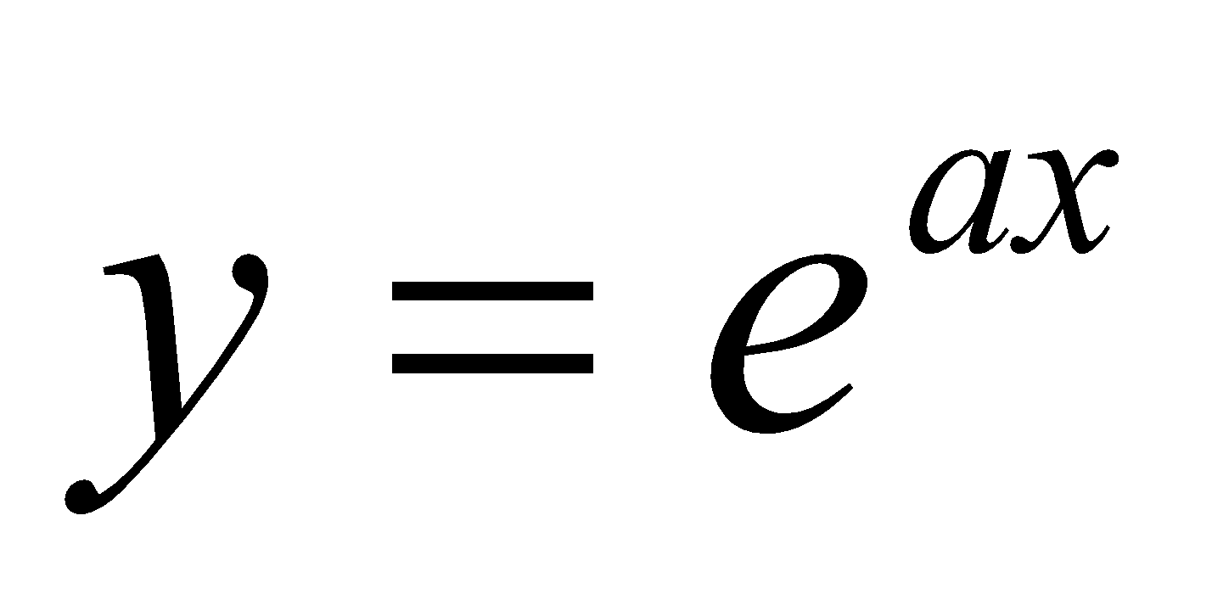 in the power of 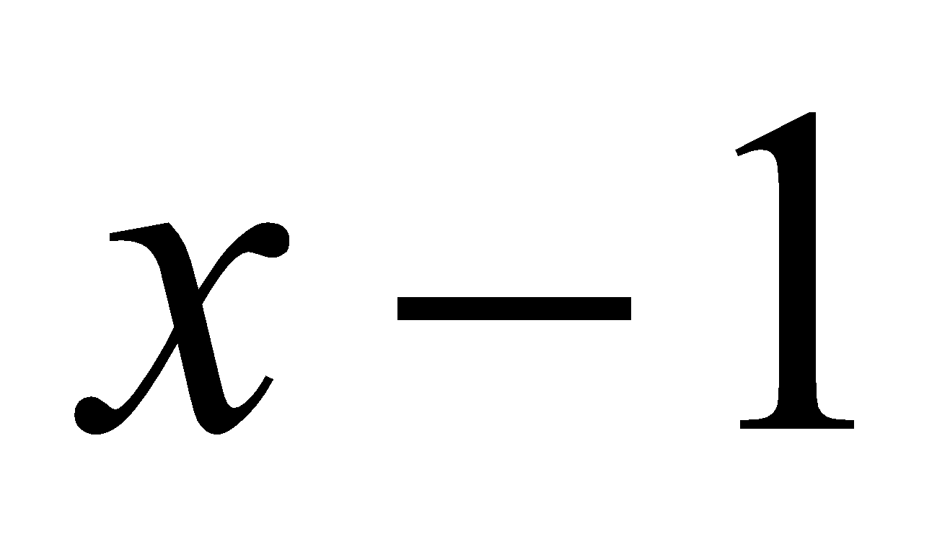.

- Find the Maclaurin series for the function 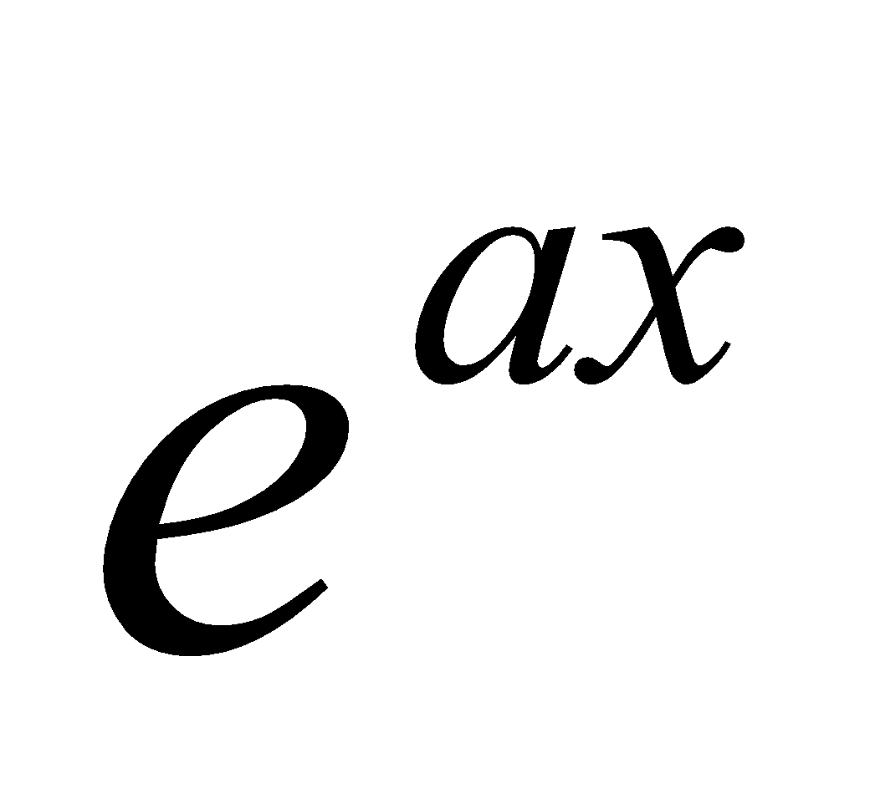and 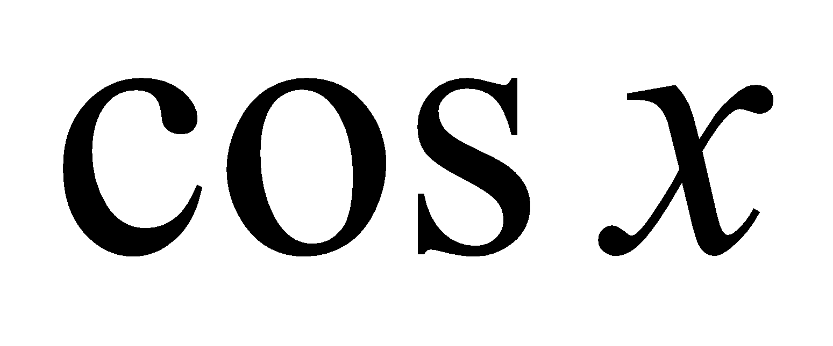.
- Find the Maclaurin polynomial 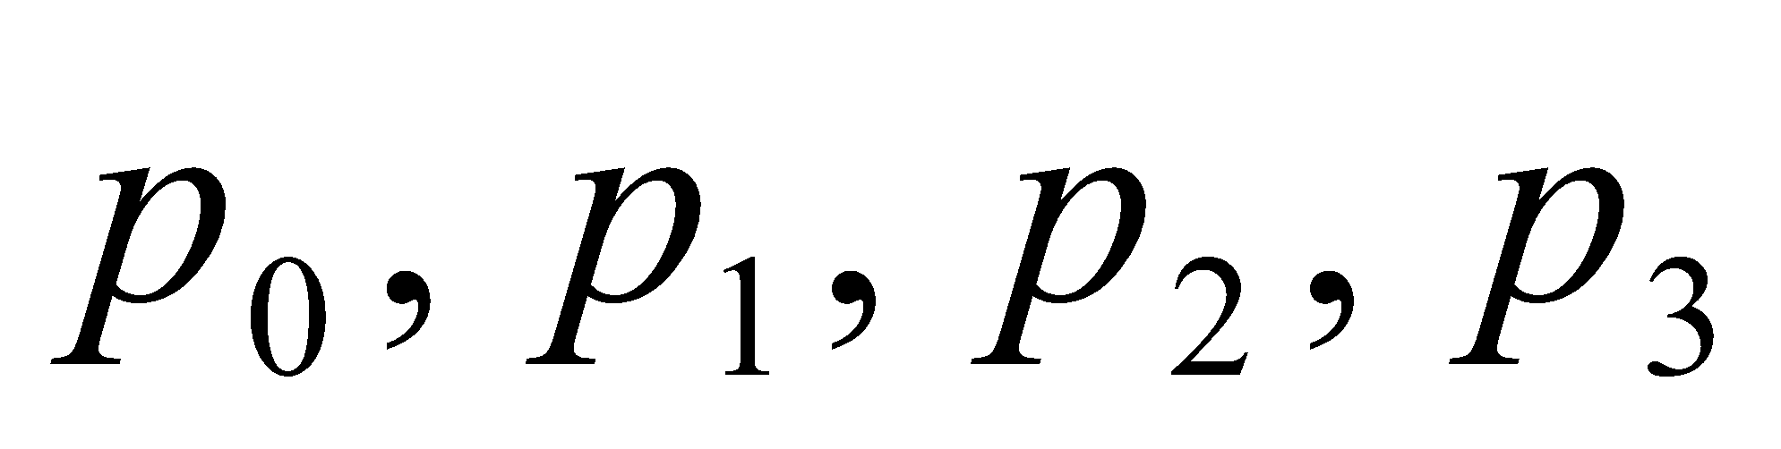for 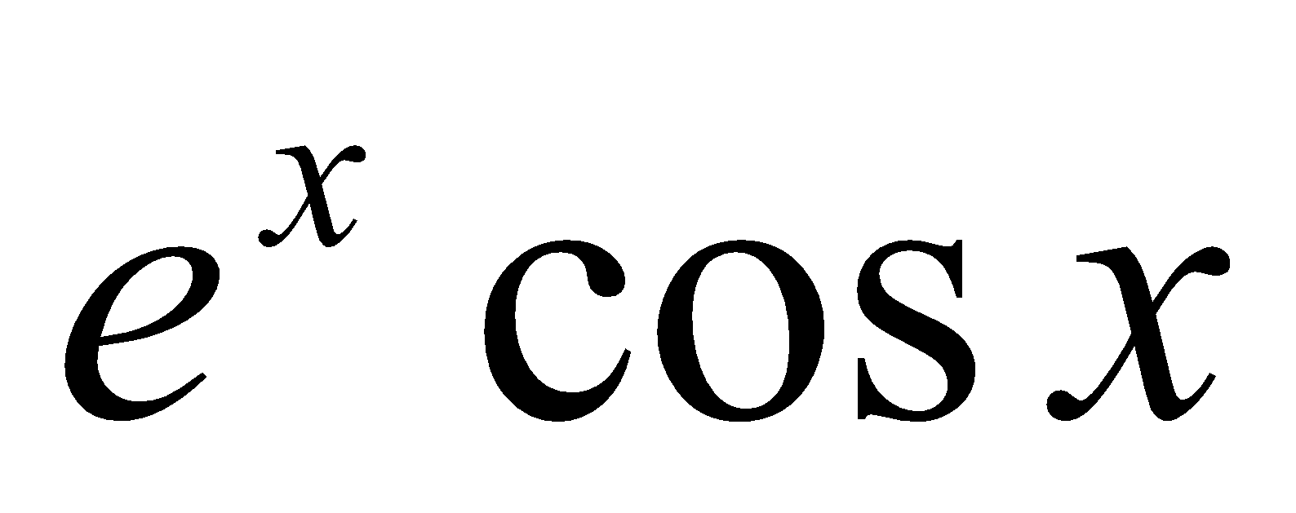.
- Expand 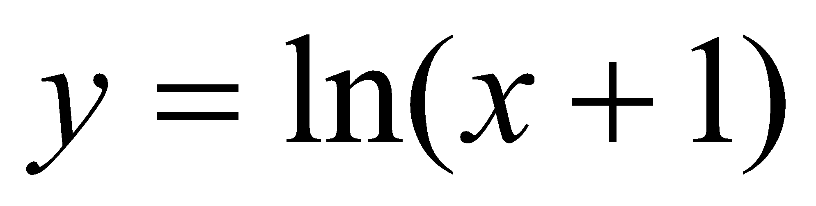 ,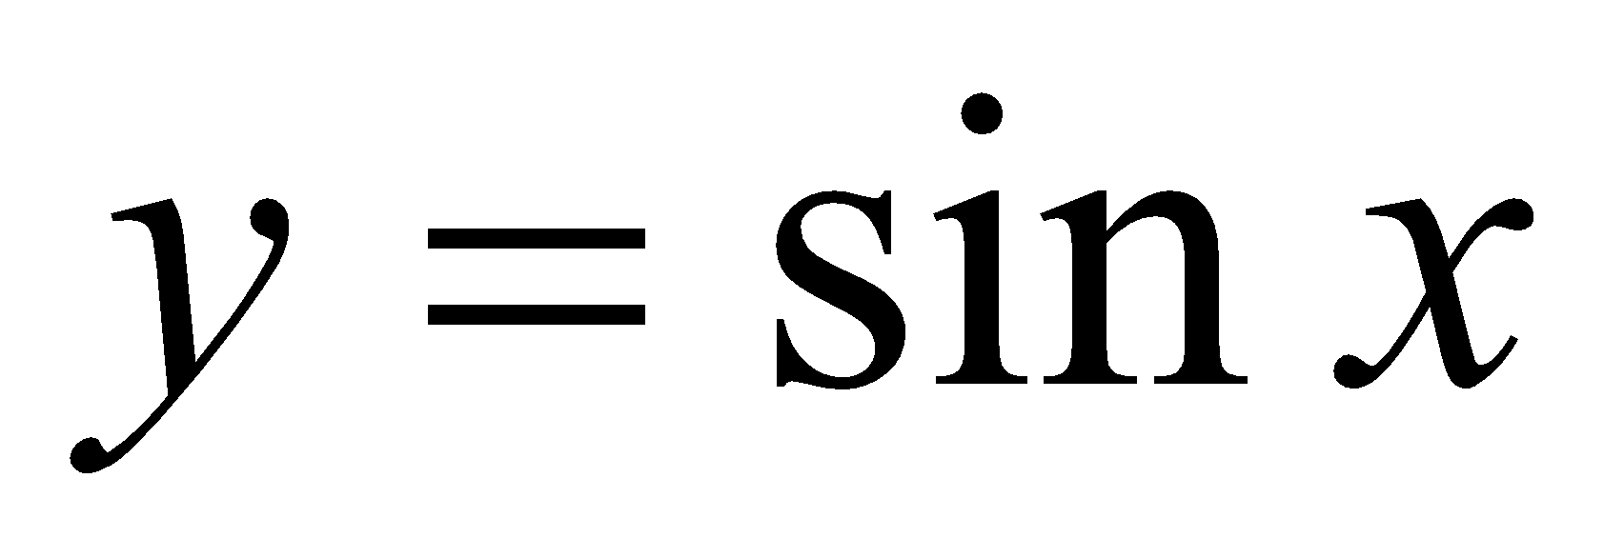,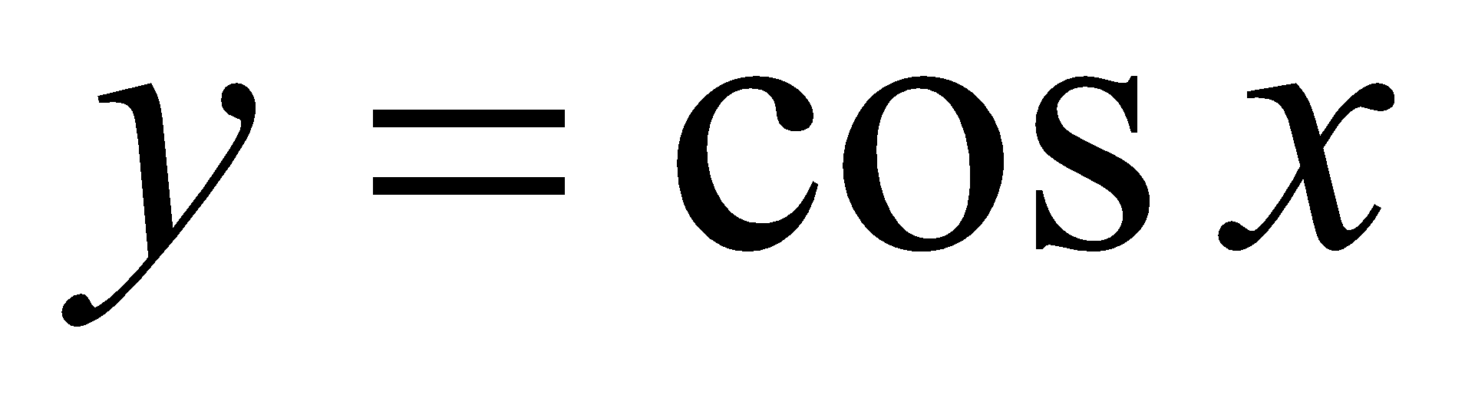in the power of x.

*Home work sheet # 7
Leibnitz’s Theorem

1. If 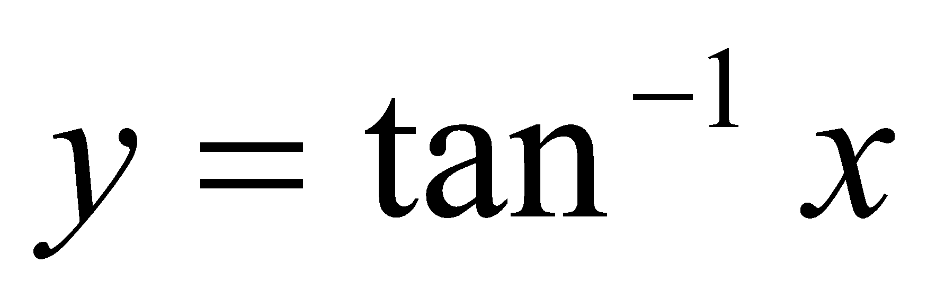, then show that
2. If 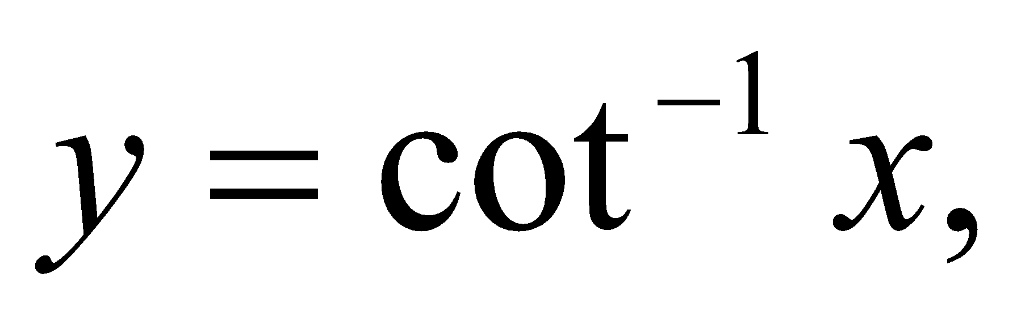then show that
3. If 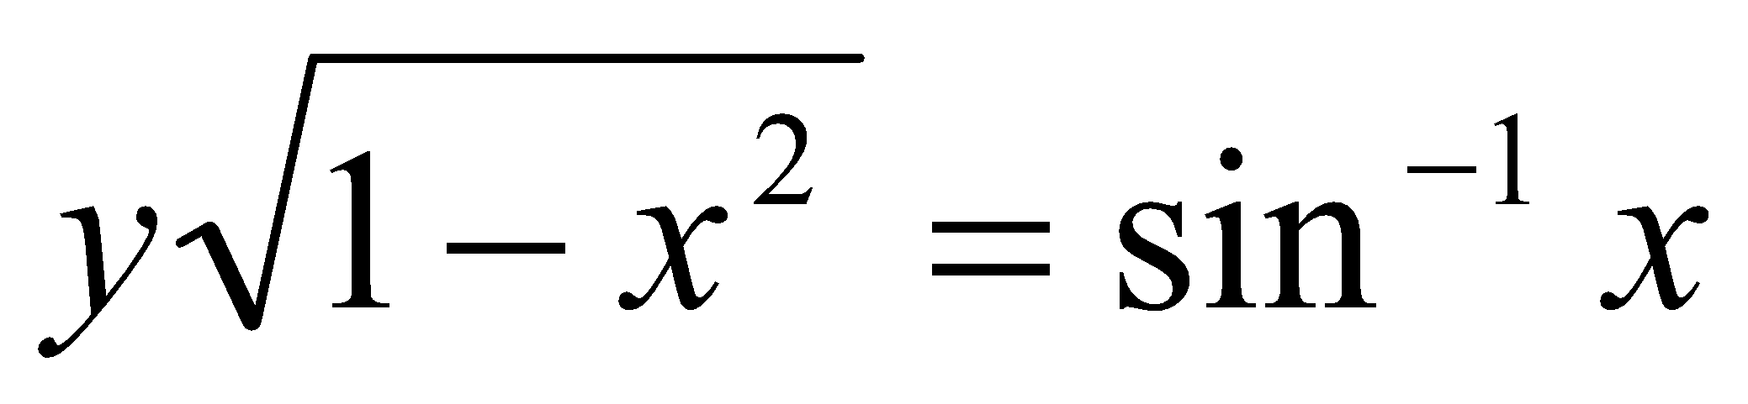,then show that 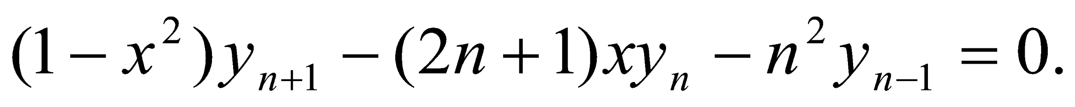
4. If 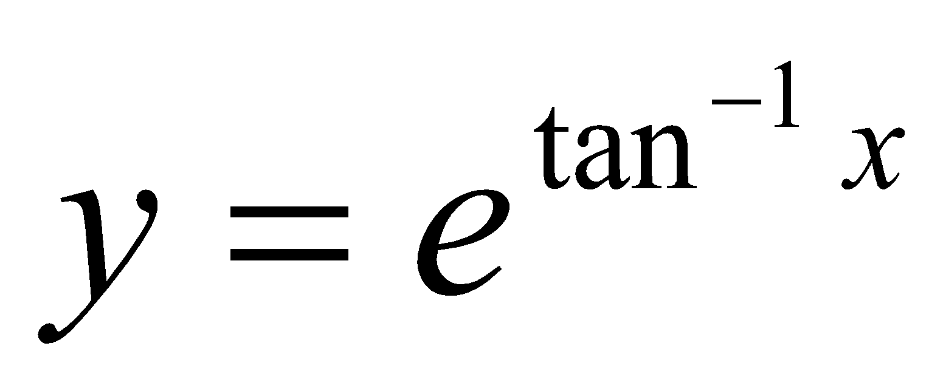 , then show that
5. If 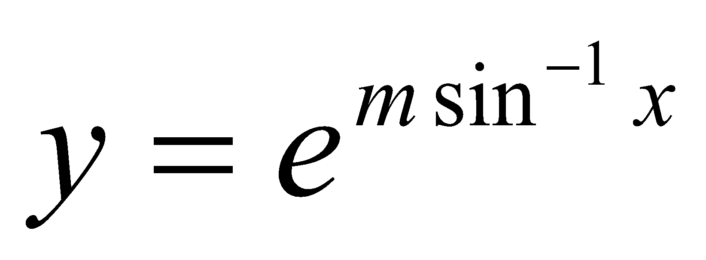 , then show that
6. If 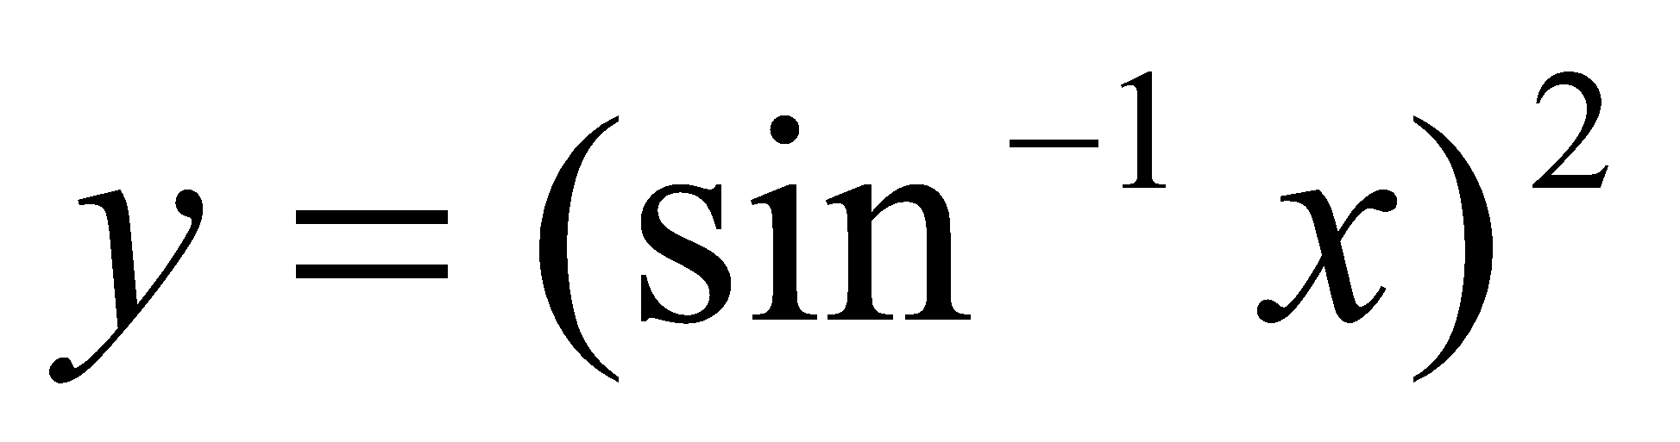, then show that 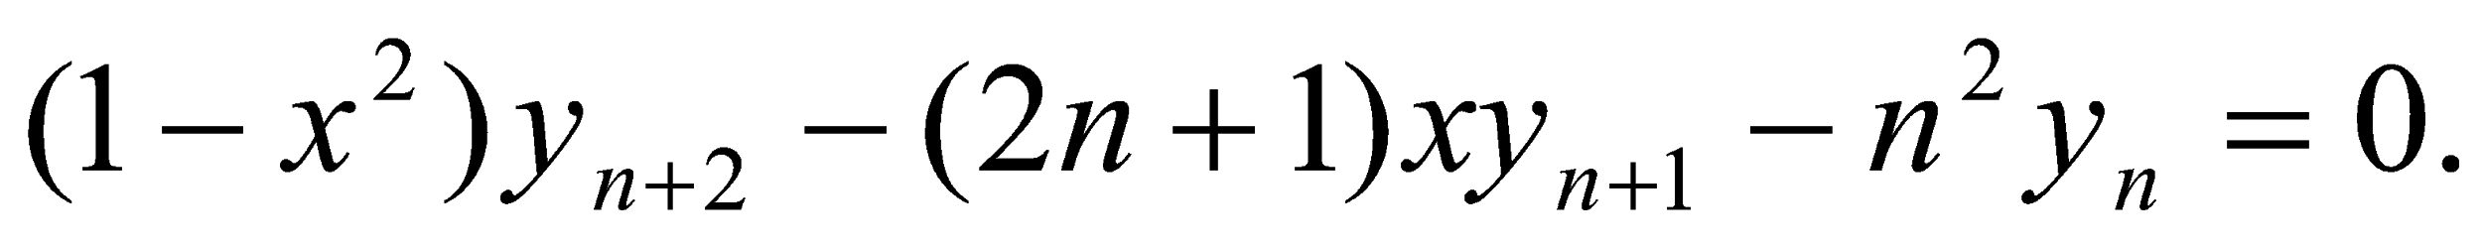
7. If 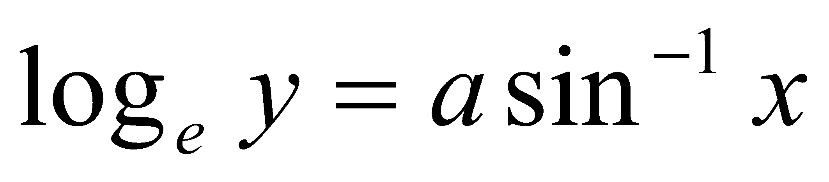 then show that
8. If 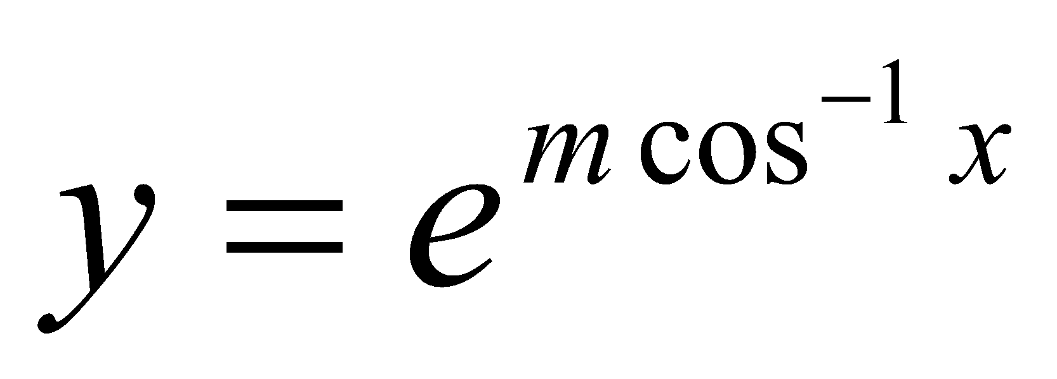 then show that
9. If 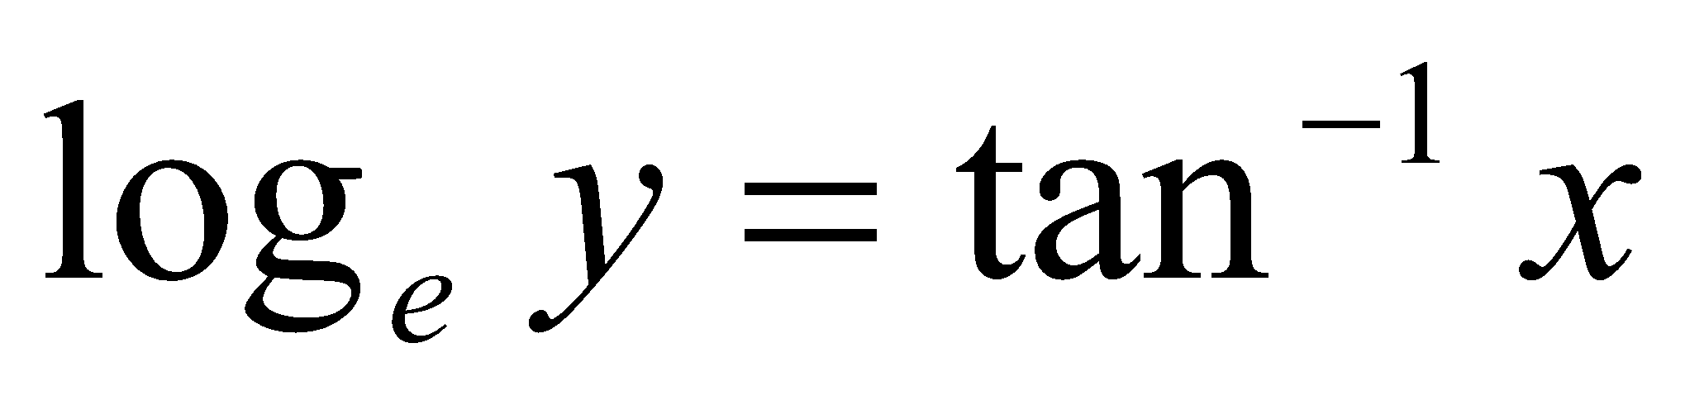 then show that
10. If 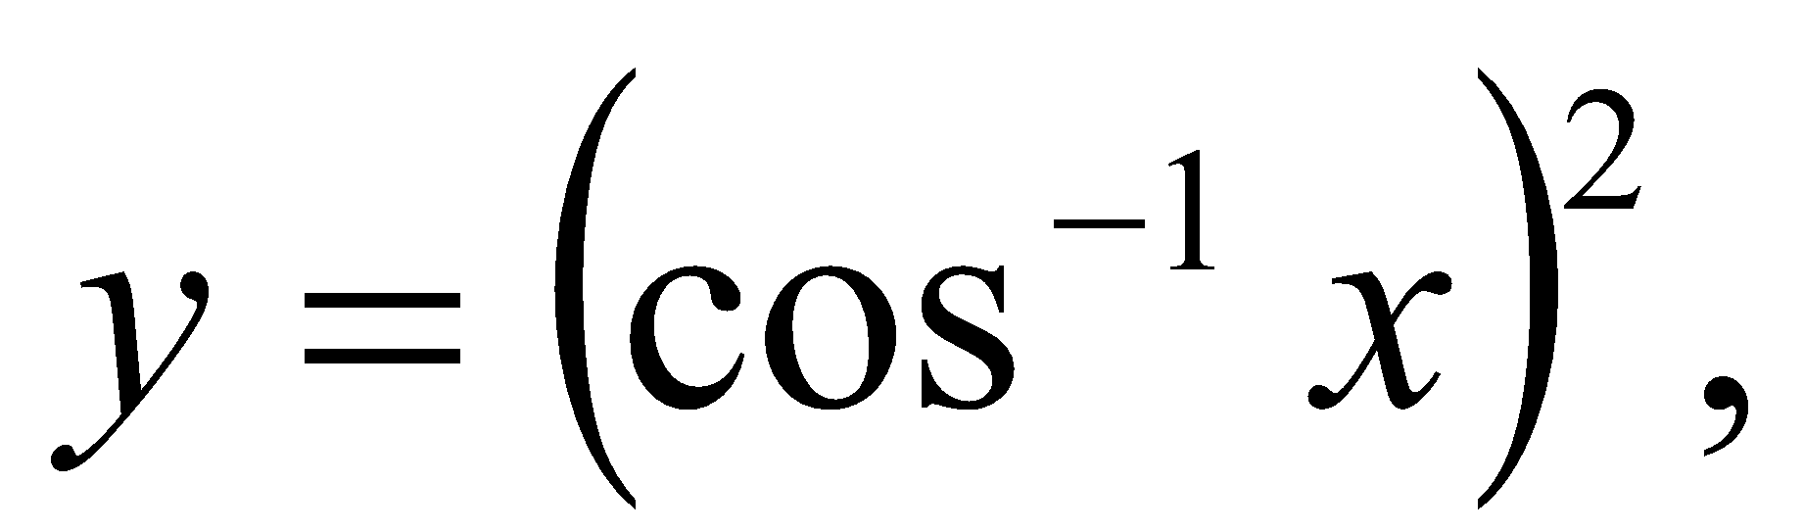then show that 
11. If 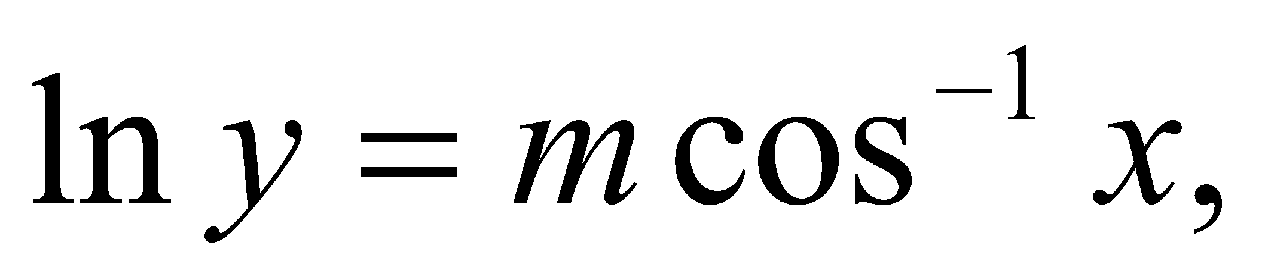then show that
12. If 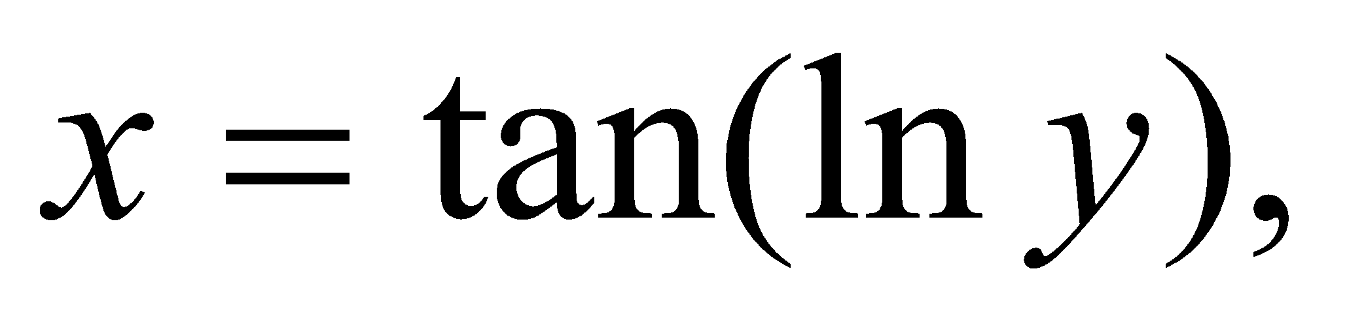then show that

Indeterminate Forms

Find the limit using L’ Hospital’s rule:

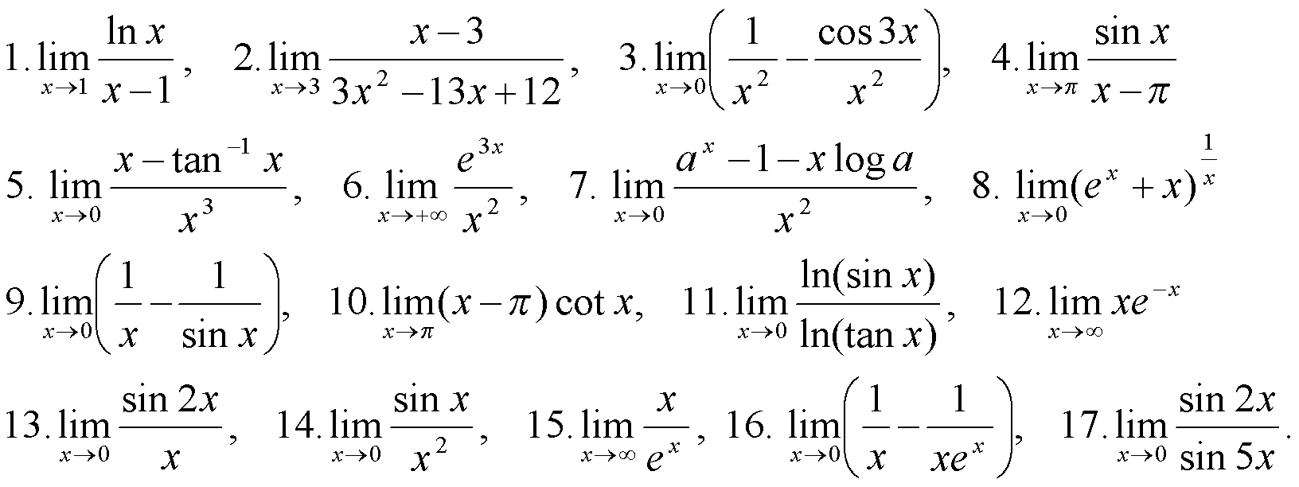

*Home work sheet # 8

Partial derivative

1. Let 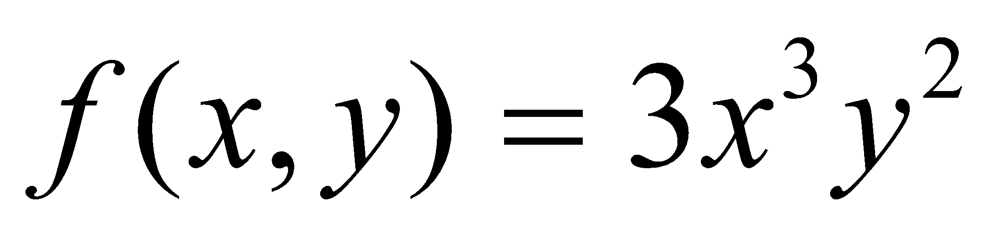. Find
(a) 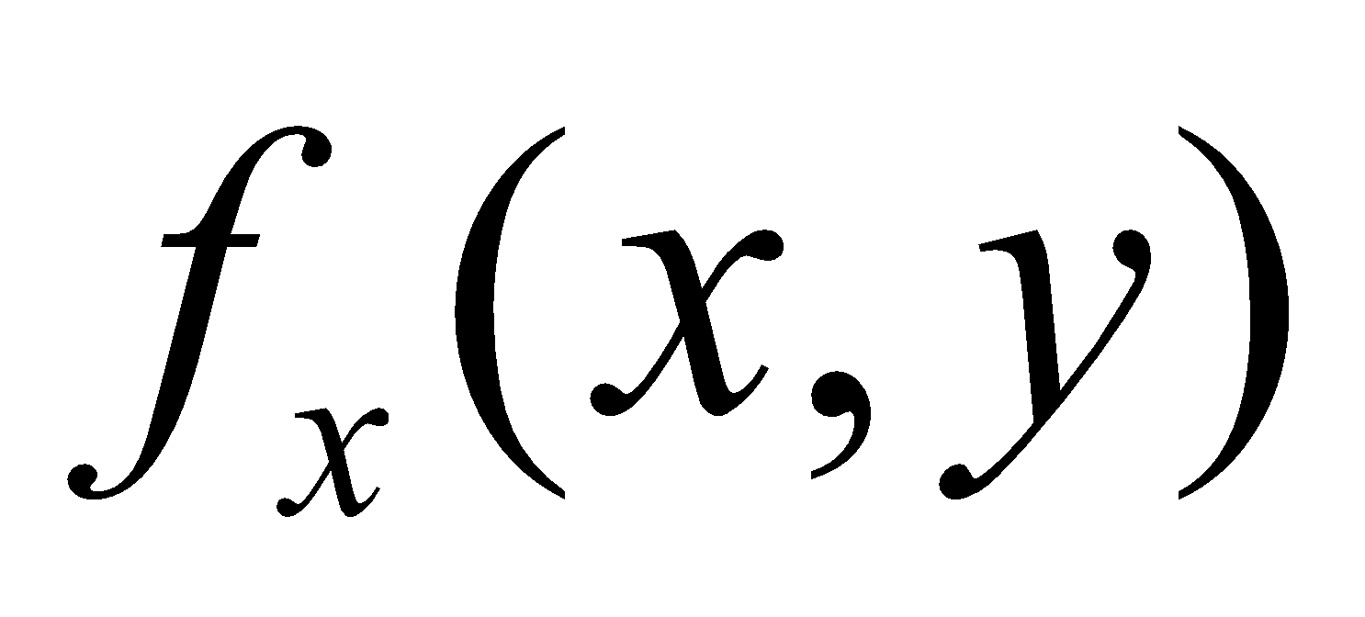(b) 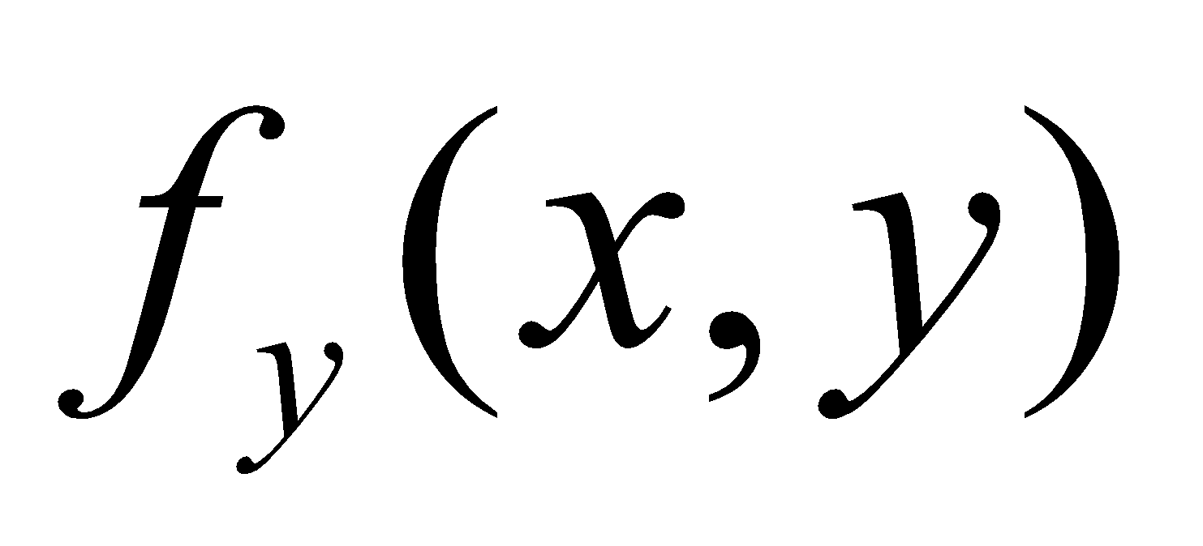 (c)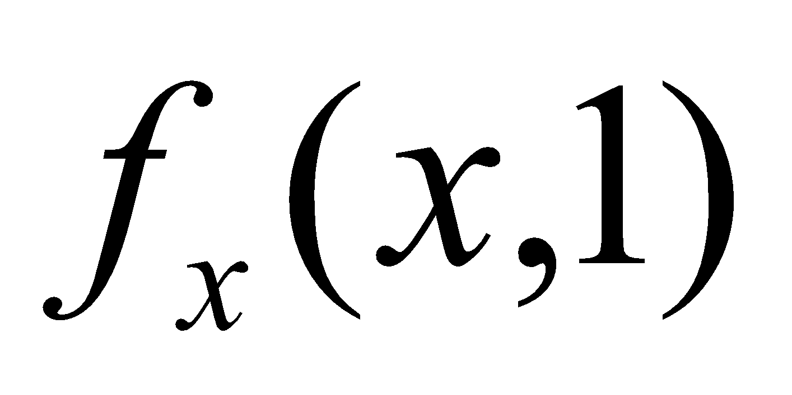(d) 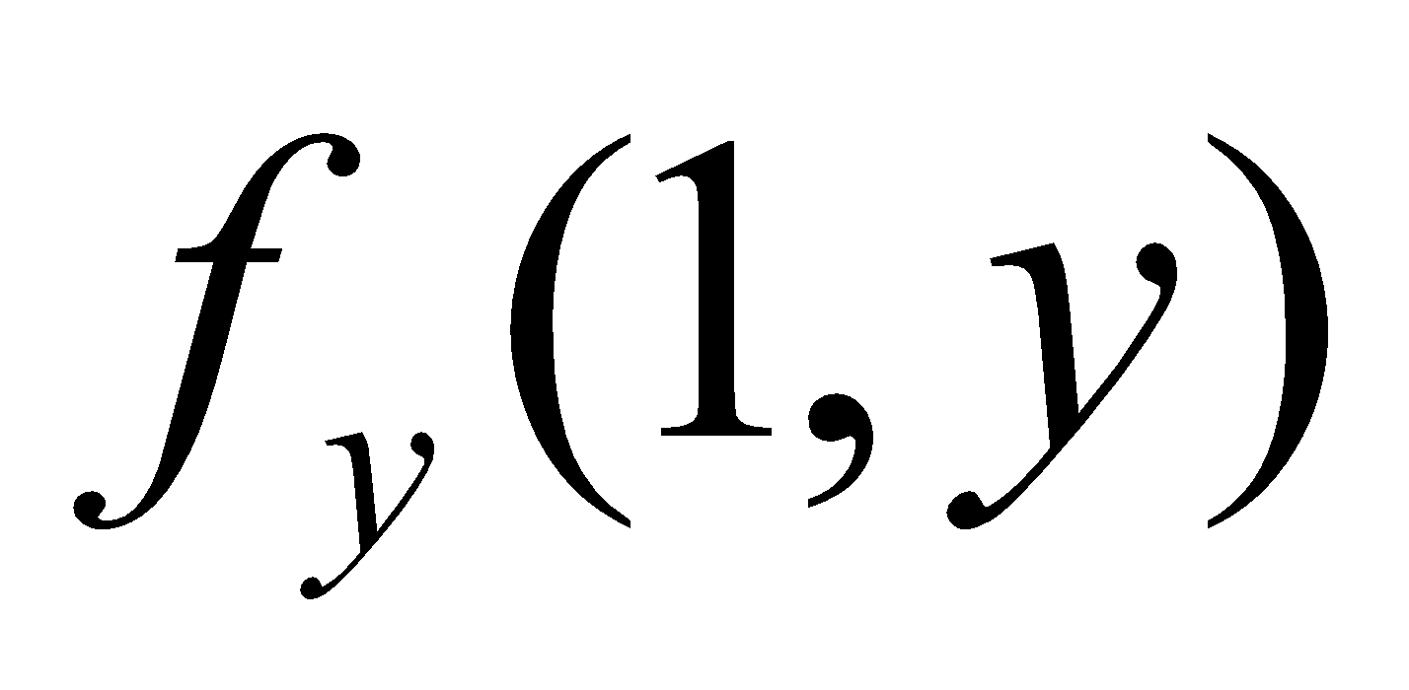(f) 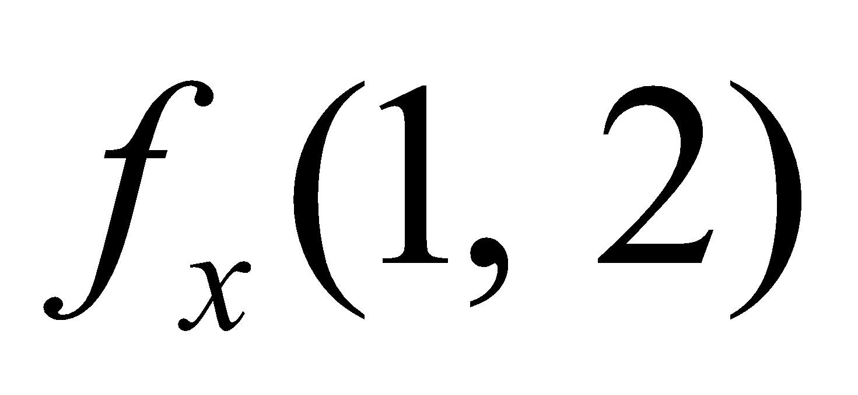(g) 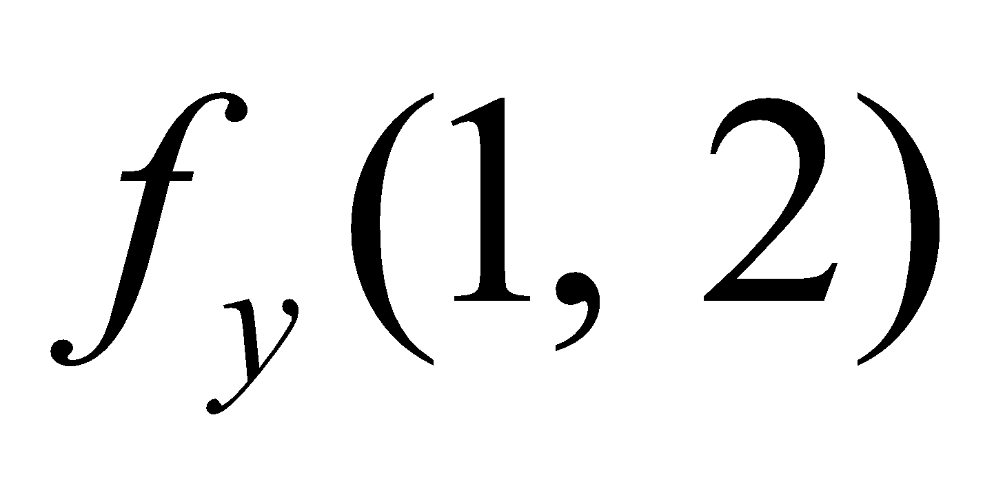.
2.Let 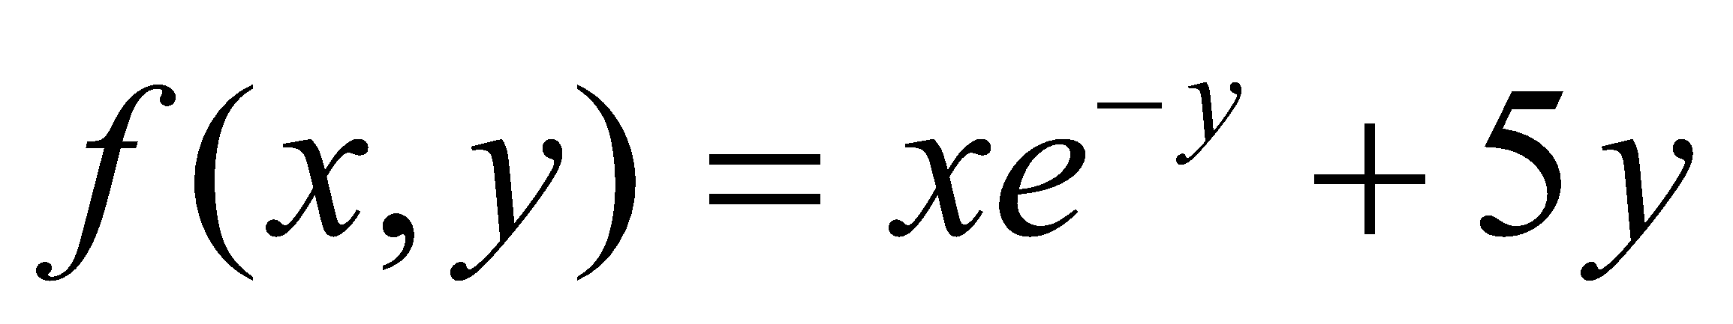, 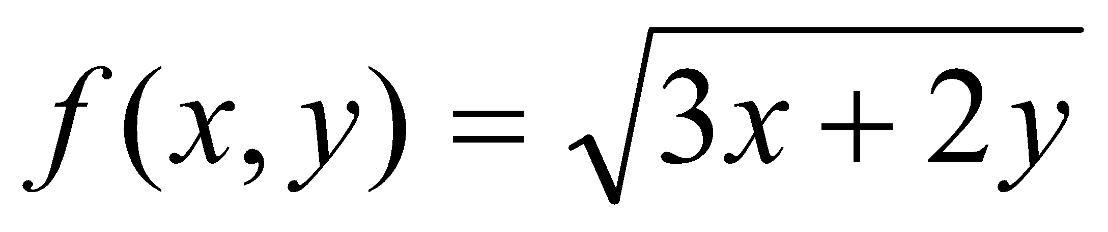
(a) Find the Slope of the surface 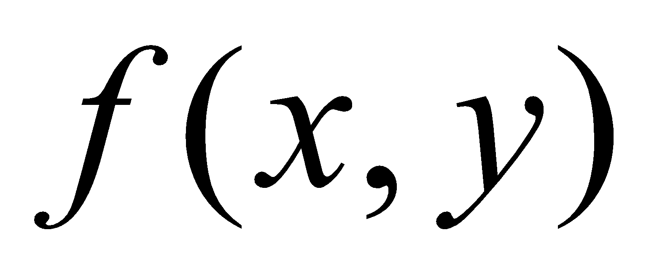 in the x- direction at the point (3,0) and
(4,2)
(b) Find the slope of the surface  in the y direction of the point (3,0) and
(4,2)
3. Let 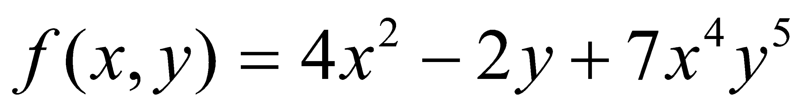 , Find (a) 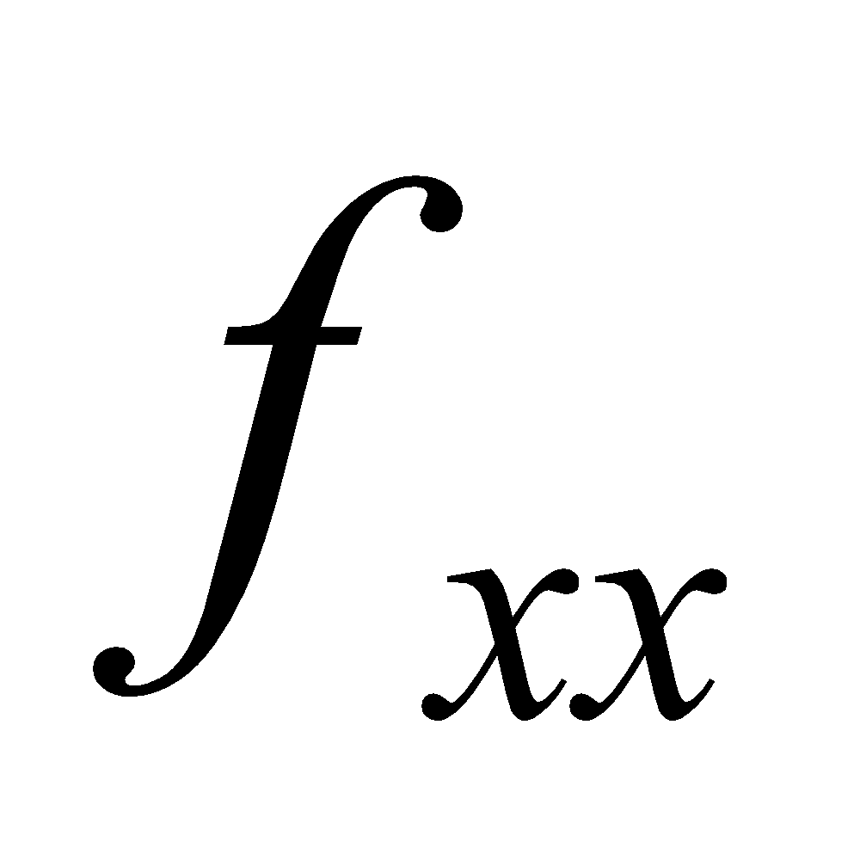 (b) 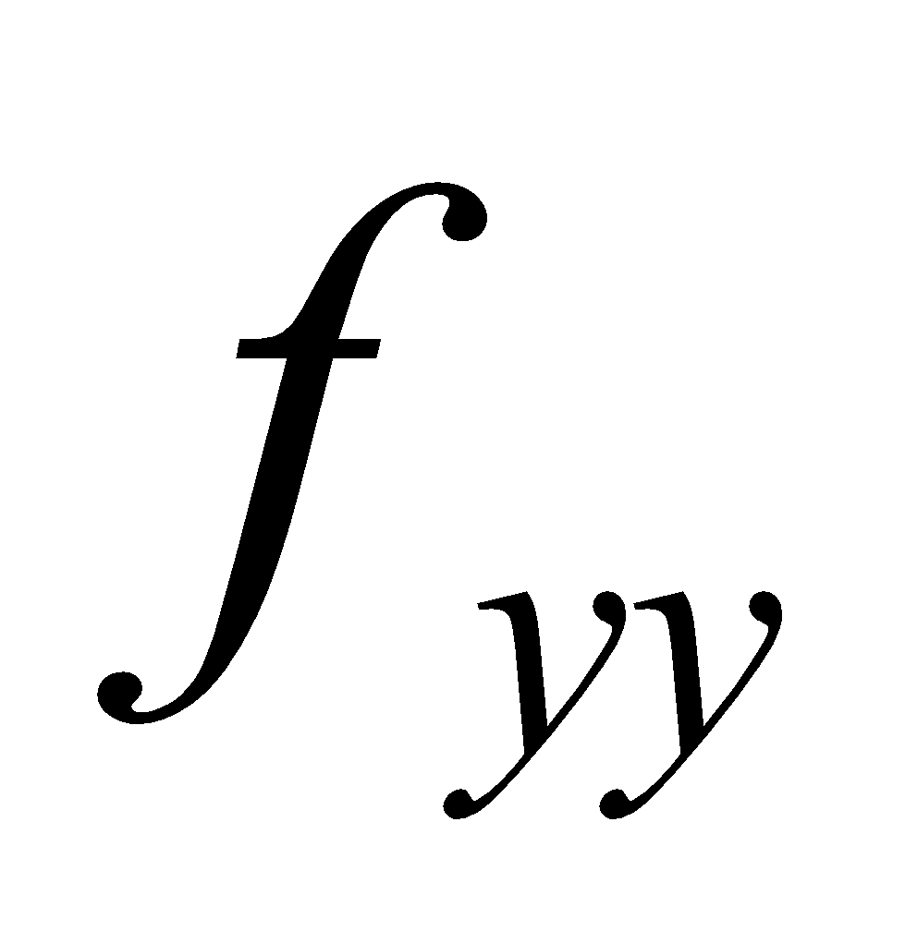 (c) 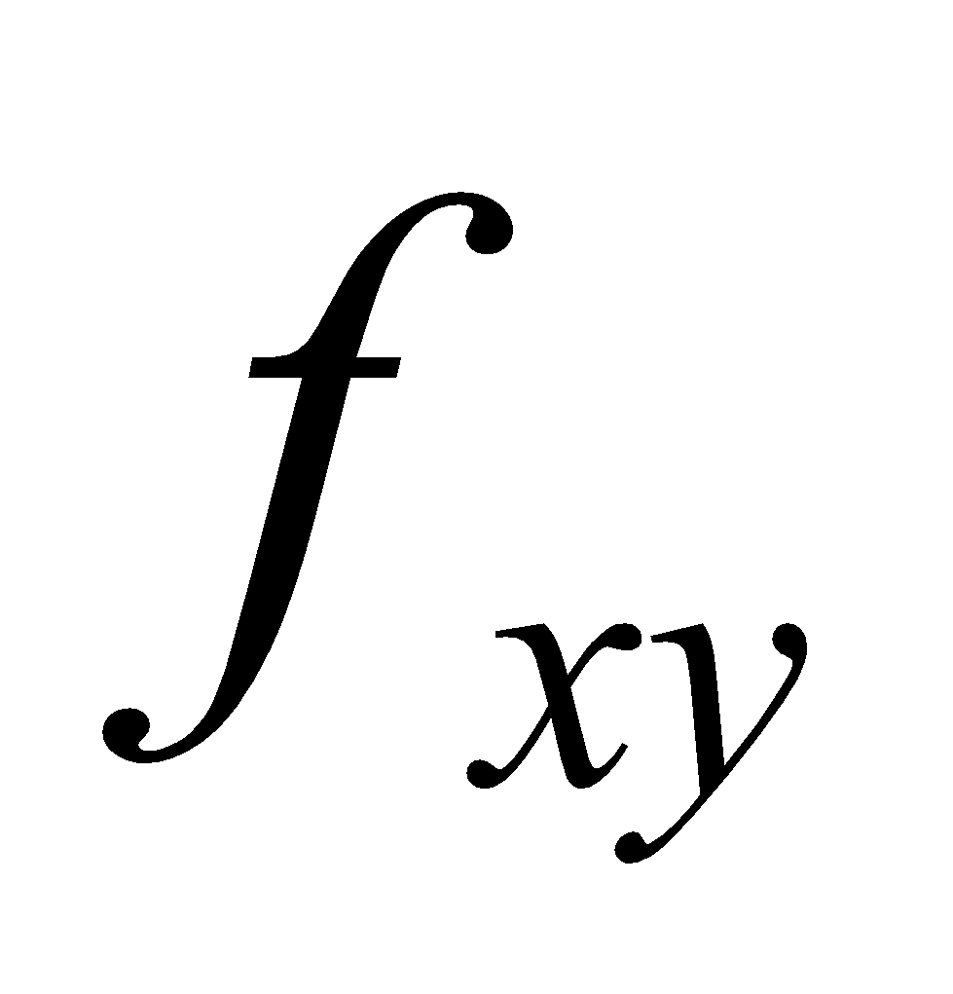 (d) 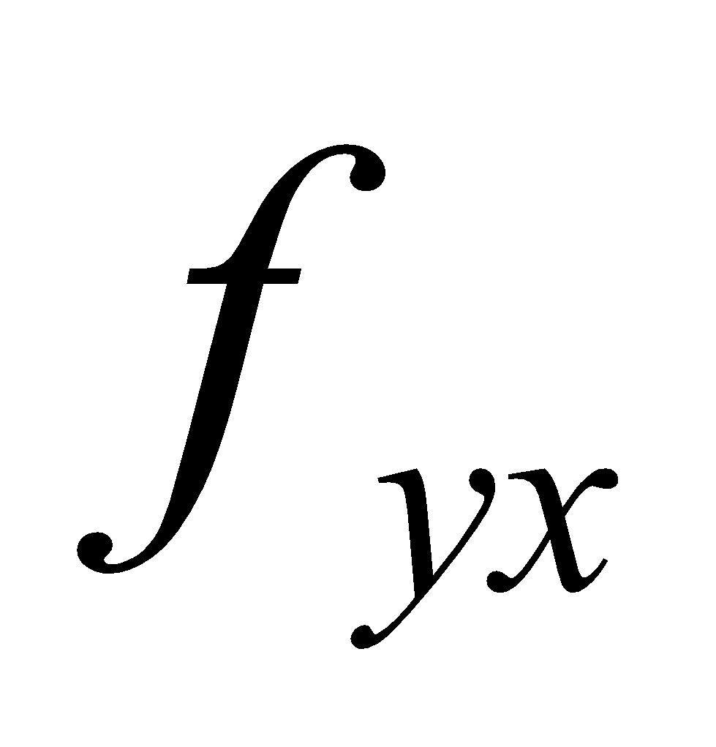.
4. Let 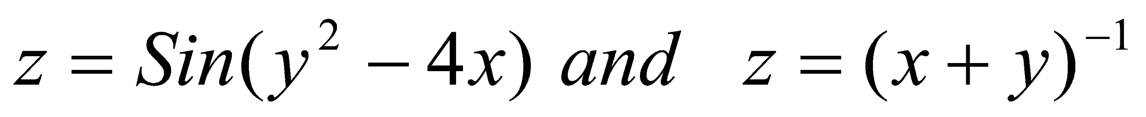
(a) Find the rate of Change of z w. r. to x at the point (2,1) and (-2, 4) with y kept fixed.
(b) Find the rate of Change of z w. r. to y at the point (2,1) and (-2, 4) with x kept fixed.
5. Let 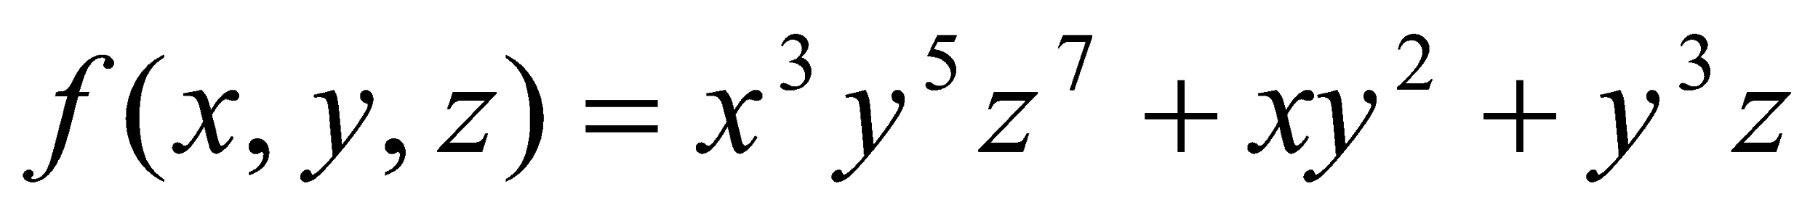 , find
(a) (b) 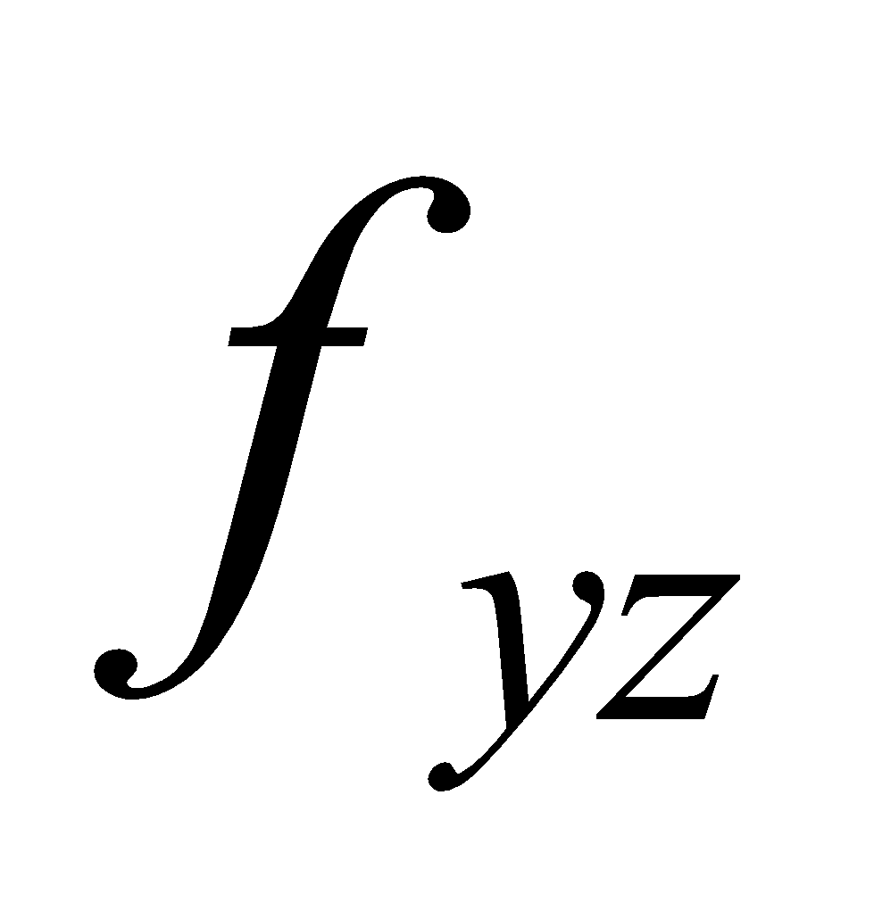 (c)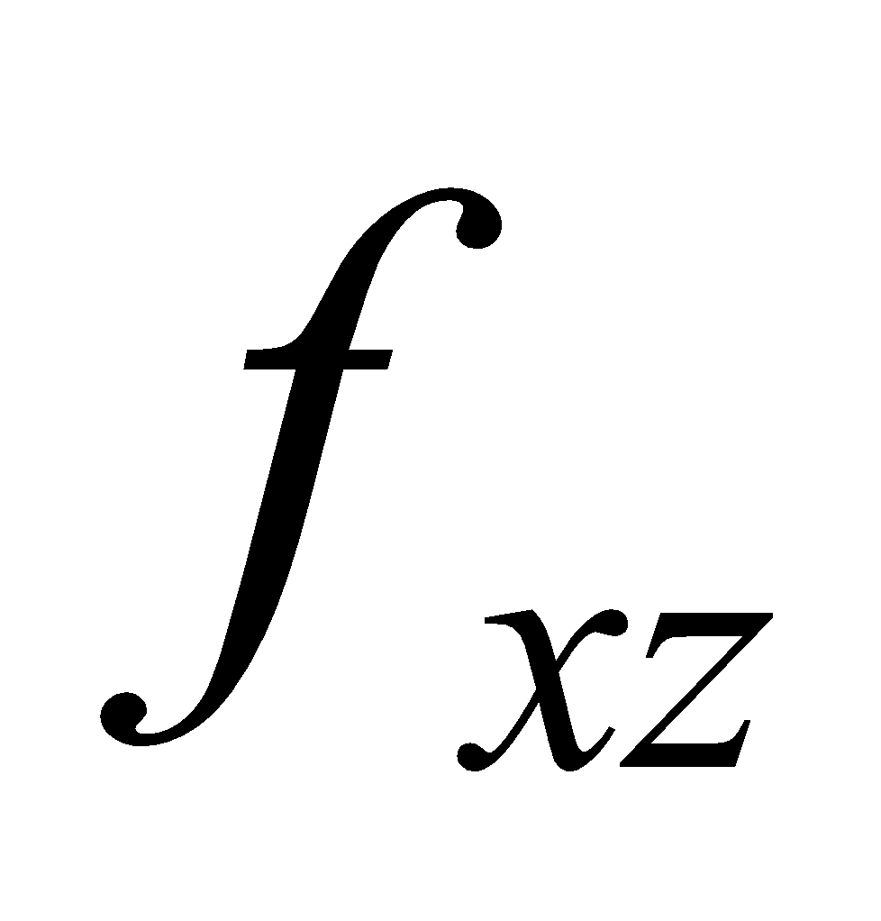 (d) 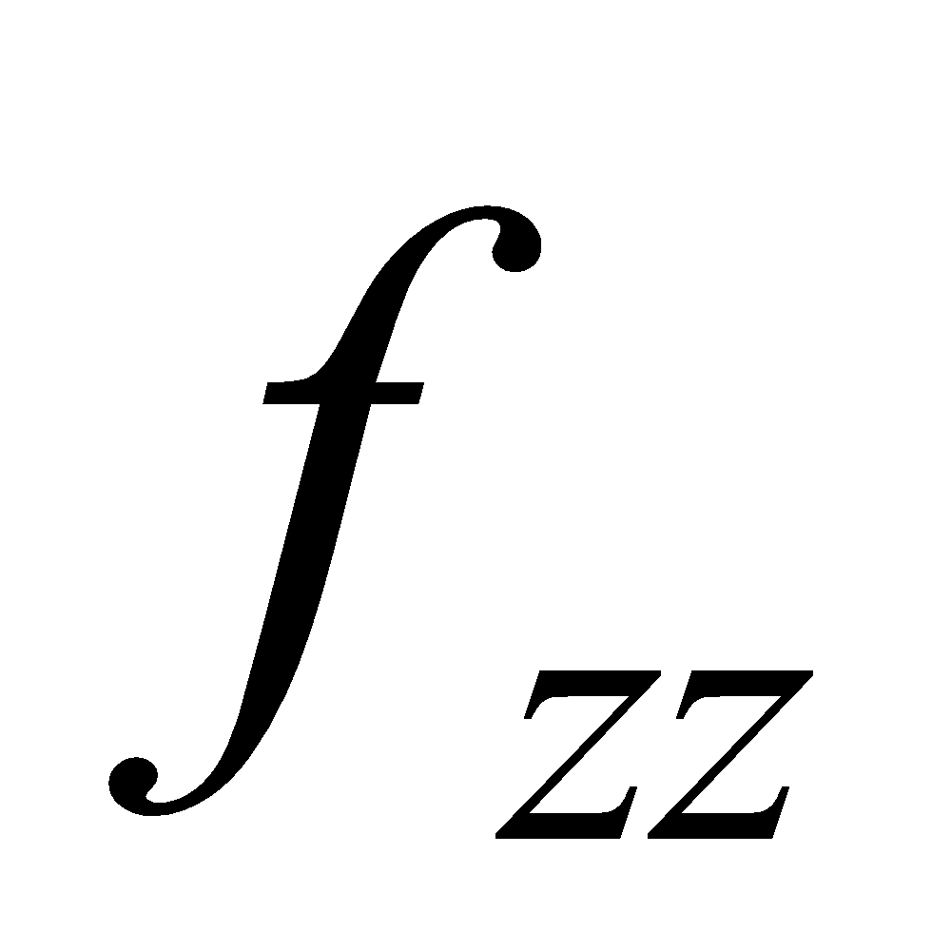 (e) 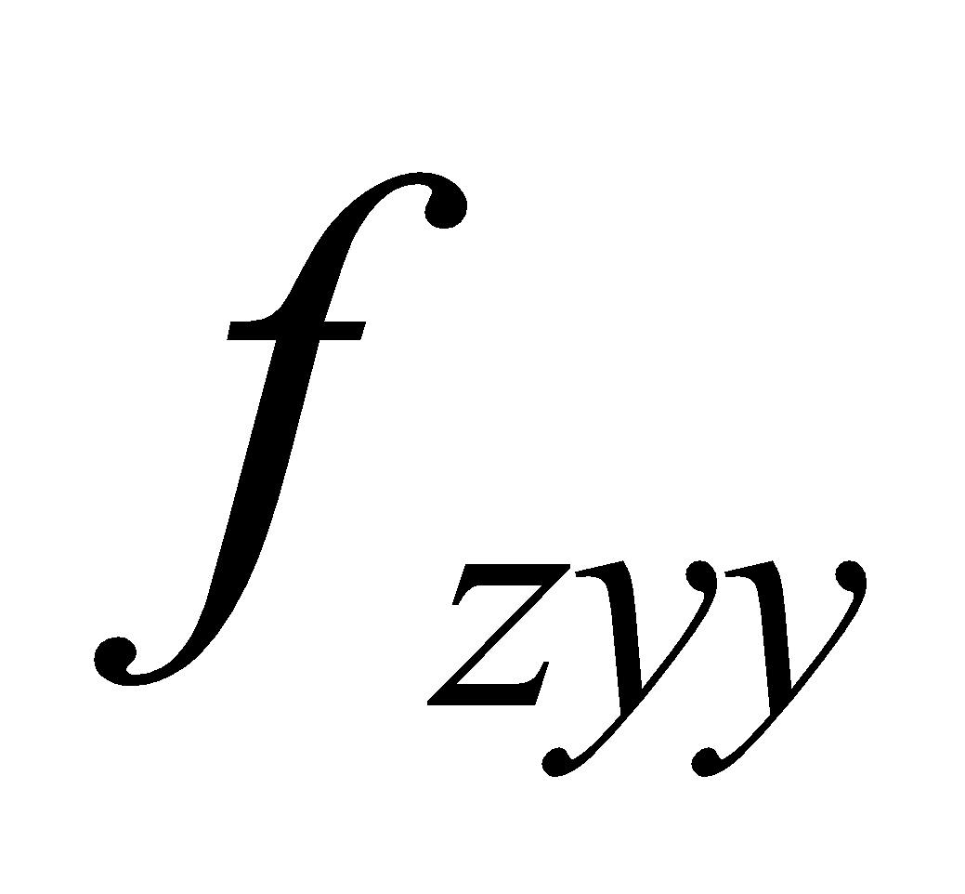 (f) 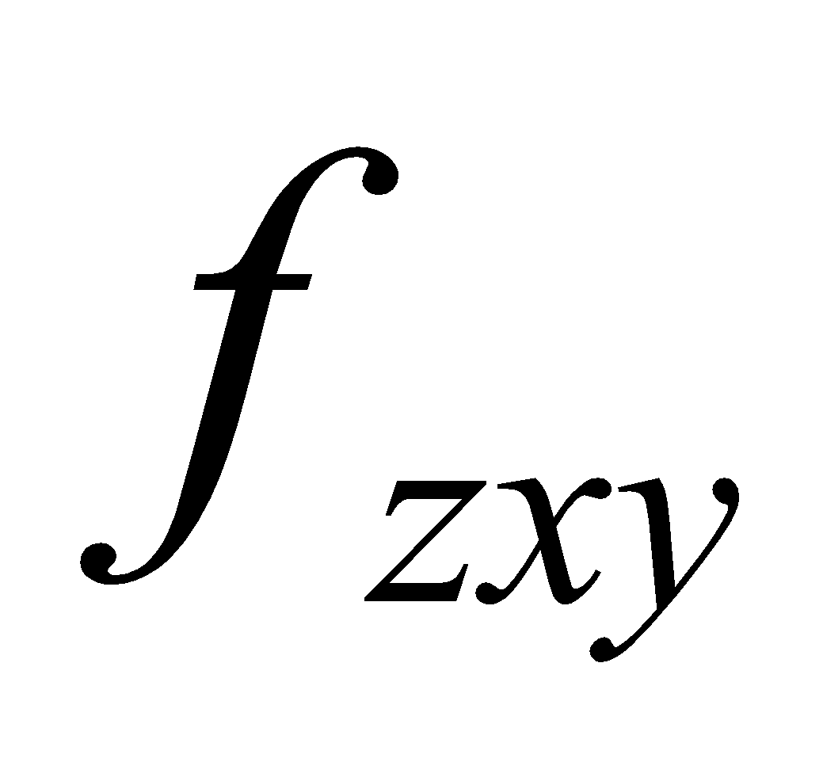 (g) 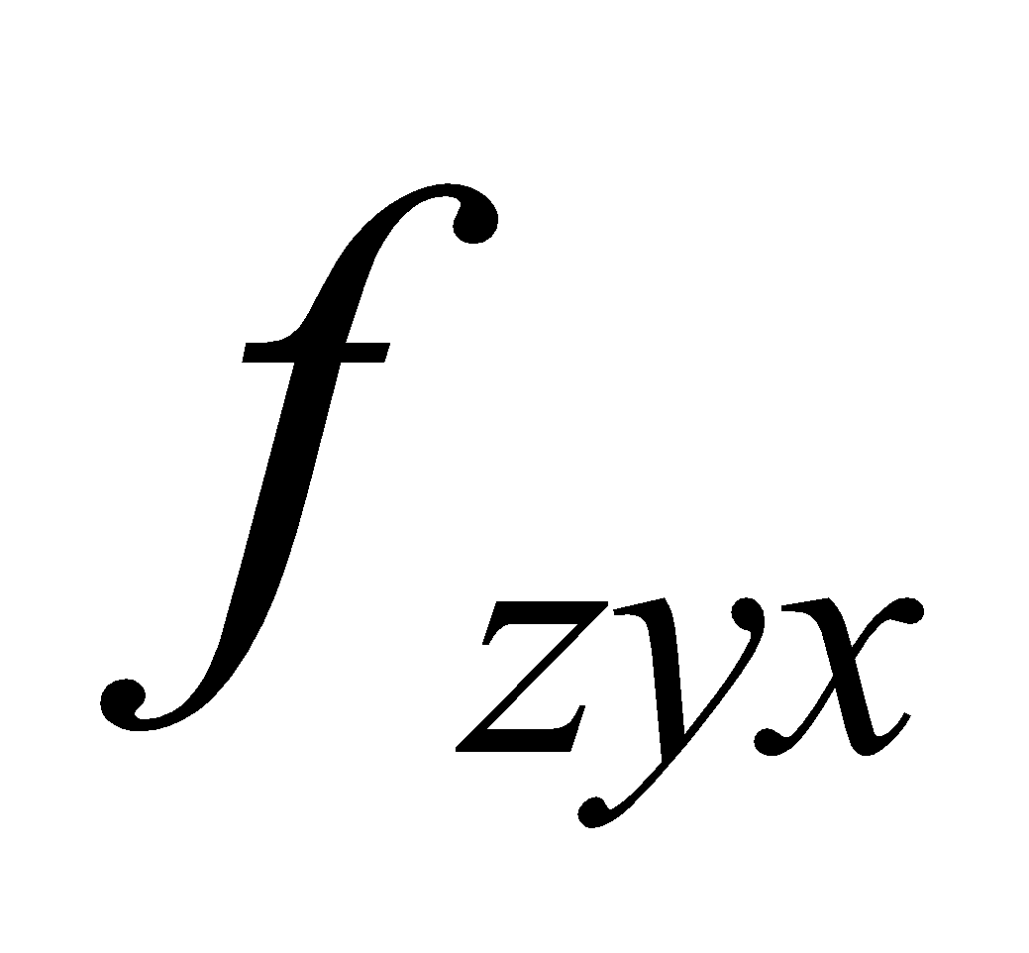 (h) 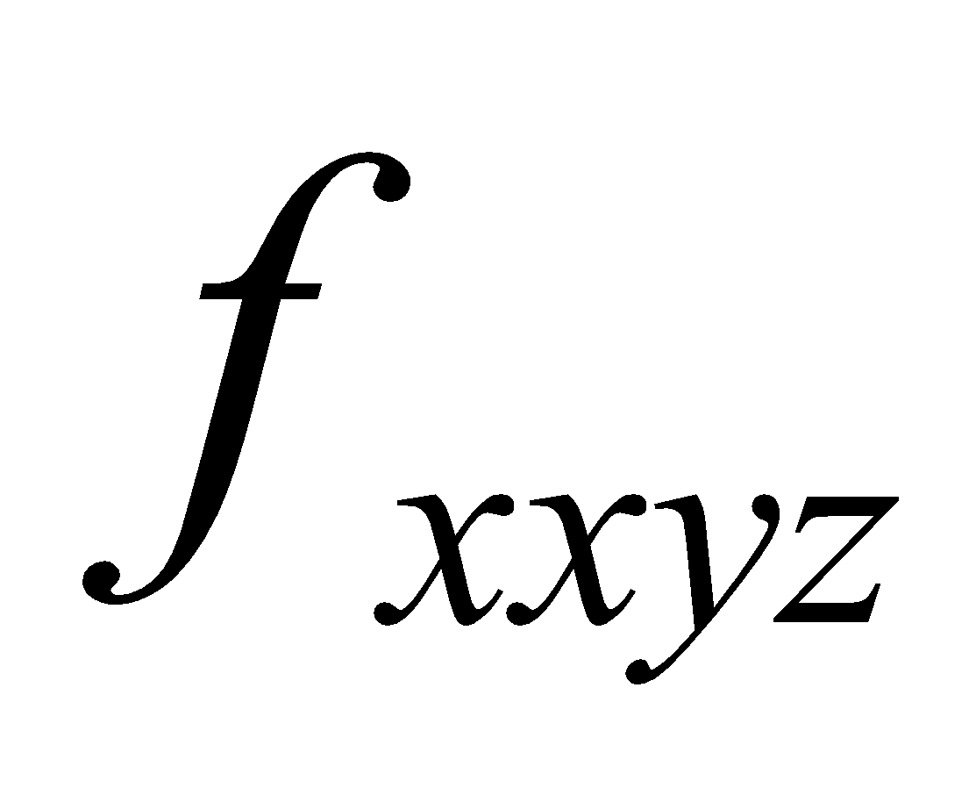.
6. Let 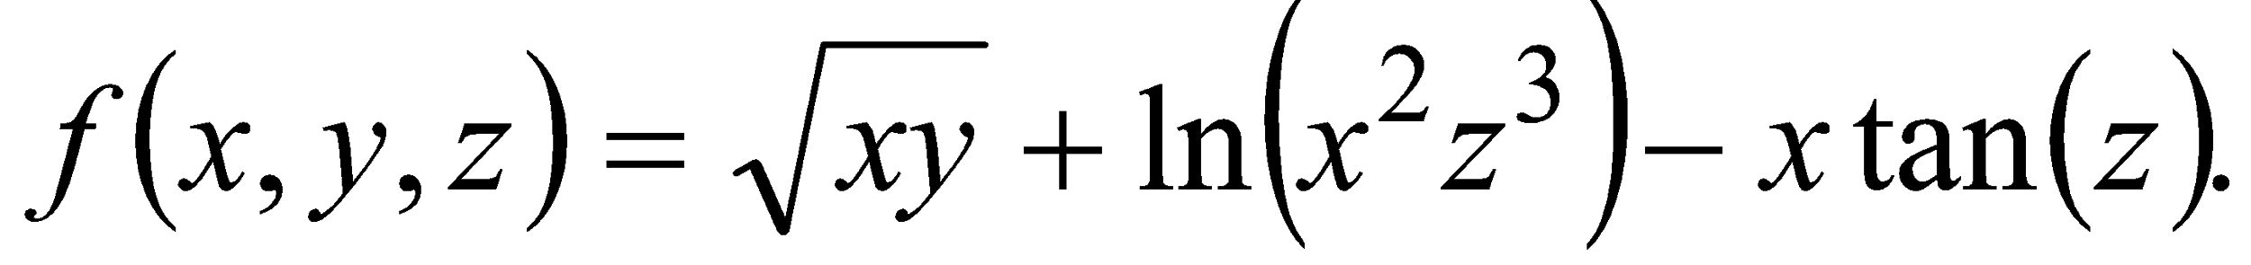 Compute 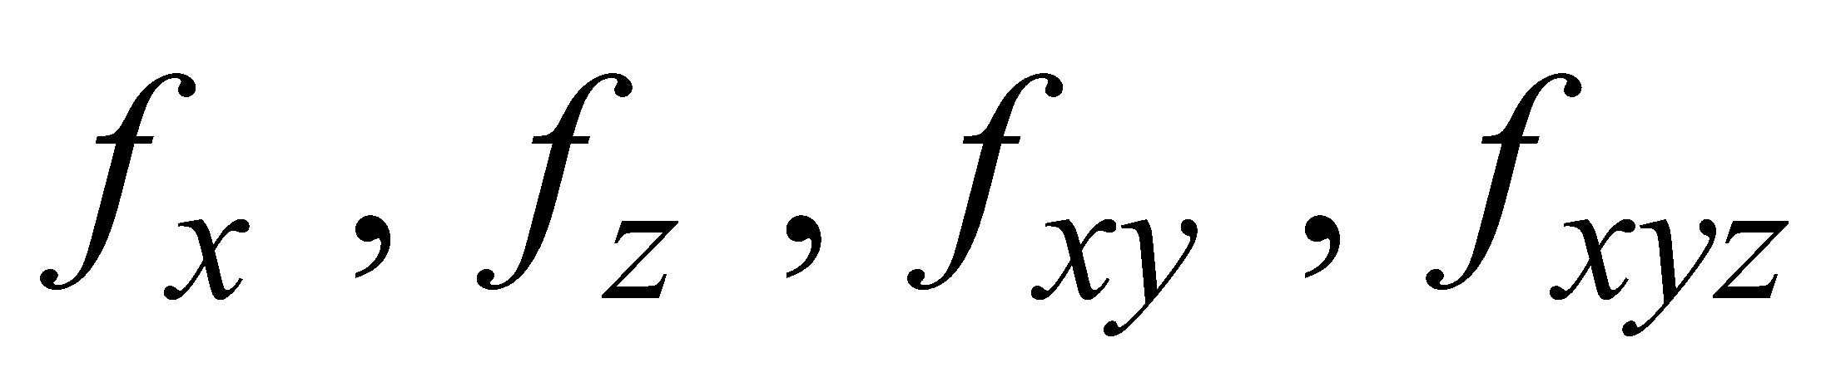

Maxima Minima of
function of several variable
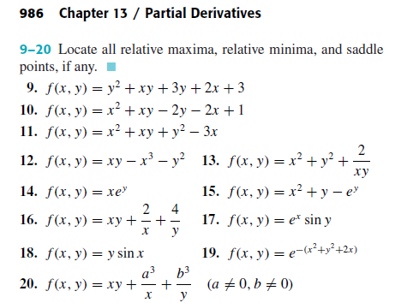

Lagrange Multiplier

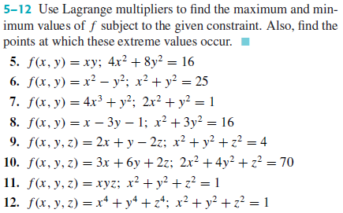

*Home work sheet # 9

Transformation of Co-ordinates

- Find the polar co-ordinates of the points 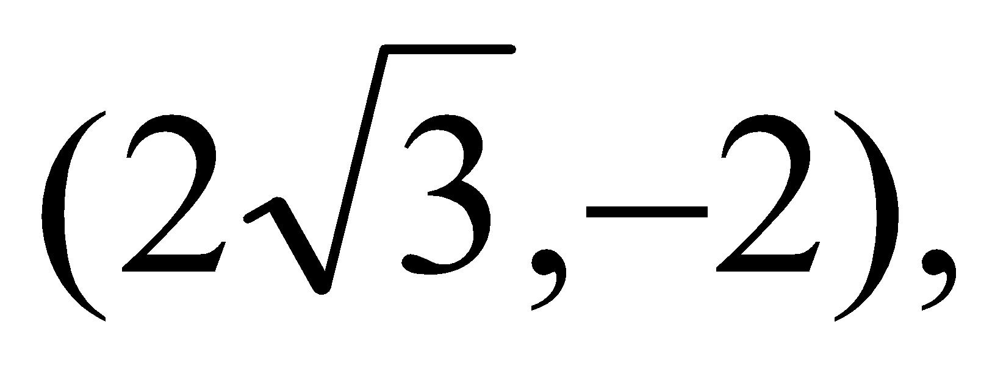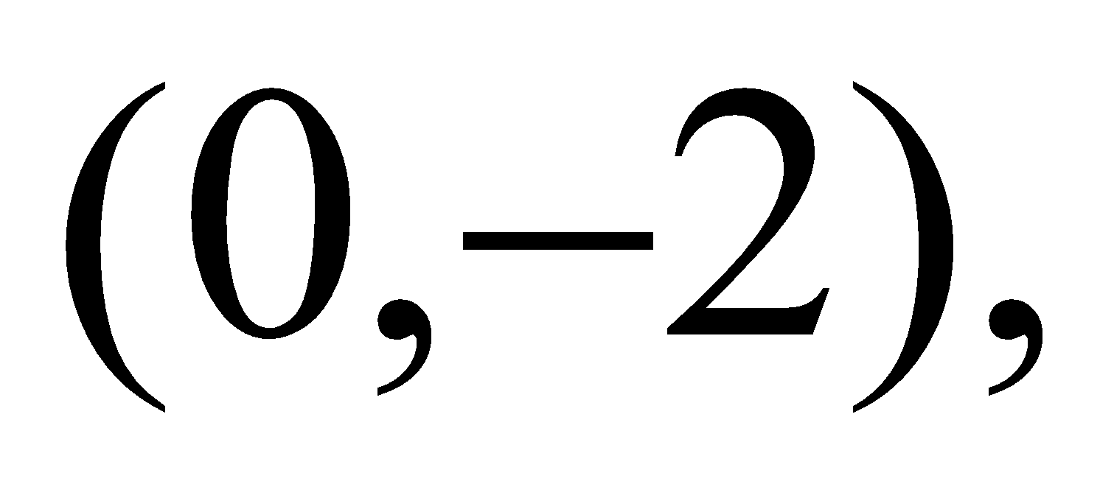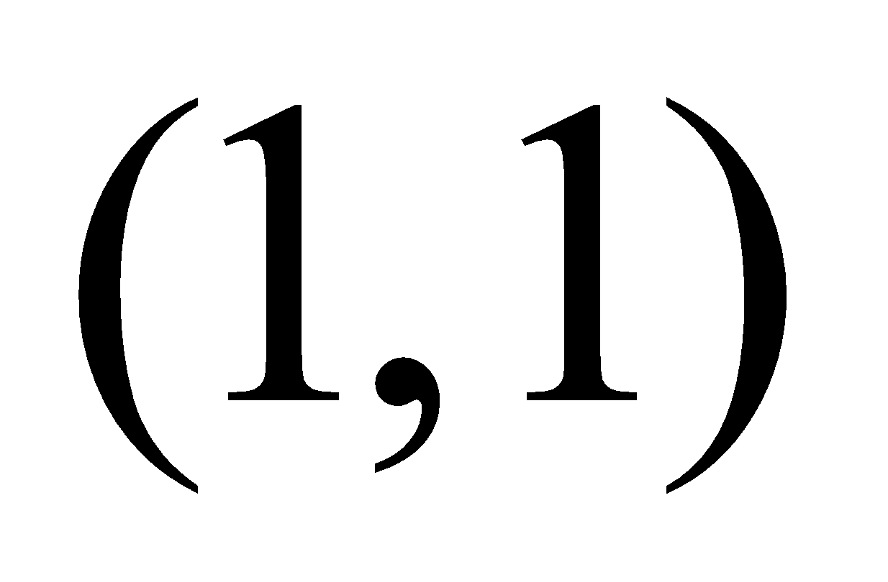.
- Find the rectangular co-ordinates of the points 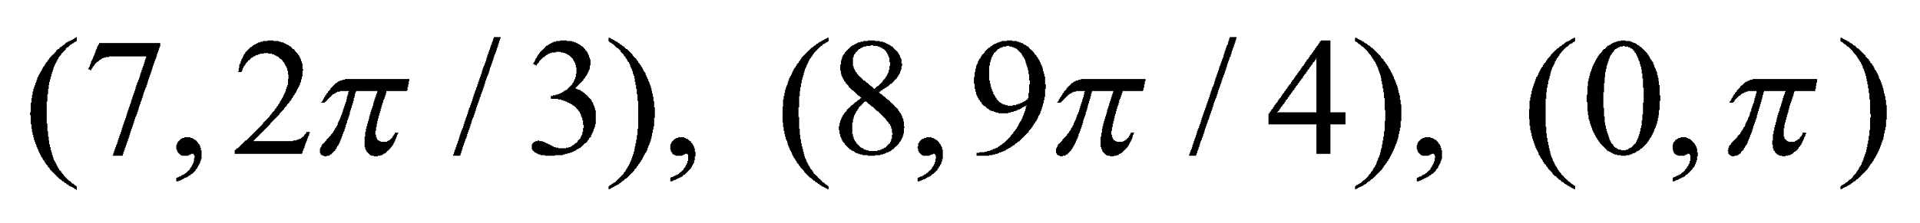.
- Change to Cartesian coordinates the equations 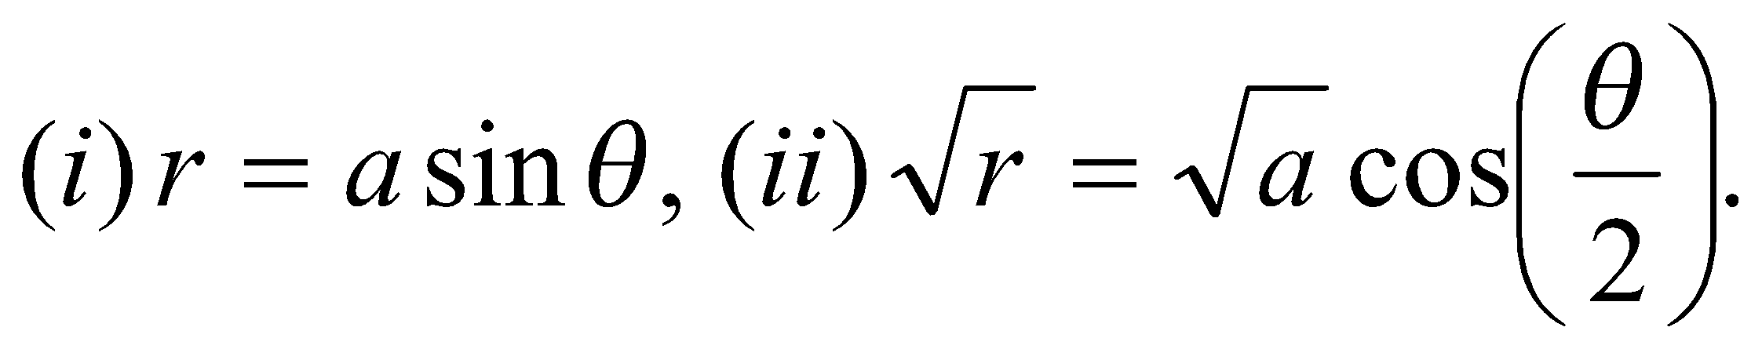
- Transform to polar coordinates the equations
- Transform to parallel axes through the new origin (1,-2) of the equation 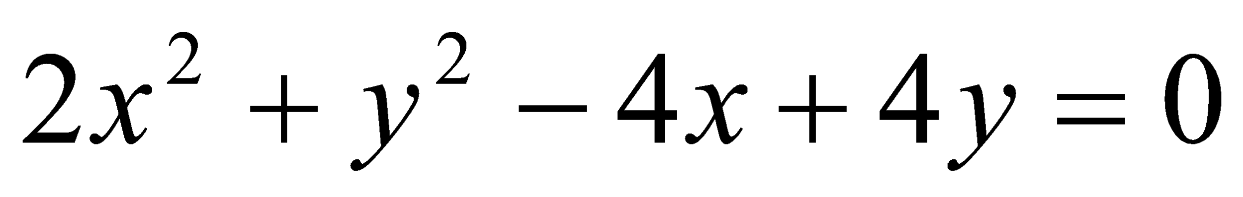.
- Transform the equation 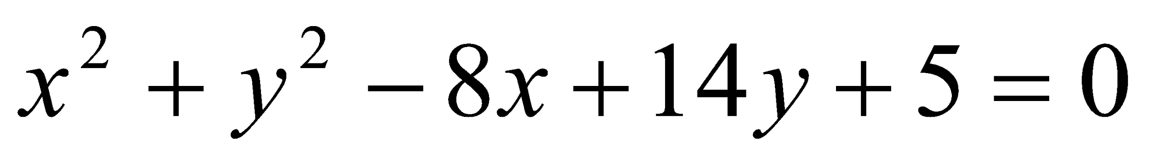 to parallel axes through (4,-7).
- Transform the equation 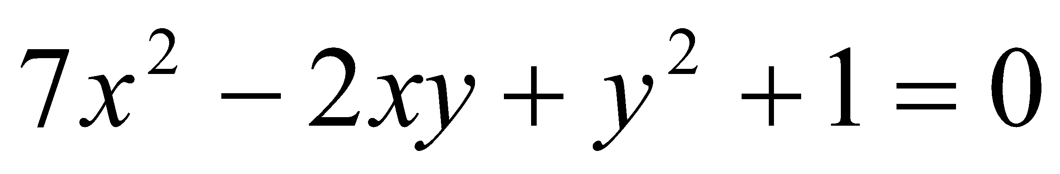 to axes turned through the angle 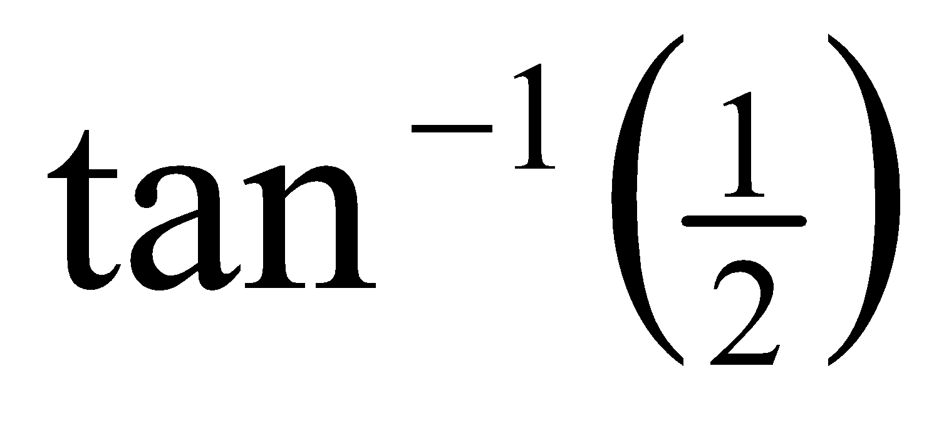.
- Transform the equation to rectangular axes through the point (2,-1) and inclined at an angle 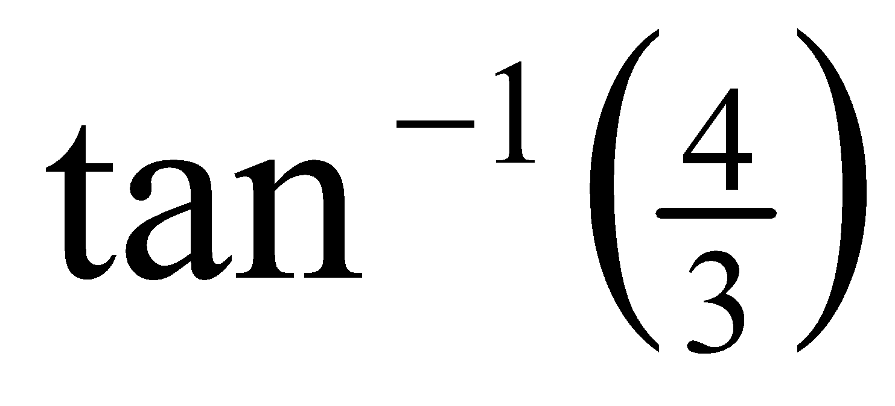.
- Transform the equation 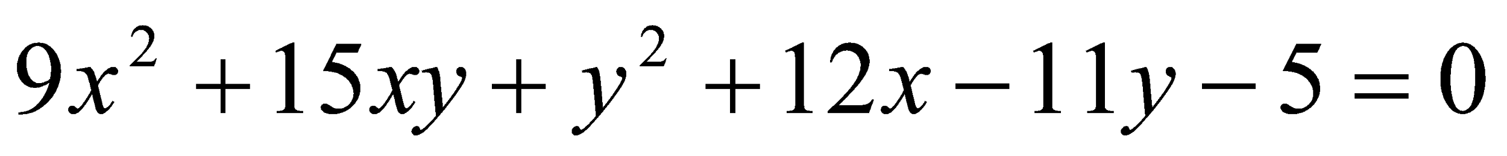, so as to remove the terms x and y.
- Transform the equation 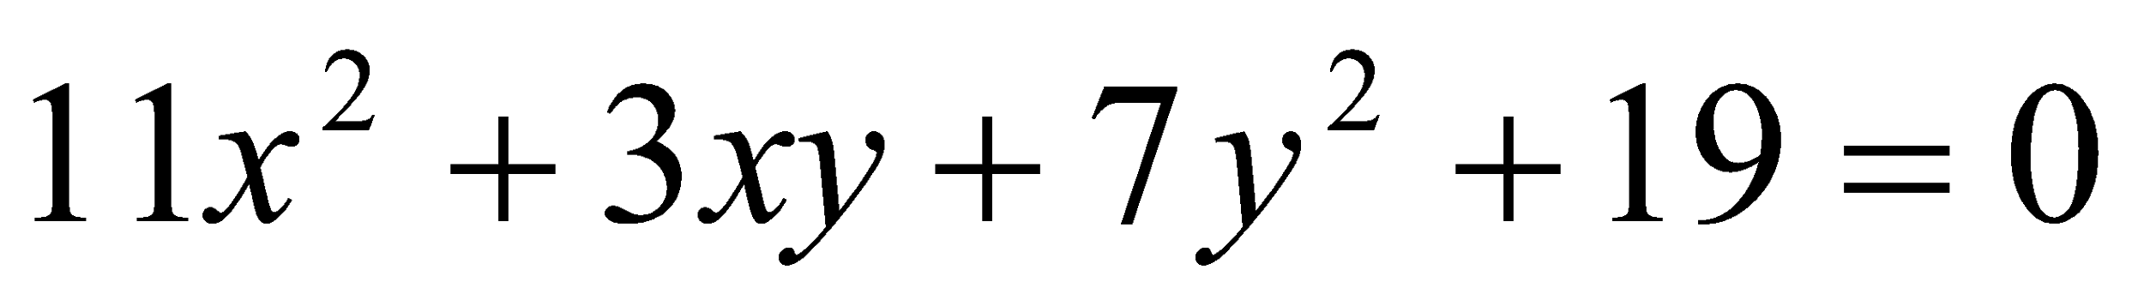, so as to remove the term 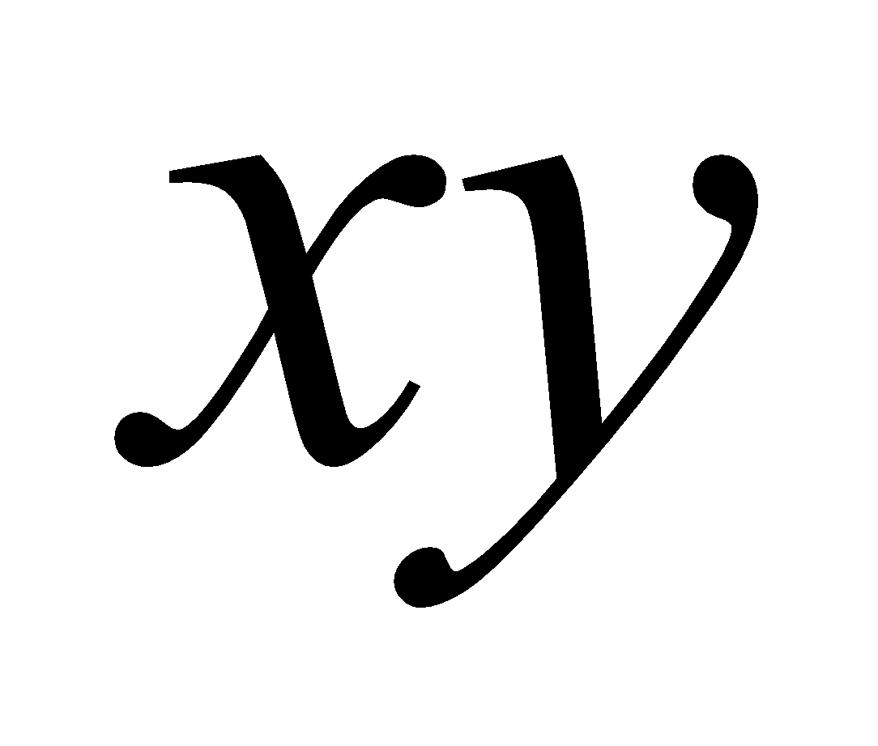.
- Determine the equation of the curve 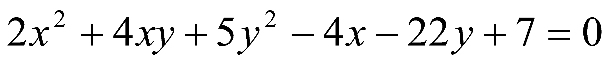 when the origin is transferred to the point 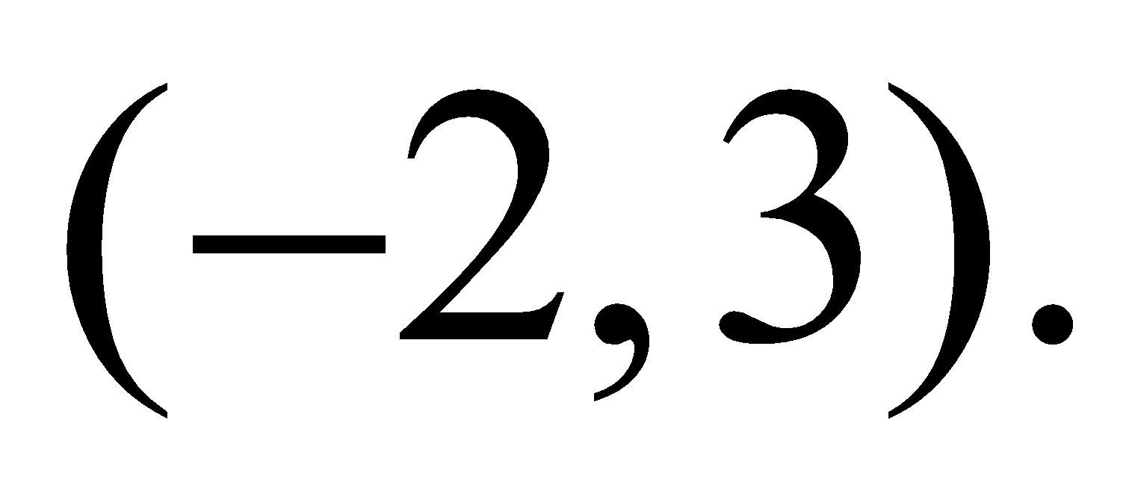
- Remove the  term from the equation 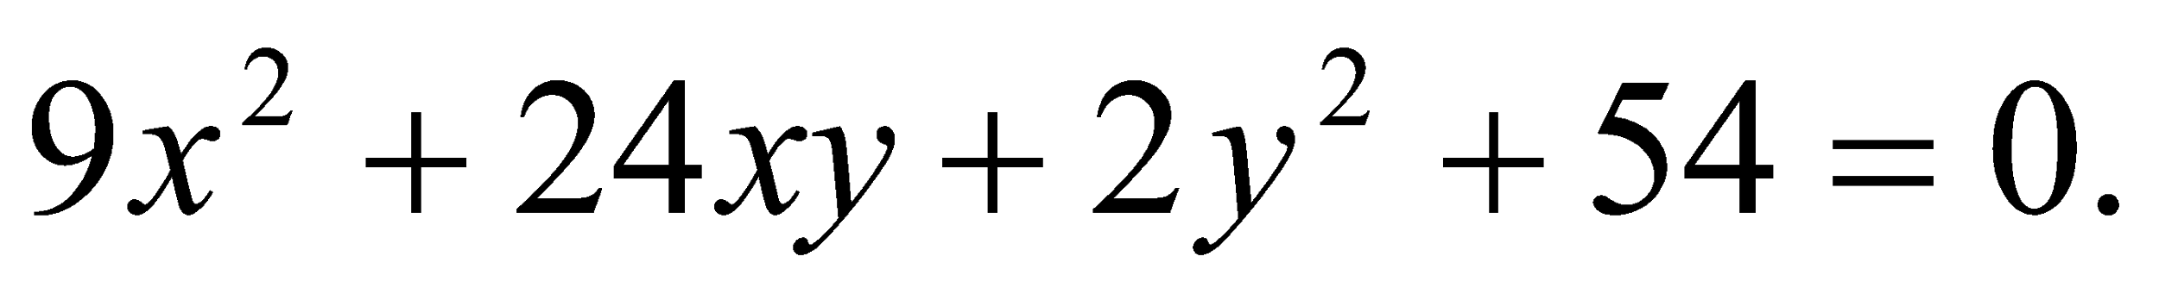
- Determine the equation 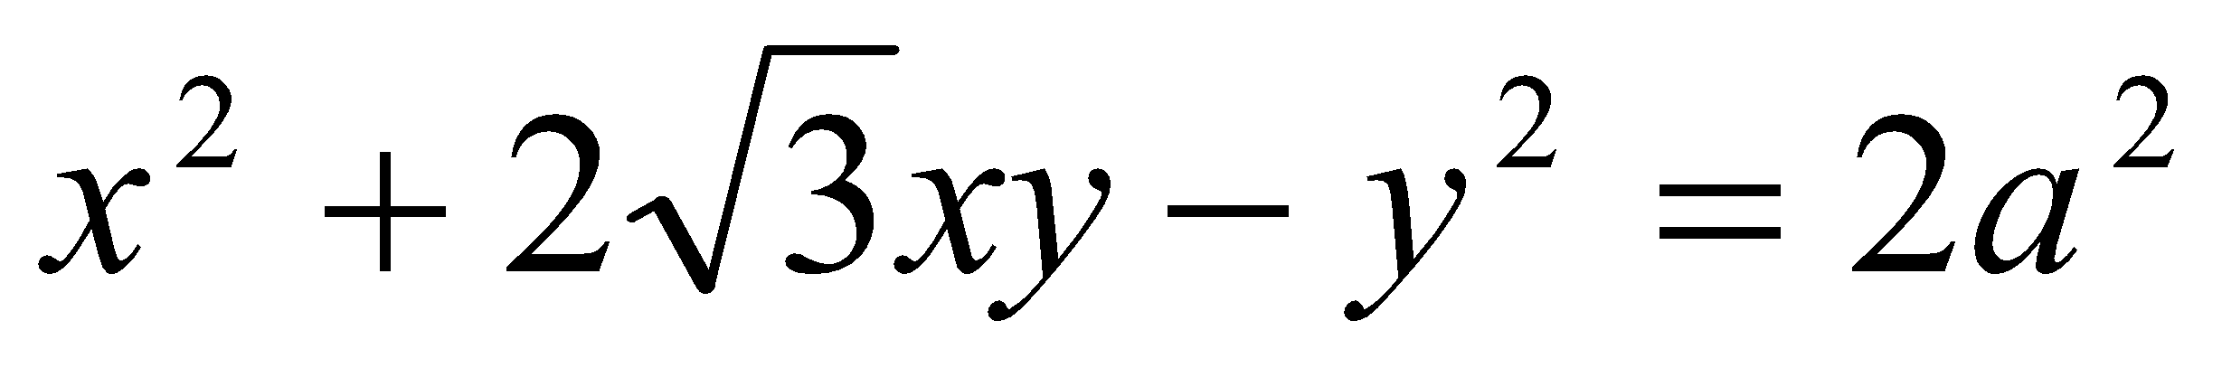after rotating of axes through 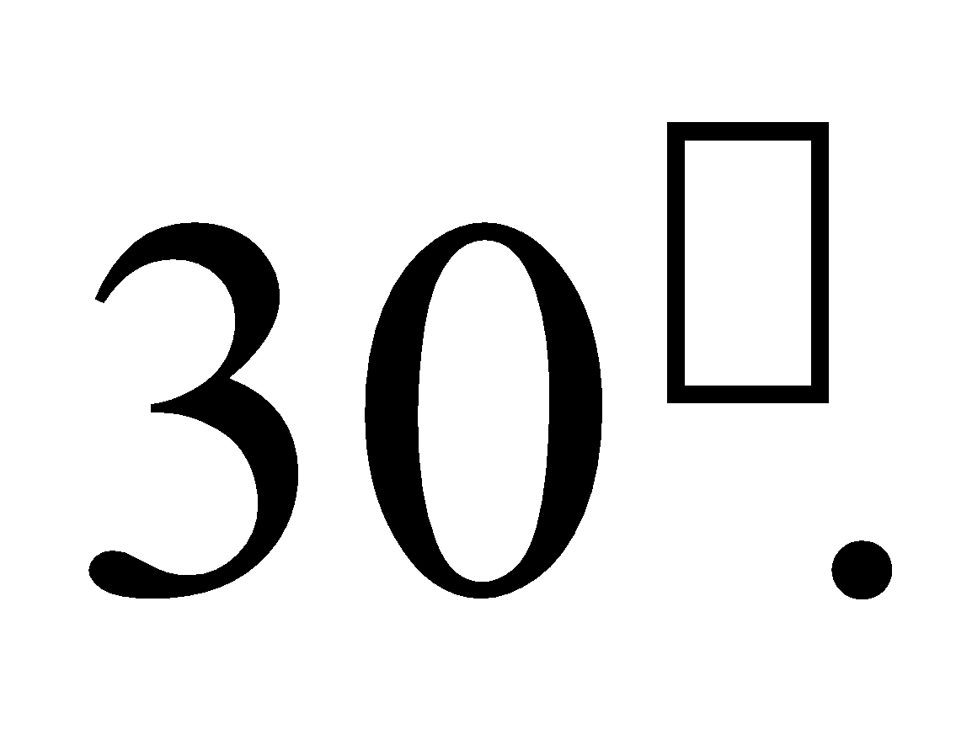
- Transform the equation so as to remove
the terms in x and y.

*Home work sheet # 10

Pair of straight lines

- Show that the following equations represents a pair of straight lines; find also their point of intersection and the angle between them:
- Find the value of λ or k so that the following equations may represent pairs of straight lines:
- Find the equations of the bisectors of the angles between the following pairs of straight lines:
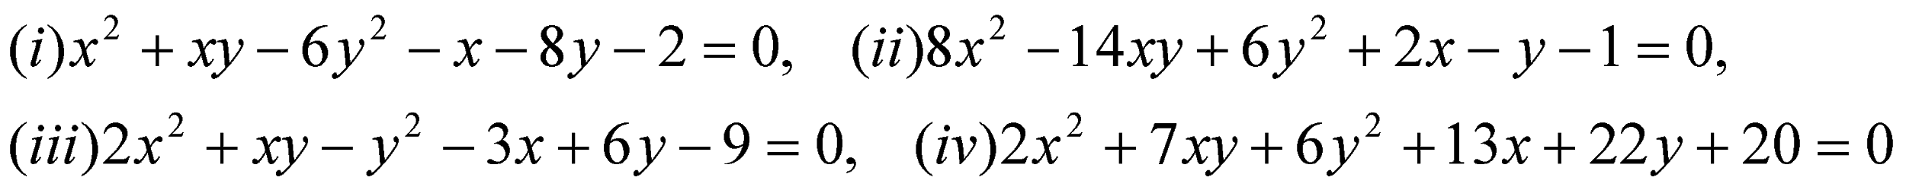

Circle

- Find the equation of the circle with
(i) centre (-2, -1) and radius 4, (ii) centre (9, 0) and radius 1,
(iii) centre (0, 0) and radius 5.
- Find the centre and radius of the following circles:
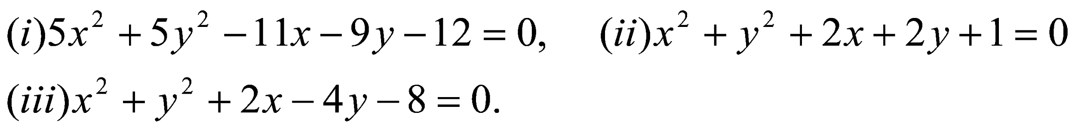
- Find the equation of the circle passing through the points:

*Home work sheet # 11

Tangent and Normal of Circle

- Show that the circles 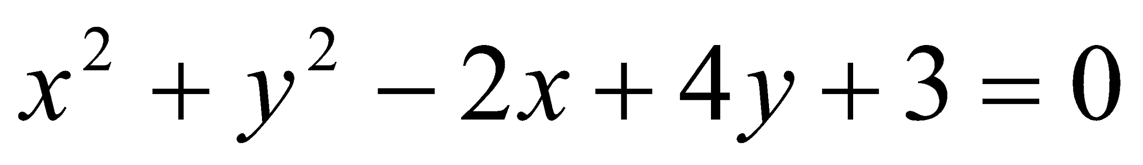and 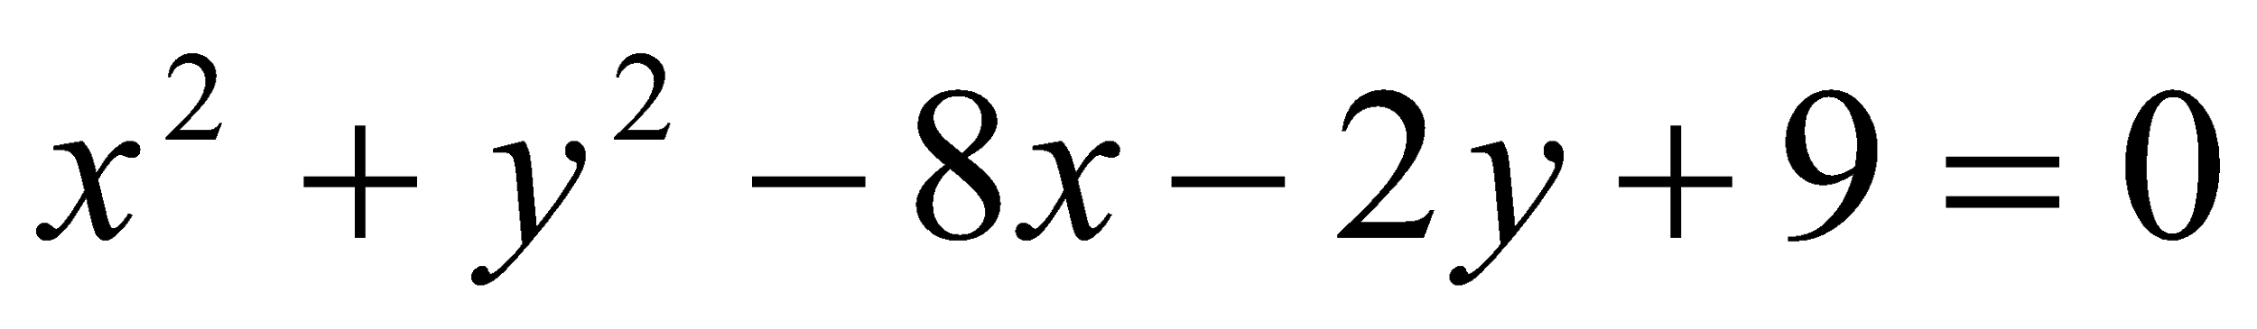 touch one another at (2, -1).
- Find the equation of the circle through the intersection of the circles 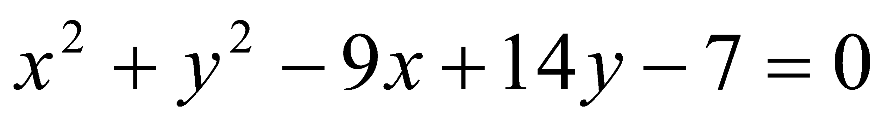 and 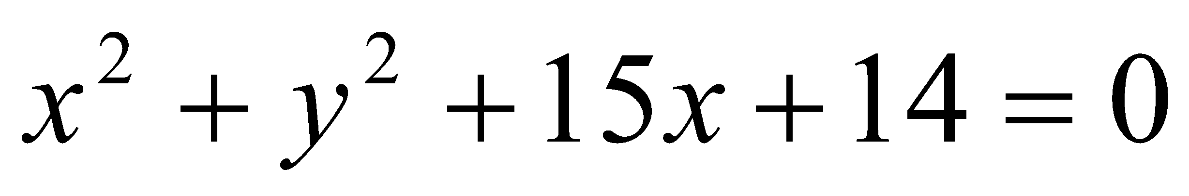and passes through the point
(2, 5).
- Find the equation of the circle which passes through the intersection of the circles 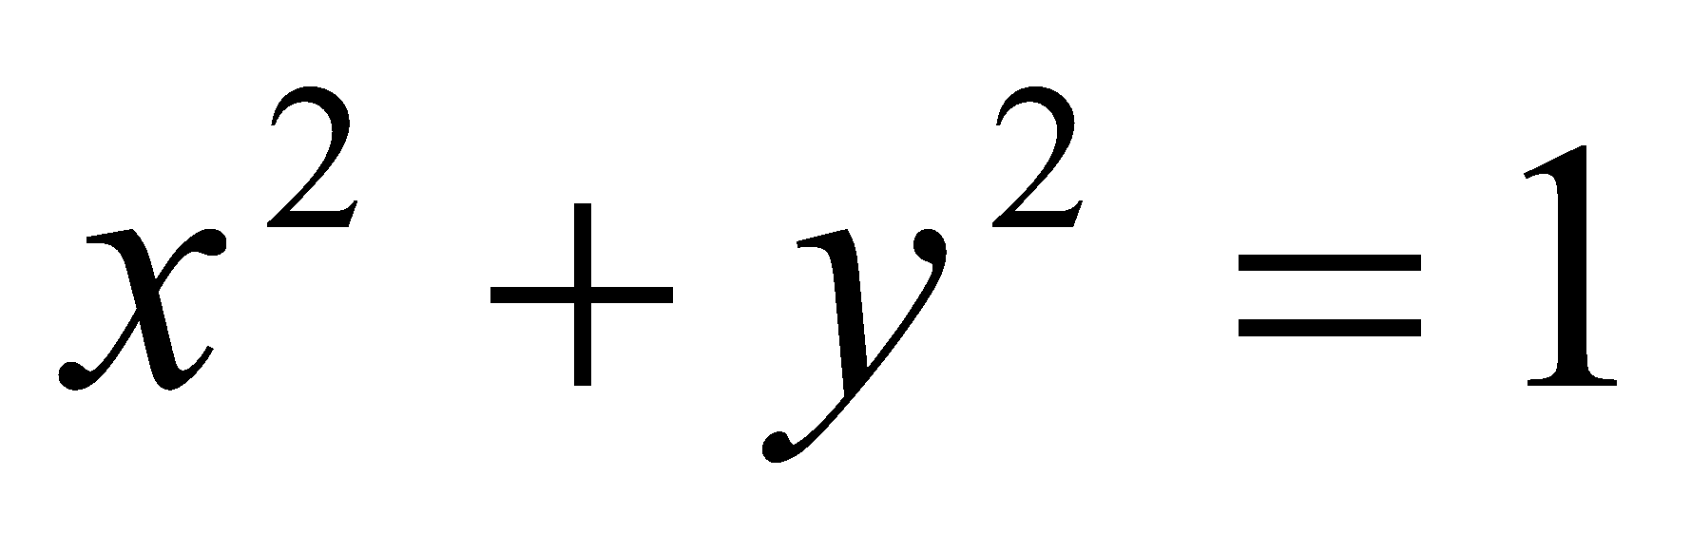 and 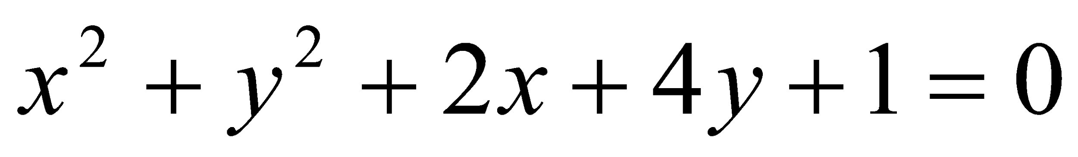and touches the straight line 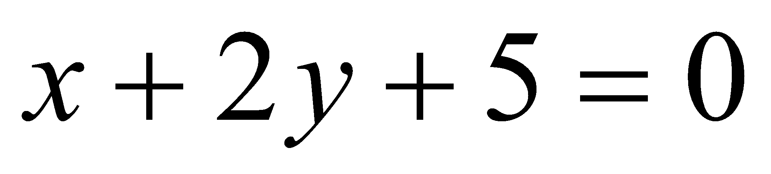.
- Find the radical centre of the three circles 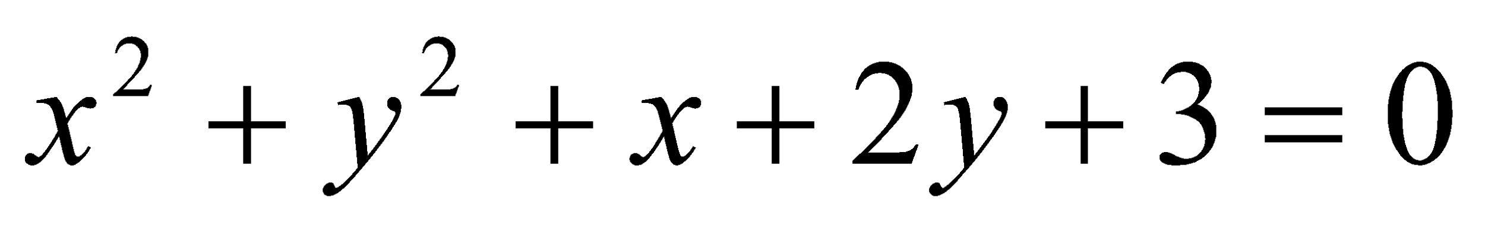,
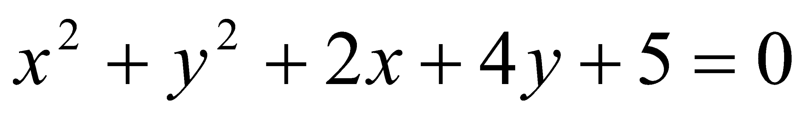and 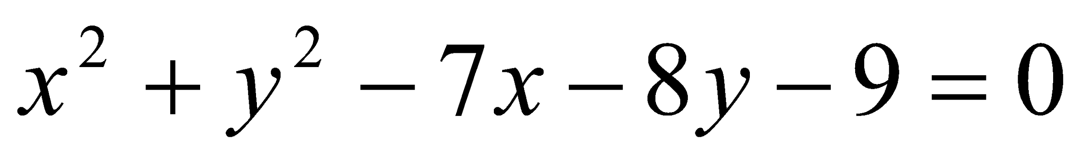.

Conic Section

- Reduce the following equations to their standard forms:

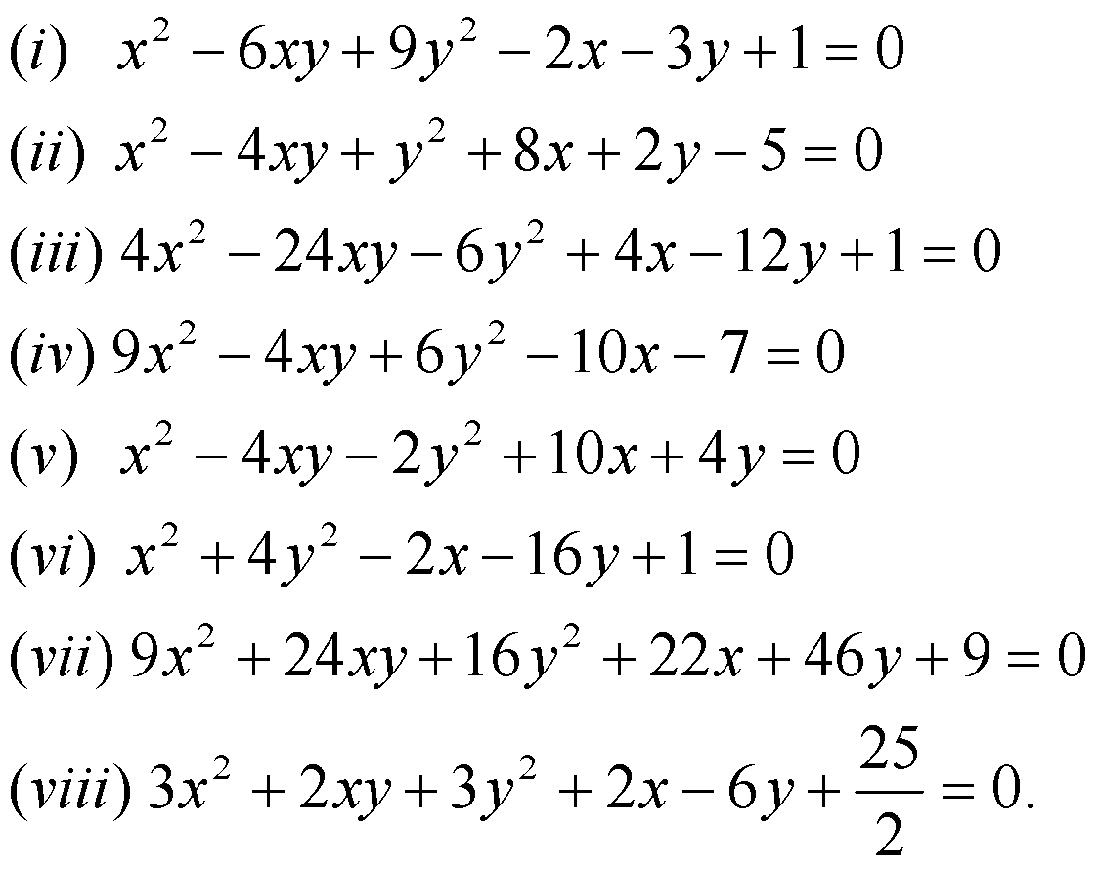

- Find the centre of the following conics:

